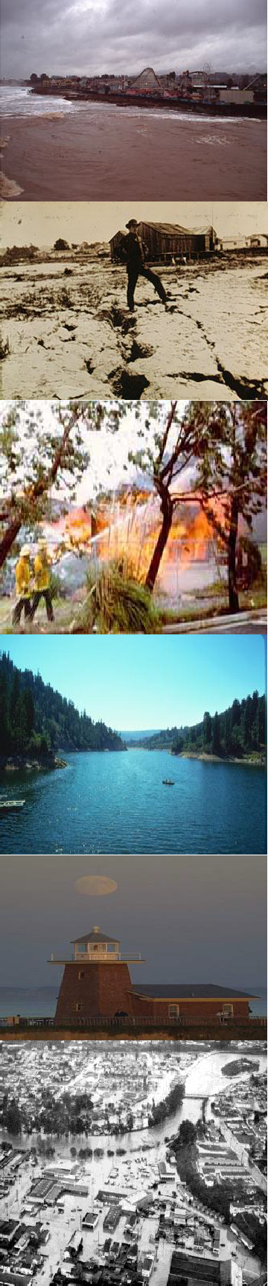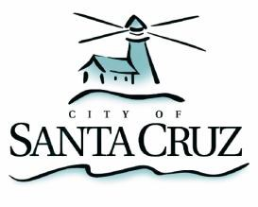
City of Santa Cruz
CLIMATE ADAPTATION PLAN
An update to the 2007 Local Hazard Mitigation Plan
2012 - 2017

......................................................................................................................................
...............................................................................................................................................
...................................................................................................................................................
........................................................................................................................................
......................................................................................................................
.....................................................................................................
................................................................................................................................................
.....................................................................................................................................................
....................................................................................................................................
.........................................................................................................................
..............................................................................
..........................................................
..........................................................................................................................................................
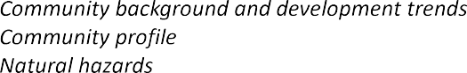
...............................................................................................
................................................................................................................................................
....................................................................................................................................................
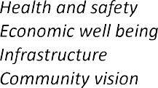
.................................................................................................................................................
.............................................................................................................................................
.......................................................................................................................................................
.................................................................................................................................................
.....................................................................................................
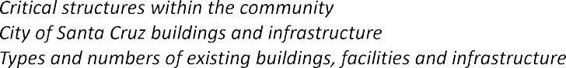
.............................................................................................................
....................................................................................................
.................................................................
.....................................................................................................................
...................................................................................................................
..........................................................................................................................
...................................................................................................................................
.....................................................................................................
.........................................................................................................
........................................................................................................
.......................................................................................................
...............................................
...........................................................................
........................................................................................................................................
- ...........................................................................................................................................................
.................................................................................
.......................................................................................................................................................
...........................................................................................................................
....................................................................................................................
..............................................................................................................................................................
...................................................................................................................................................
....................................................................................................................................
.............................................................................................................................................
............................................................................................................................................
.....................................................................................................................................
- ..............................................................................
...................................................................................................................................

.......................................................................................................................................
..................................................................................................................................
.....................................................................................................................
.........................................................................................
.............................................................................................................
..................................................................................................................................
..................................................................................................................................................................
...........................................................................................
.................................................................................................................................
...........................................................................................................................................................
.....................................................................................................
......................................................................................................................................
..........................................................................................................................................
........................................................................................................................................................
....................................................................................................................................................
.....................................................................................................................
.............................................................................................................
.....................................................................................................................
.........................................................................................................................
..........................................................................................................
........................................................................................................................................
..............................................................................
......................................................................................................
.............................................................. ............................................................................................................................

Maps and Figures
Figure 1: City limits with greenbelts 1
Figure 2: Santa Cruz location within state 3
Figure 3: State highways and major roads 5
Figure 4: Map of critical structures 9
Figure 5: Wastewater Treatment Facility service area 11
Figure 6: Water service area 12
Figure 7: Main Beach, Santa Cruz, California 20
Figure 8: Sea level rise projections 21
Figure 9: Coastal erosion in Santa Cruz 22
Figure 10: Urban/wild land fire hazard areas 23
Figure 11: Local farmer‘s market produce 24
Figure 12: Climate Adaptation planning cycle 30

CITY MANAGER’S LETTER
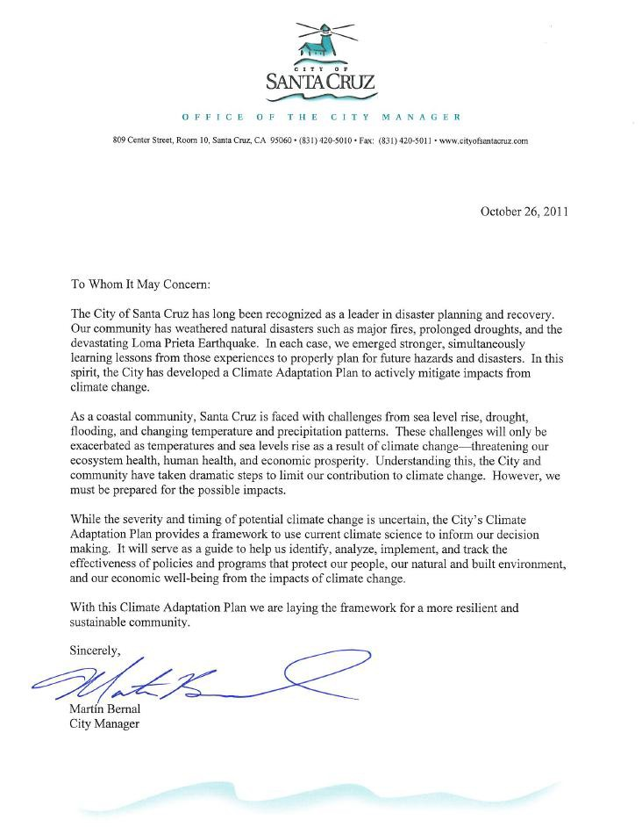

CITY COUNCIL ADOPTION

DRAFT CLIMATE ADAPTATION PLAN RESOLUTION
TO BE ADOPTED BY COUNCIL UPON APPROVAL OF PLAN BY FEMA

RESOLUTION NO.

A RESOLUTION OF THE CITY COUNCIL OF THE CITY OF SANTA CRUZ ADOPTING THE CITY OF SANTA CRUZ CLIMATE ADAPTATION PLAN AS AN UPDATE TO THE LOCAL HAZARD MITIGATION PLAN (LHMP) AS APPROVED BY THE FEDERAL EMERGENCY MANAGEMENT AGENCY (FEMA)

WHEREAS, on October 10, 2000, the Federal Disaster Mitigation Act of 2000 (Public Law 106-390) was enacted establishing new requirements for state and local government agencies to submit a comprehensive Disaster Mitigation Plan in order to be eligible for hazard mitigation grant funding; and

WHEREAS, the City of Santa Cruz has experienced a number of devastating natural hazards prior to and since its incorporation in 1866, including floods, drought and the 1989 Loma Prieta Earthquake; and

WHEREAS, the City of Santa Cruz adopted its first Local Hazard Mitigation Plan (LHMP) in 2007 formalizing the City‘s comprehensive efforts to build a resilient community; and

WHEREAS, the Climate Adaptation Plan builds upon the foundation, objectives and actions of the initial LHMP and is consistent with the Emergency Operations Plan, the draft Climate Action Plan and the 2030 General Plan Update; and

WHEREAS, the Climate Adaptation Plan has been reviewed by all relevant departments, boards and commissions, and California Emergency Management Agency; and

WHEREAS, the Climate Adaptation Plan was reviewed by the City Council and the community at a City Council Special Study Session on October 4, 2011 and was available for public comment and review for the required time period; and

WHEREAS, approval of the Climate Adaptation Plan by FEMA constitutes formal completion of the Plan and establishes continued eligibility for the City to pursue hazard mitigation funds; and

WHEREAS, the Climate Adaptation Plan will contribute to building a more resilient Santa Cruz.

NOW, THEREFORE, BE IT RESOLVED that the Santa Cruz City Council does hereby adopt the City of Santa Cruz Climate Adaptation Plan as an update to the Local Hazard Mitiga- tion Plan (LHMP) in accordance with the Federal Disaster Mitigation Act of 2000 thereby meet- ing continued eligibility requirements for the potential receipt of hazard mitigation grant funds.
Passed and adopted this 13th day of December, 2011, by the following vote: AYES:
NOES: ABSENT: DISQUALIFIED:

APPROVED:
Mayor

ATTEST:
City Clerk

ACKNOWLEDGEMENTS

Santa Cruz City Council

Ryan Coonerty, Mayor | Don Lane, Vice Mayor | Hilary Bryant
Tony Madrigal | Katherine Beiers | Lynn Robinson
David Terrazas
Climate Adaptation Team Leaders
Cathlin Atchison ............... Project Manager (Author) ...................................Public Works Robert Solick .................... Emergency Operations Center Manager .............Public Works Juliana Rebagliati ............. Planning Director................................................Planning
Ross Clark ........................ Climate Action Coordinator ................................Planning
Mary Arman...................... Operations Manager............................................Public Works

Climate Adaptation Advisory Team Members
Member Position Department Martin Bernal.................... City Manager ......................................................City Manager
Tina Shull ......................... Assistant City Manager.......................................City Manager
Ron Oliver ........................ Fire Chief ............................................................Fire
Eric Aasen......................... Division Chief of Training ..................................Fire
Mark Ramos ..................... Division Chief of Operations ..............................Fire
Dannettee Shoemaker ....... Parks and Recreation Director ............................Parks and Recreation Carol Scurich .................... Recreation Superintendent ..................................Parks and Recreation
Leslie Keedy ..................... City Arborist .......................................................Parks and Recreation
Mauro Garcia.................... Parks Superintendent ..........................................Parks and Recreation
Ken Thomas...................... Principal Planner.................................................Planning
Mark Dettle....................... Public Works Director.........................................Public Works Christophe Schneiter......... Deputy Director/City Engineer ...........................Public Works
Dan Seidel ........................ Superintendent Wastewater Treatment ...............Public Works Mike Sanders .................... Operations Manager............................................Public Works
Steve Wolfman.................. Associate Civil Engineer ....................................Public Works Corinna Beardsley………Administrative Assistant II...................................Public Works
Bonnie Lipscomb.............. Economic and Redevelopment Director .............Redevelopment Katherine Donovan........... Redevelopment Manager ....................................Redevelopment
Bill Kocher ....................... Water Department Director.................................Water Linette Almond ................. Deputy Water Director/Engineering Manager ....Water Toby Goddard ................... Water Conservation Manager .............................Water

Scientific Advisors
University of California • Santa Cruz
Gary Griggs Director, UCSC Institute of Marine Sciences
Brent Haddad Professor of Environmental Studies
Director of the UCSC Center for Integrated Water Research

EXECUTIVE SUMMARY
T
he scientific community has reached a strong consensus that the climate is changing.i Climate change impacts include threats not only to our infrastructure but to our health, safety and to the economic vitality of our community. Climate scientists agree that there
are only three approaches to addressing the impacts of climate change: retreat, resist or ignore. There is a cost associated with each of these paths.

Incorporating climate resilience planning into all that we do as a city allows us to address some of these difficult decisions in advance and take advantage of potential opportunities to protect our residents, infrastructure and economic well-being. This City of Santa Cruz Climate Adapta- tion Plan creates a framework for decision makers to build a more resilient and sustainable community, one that is informed by the most current climate science.

Surrounded by a greenbelt of open space areas and the Pacific Ocean, Santa Cruz is a compact, vibrant beach community that preserves the diversity and quality of its natural and built envi- ronments, creates a satisfying quality of life for its residents and attracts visitors from around the world. Its unique position, along the Pacific Ocean cliffs and Monterey Bay beaches with a river running through its downtown and tourist-serving areas, is a part of its appeal, yet these features also increase its vulnerability to the impacts of climate change. Every aspect of the city — its economic prosperity, social and cultural diversity, scenic beauty and historical character — is threatened by potential impacts of climate change. While the time frame and severity of potential climate change impacts are uncertain, climate scientists agree that they will be significant.

The City of Santa Cruz has long been a leader in environmental sustainability and disaster recov- ery. Santa Cruz has extensive experience in preparing for and responding to disasters such as earthquakes, floods and drought. The community has come back from each experience stronger and better prepared for what lies ahead. We have not only recovered from these hazards but have strengthened our city by taking steps to avoid the impacts of these hazards should they occur again. As an example, our downtown corridor along Pacific Avenue was nearly destroyed by the 1989 Loma Prieta earthquake. The community rebuilt downtown to standards that make each building and the whole of downtown better prepared should another earthquake strike. Hazard mitigation planning contributes to the protection of lives, property and the economic vitality of our city. The 1989 earthquake was devastating but it was also an opportunity to create a safer and more disaster resistant city.

Our downtown, visitor-serving facilities, neighborhoods and vital municipal infrastructure are within a few feet of sea level. Awareness of potential climate change impacts, especially sea level rise, and planning for such impacts, is critical for the future of Santa Cruz.

Climate change mitigation and adaptation planning was identified as a critical action item in the City‘s Local Hazard Mitigation Plan (LHMP, 2007). The Federal Emergency Management Agen- cy (FEMA) reviews and approves LHMPs and requires an update on a five-year cycle. To ac- complish this mandate, the City applied for and received FEMA Hazard Mitigation Planning funds to address potential impacts of climate change as our update to the adopted LHMP.

The intent of this Climate Adaptation Plan is to identify our most significant potential climate change risks and vulnerabilities, and to create an action plan that will guide current and future decision makers in protecting our natural and built environment, our residents and visitors, our economic base, and our quality of life. Having a well-researched and thought out Climate Adap- tation Plan in place creates the opportunity for the City to apply for FEMA and other funding to address identified adaptation priorities.

The City used FEMA grant funding to enter into an agreement with University of California at Santa Cruz (UCSC) to provide the most current available local and regional climate change sci- entific information upon which to build the Climate Adaptation Plan. Dr. Gary Griggs, Director of the Institute of Marine Sciences, and Dr. Brent Haddad, Professor of Environmental Studies and Director of the UCSC Center for Integrated Water Research, co-authored the Climate Adap- tation Vulnerability Study. Their recently completed ―City of Santa Cruz Vulnerability Study‖ identified climate change impacts for which the community should prepare. Identified vulnera- bilities include:
- sea level rise
- precipitation patterns that may lead to more extreme storm events
- flooding
- drought
- ocean acidification
- cliff erosion
- salt water intrusion
- urban/wildland fires
- ambient temperature changes which may result in species migration, ecosystem endangerment, and increased risk of wildfire
The concept of sustainability includes a community‘s environmental, social and economic health as well as disaster resilience. Traditionally, we have viewed disaster resilience as preparation for sudden hazard events such as earthquakes or floods. This Climate Adaptation Plan expands dis- aster resilience to include climate change impacts which may occur gradually or in the future. Because of the more gradual and long term impacts of climate change, we have the opportunity to prepare and to take advantage of opportunities to incorporate climate adaptation into our ac- tions. This Plan establishes specific Goals and Objectives for the City Santa Cruz to adapt to climate change impacts while maintaining the community‘s environmental, social and economic health.

Climate Adaptation Goals
- Protect the unique character, scenic beauty and culture in the natural and built environment from being compromised by climate change impacts
- Support initiatives, legislation, and actions to respond to climate change
- Build resilience into all programs, polices and infrastructure
- Encourage climate change resilience planning and actions in private companies, institutions, and systems essential to a functioning City of Santa Cruz
- Encourage community involvement and public-private partnerships to respond to potential climate impacts

- Insure that Santa Cruz remains a safe, healthy and attractive place with a high quality of life for its residents, businesses and visitors
ADOPTED CITY COUNCIL STRATEGIC GOALS
In 2011, the City Council developed a strategic three-year plan that identifies five goals for the community. These strategic goals (below) inform and support the goals and objectives presented in the Climate Adaptation Plan.
  - To enhance environmental sustainability and resources
  - To enhance community safety
  - To attract and retain businesses and jobs
  - To achieve financial stability and sustainability
  - To improve and maintain infrastructure and facilities

Climate adaptation will require actions by individuals, businesses, and government. This Plan identifies 41 Climate Adaptation Action Items to adapt our community infrastructure, businesses and neighborhoods to potential climate change impacts, and to prepare for changes to natural resources that impact our community.

1Pew Center on Global Climate Change — Adaptation Planning — What U.S. States and Localities are Doing, 2/13/2008 www.pewclimate.org/docUploads/State_Adapation_Planning_02_11_08.pdf

CHAPTER 1

CITY OF SANTA CRUZ CLIMATE ADAPTATION PLAN
BACKGROUND, DEVELOPMENT TRENDS, COMMUNITY PROFILE AND CRITICAL STRUCTURES

Introduction
P
eople and property in Santa Cruz are at risk from a variety of hazards that have the poten- tial to precipitate wide spread loss of life, damage to property, infrastructure and the envi- ronment. Some hazards are natural, such as earthquakes, others are natural hazards
exacerbated by the use of land, such as building along the cliff and development within flood- plains. A natural hazard can result in damages and hardships for an entire community for many years following the event.

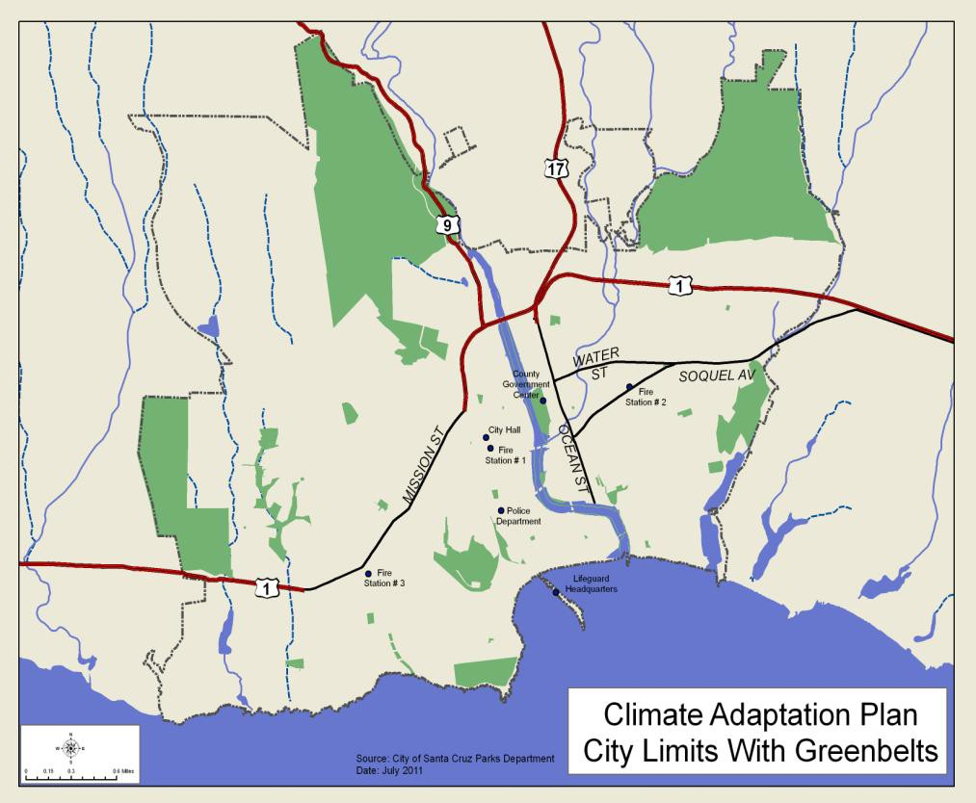
Flooding, drought, earthquakes and cliff retreat have all occurred in the City within the last fifty years.

Recent history has identified earth- quakes as having caused the greatest damage in the past. However, one of the greatest threats that our community may be facing in the future may be one that was not iden- tified until 2007 within the Local Hazard Mitigation Plan (LHMP).
FIGURE 1: CITY LIMITS WITH GREENBELTS
That threat is the
potential impacts of climate change including sea level rise, extreme storm events, cliff erosion, flooding, drought, ocean acidification and increased risk of wildfire. While climate science is uncertain it is imminent and the City of Santa Cruz is committed to building adaptive capacity into policies, plans programs and infrastructure and will incorporate systems to view decisions through a climate lens.

The purpose of hazard mitigation is to implement and sustain actions that reduce vulnerability and risk from hazards, or reduce the severity of the effects of hazards on people and property. These mitigation actions include both short-term and long-term activities which reduce the im- pacts of hazards, reduce exposure to hazards, or reduce impacts of hazards through various means including preparedness, policy and infrastructure decisions, and response and recovery measures. Effective mitigation actions also reduce the adverse impacts and cost of impacts from future disasters.

The City of Santa Cruz developed the 2007 Local Hazard Mitigation Plan to create a safer and more sustainable community. This Climate Adaptation Plan is a continuation of that commitment through an analysis of the steps necessary to reduce the risks from climate change impacts. This Climate Adaptation Plan serves as a guide for decision-makers as they commit resources to building a climate resilient community.

Community background and development trends
Santa Cruz is a ‗built out‘ community so we do not have the luxury of declaring that no devel- opment will exist within the areas that are threatened by flood or sea level rise. The core of our downtown and visitor serving areas are in a flood plain and adjacent to the sea. While we may not be able to fully retreat to a location that is not threatened by the impacts of climate change, including sea level rise, we can incorporate current climate science to build resilience into devel- opment decisions that may impact us now and in the future.

Santa Cruz is the largest city in Santa Cruz County and serves as the County government seat. Since its founding, it has been the urban center of the County providing employment and com- mercial, governmental, social, educational and cultural services to the larger area. The establish- ment (1964) and growth of the University of California at Santa Cruz have reinforced the City‘s role as a major social, scientific and cultural center.

Located between the Pacific Ocean and the Santa Cruz Mountains, the City is met on the south by the Monterey Bay. Public and privately owned lands form a greenbelt of open space along the City‘s western, northern and eastern boundaries including agricultural, natural areas, parks, and coastal recreation. These areas give definition to the City and serve as barriers to further expan- sion of urbanization.

The City limits enclose approximately 12 square miles. In 2011 the City‘s population is ap- proaching 60,000. The City exercises zoning control and provides public services including re- fuse, parks, police and fire protection to this area. It provides water and wastewater treatment services to both City residents and population in the surrounding area. Decisions impacting water and wastewater services and infrastructure impact the 60,000 City residents and 30,000 to 60,000 additional water or wastewater treatment customers outside City limits.

Santa Cruz is a compact city with an urban central core, circumscribed by open space land uses and blessed with a diverse natural and built environment. To maintain and build upon the City‘s sense of place, the Draft General Plan 2030 stipulates that growth will be accommodated by de- velopment and intensification of residential, commercial and industrial lands within the City‘s

existing boundaries. The Pacific Ocean, agricultural, publically-owned open space and natural areas will also be preserved to define and contain urban development.

The General Plan 2030 map (Appendix J) of land use designations includes the location and in- tensity of uses throughout the city‘s planning area. In addition to land within the city limits, the planning area includes park land and agricultural/grazing land north of the City in the unincorpo- rated area. The City is predominately built out (approximately 97%).

The Draft General Plan 2030 envisions residential and commercial intensification along the ma- jor street corridors (Water Street, Soquel Avenue, Mission Street and Ocean Street) through pri- vate and public redevelopment of opportunity sites. The Plan also encourages intensification in the downtown area including the Front Street corridor and lower Pacific Avenue. New land use designation for these areas include ground floor commercial with upper residential and densities ranging from 20.1 to 55 dwelling units/acre.

Due to the recent economic recession the development trend for the City has been very slow. Although both residential and commercial projects have obtained land use entitlements, con- struction has been hampered by the lack of financing.

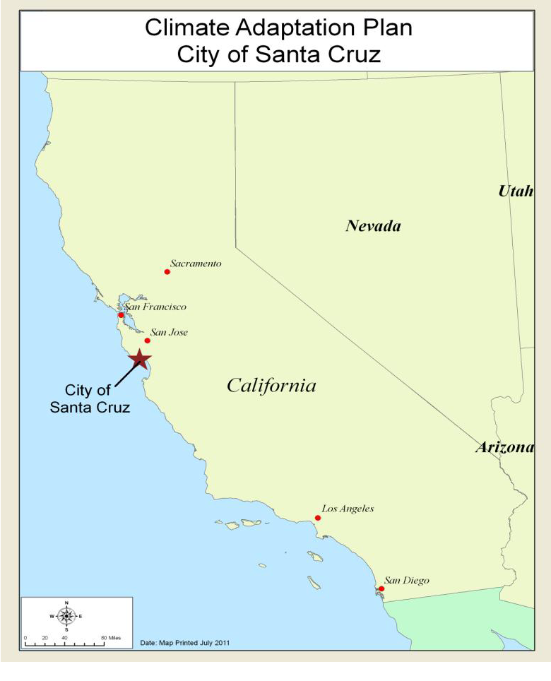Employment and population projections prepared by the Association of Monterey Bay Area Governments (AMBAG) for the City estimate a 2030 population of 65,884 or a 9.9% increase over the 20 year planning period.
FIGURE 2: LOCATION WITHIN THE STATE
Employment is expected to increase from 33,826 jobs to 41,548 jobs over the same period (22.8% over 20 years). Most if not all of this growth will occur as infill development of vacant and underutilized parcels throughout the City.

Community profile
As home to the Monterey Bay Ma- rine Sanctuary and University of California at Santa Cruz (UCSC) Longs Marine Lab; the bay, beaches and coastline are appreciated by the community as a valuable natural resources as well as a key economic resource. This location along the coast also presents the greatest vul- nerability to the impacts of climate change and extreme storm events.

Natural hazards
Natural hazards that have affected Santa Cruz in the past and many that

may impact the community in the future can be identified with a high degree of probability. Cli- mate change has now been added to the list of potential hazards that threaten Santa Cruz.

Building a resilient community in the face of climate change requires acceptance of a certain degree of uncertainty in both the timing and severity of those hazards. Yet, as a community it is important that we consider the range of potential impacts from climate change on our services, infrastructure and quality of life. Flooding, drought, earthquakes and cliff erosion have all oc- curred in the City within the past thirty-five years and will continue to occur in the future, exac- erbated by changes to the climate.

Given our current understanding of climate science and our awareness of our own history, we know that climate change impacts will occur. We do not have complete information on the tim- ing and severity of potential impacts but using the information we do have to inform our deci- sions will allow us to build resilience into many facets of our community.

This Climate Adaptation Plan is part of an ongoing process to evaluate the risks that potential climate change impacts pose to Santa Cruz and to establish an ongoing community dialogue to identify the most important steps to pursue in order to reduce our community‘s vulnerability to climate change impacts based on the best scientific information available.

Health and safety
In addition to the more obvious threats of sea level rise and flood, the availability of water, food and fuel must also be considered when looking at potential climate impacts. The Water Depart- ment has identified water portfolio diversification as a key action to build resilience into City services. The City is continually exploring ways to reduce fuel consumption and support alterna- tive energy opportunities within the City as well as encouraging those actions in the private sec- tor. Food availability is also a critical aspect of our community‘s long term resilience.

Our vulnerable populations, the economically disadvantaged, the non-English speaking, the el- derly and the infirm may have less adaptive capacity to climate impacts. The City‘s long term planning will include reaching out to these populations to educate and assist in climate awareness and adaptation planning.

Economic well being
There are costs associated with implementation of adaptation measures. Climate awareness and long term planning will allow us to take advantage of opportunities to implement adaptation measures cost effectively as we provide services to our community. It will also provide opportu- nities to encourage public-private partnerships in building in adaptive capacity.

The City‘s mild weather, proximity to several northern California metropolitan centers, and sce- nic and recreation resources make it a popular day and extended-stay recreation area. As a result, the population is subject to large seasonal variations due to an influx of visitors during summer and other peak recreational periods. Planning for potential impacts of climate change in Santa Cruz will allow us to address the impacts on our visitor population as well as residents, student population, and workers within the community.

Infrastructure
The City of Santa Cruz and community members, with the guidance of UCSC scientists and state and federal resources, are working to identify and address the risks posed by cli- mate change as well as other threats to our natural and built environment.

Measures such as raising lev- ees, vegetation management, and a comprehensive water management plan are critical steps in building resiliency. This Climate Adaptation Plan looks at the resilience of our infrastructure such as our Wastewater Treatment Facility, roads and bridges, and munici- pal buildings particularly in relation to sea level rise.

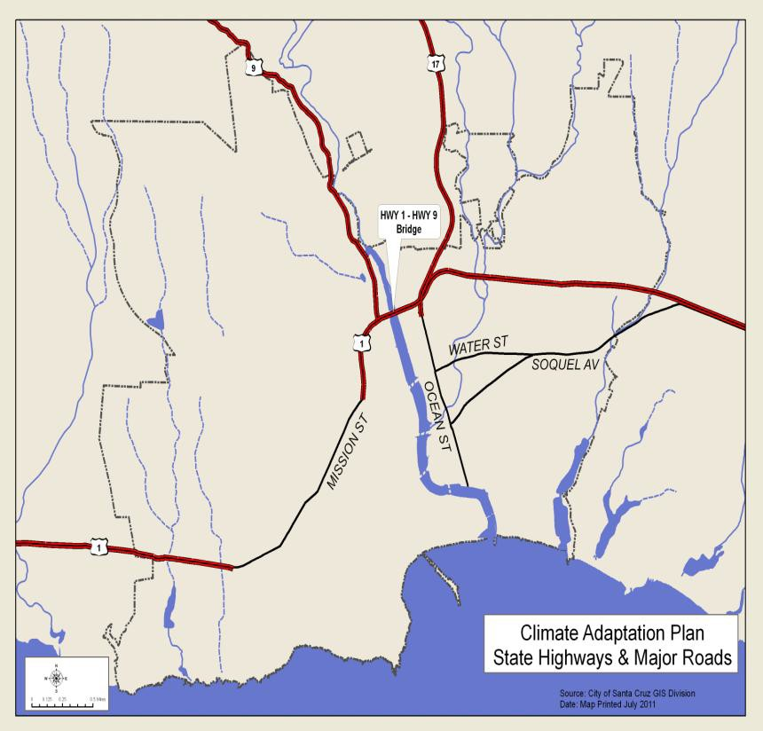
FIGURE 3: STATE HIGHWAYS AND MAJOR ROADS

As mentioned earlier the City occupies a picturesque location along the banks of the San Lo- renzo River, between the Pacific Ocean on the Monterey Bay and the Santa Cruz Mountains. This picturesque location contributes to its unique appeal but also contributes to the very real and immediate concern about potential impacts it may experience as the result of climate change. The downtown and higher density urban core is located within a flood plain. There are only four bridges across the river connecting the two sides of the community. Past experience has shown that losing even one of these bridges in a disaster presents significant problems in addition to traffic impacts. Most bridges have been replaced but the Highway one/nine bridge which has contributed to flood water build up and as a debris catching obstacle remains at the edge of town. Replacement of the Highway 1/ Highway 9 Bridge has been identified as a very high priority.

The City of Santa Cruz will become a more resilient and sustainable community by reviewing policies, programs and investments in infrastructure through a climate resilience lens.

Community vision
The City of Santa Cruz is in the process of updating its General Plan including the Safety Ele- ment, which promotes public health and safety through goals, objectives and action addressing potential hazards including the impacts of climate change. The Safety Element provides the di- rection and resources to help reduce death, injuries, property and environmental damage, and the economic and social dislocation resulting from natural hazards including impacts of climate change. The General Plan Update informed the LHMP, the Climate Action Plan and this Climate

Adaptation Plan. Working collaboratively these Plans support the broader vision and values of the community as reflected in the new vision statement for the General Plan update.
GENERAL PLAN GOALS RELATED TO CLIMATE ADAPTATION

General Plan Natural Resources and Conservation (NRC) Goal 4:
Effective leadership and action in reducing and responding to global warming
NRC 4.3 Support initiatives, legislation and actions for reducing and responding to climate change.
NRC 4.4 Encourage community involvement and public-private partnerships to reduce and respond to global warming.
NRC 4.5 Minimize impacts of future sea level rise.
NRC 4.6 Take early action on significant and probable global warming, land use and development issues, including those that arise after 2025.

Critical structures within the community
As we review critical structures within the community such as hospitals, County government buildings, post offices and City structures such as police and fire stations, the Emergency Opera- tions Center and the Wastewater Treatment Facility, we evaluate the potential impacts that cli- mate change might have on these structures. This Plan guides us in identifying the vulnerability of each structure to the potential impact/s and the expected consequences of that impact. For example, we evaluate the impact of sea level rising perhaps 18 inches, and determine which of the structures at the Wastewater Treatment Facility might be vulnerable and to what degree. This allows us to make decisions that incorporate climate change science as we invest in our commu- nity. It also allows us to better prepare for sudden onset climate events such as an extreme storm event that might occur along with sea level rise. Maps in Appendix F show potential sea level rise and potential projected losses.

City of Santa Cruz buildings and infrastructure
The City of Santa Cruz owns or leases approximately forty buildings. These buildings are used for various municipal purposes including City government administration, providing essential and emergency services, recreation, cultural and performing arts.

Types and numbers of existing buildings, facilities and infrastructure
Much of the downtown and beach areas are in the identified 100 year floodplain. As described in the Vulnerability Study this area is threatened by increased storm events, sea level rise and grad- ual inundation. Climate scientists predict more frequent, more severe storm events which have the potential for significant structural and financial losses. The Emergency Operations Center (EOC) as well as most of the City and County government buildings are in the threatened area. This area includes the following:

- 2,100 Structures (2,269 parcels)
- Central Fire Station
- Police Station
- City Hall
- Lifeguard and Marine Safety Headquarters

- County Government Center
- 40 schools and day care centers

With an uncertain economy it is difficult to determine the potential dollar losses that might occur as a result of vulnerability to the impacts of climate change.

Coastal erosion and wildland fires have the potential to cause significant losses but the greatest threat to the community in terms of potential dollar loss is flooding combined with sea level rise. The Wastewater Treatment Facility appears to be the highest potential dollar loss under current climate science. The Downtown and tourist serving beach area is also at significant risk.
METHODOLOGY USED TO PREPARE ESTIMATE

Determining potential losses as a result of climate change impacts
With an uncertain economy and uncertain timing on the impacts of climate change it is difficult to estimate the potential dollar losses that might occur as a result of vulnerability to the impacts of climate change.

The tables of estimated losses are included in Appendix E. The methodology used to estimate included the following:

Parcel valuation
Valuation of parcels within an impact area are based on improvement values only as collected by appraisers with the County of Santa Cruz County Assessor‘s Office. They don‘t reflect sale value or replacement value. If a parcel intersected a hazard, the entire improvement value of that parcel was used.

Population
2010 Census population blocks were reduced to center points. If a hazard intersected a center point, that population was counted.

Flood and sea level rise analysis
100 year flood loss is shown in Appendix E - Table 1. Since FEMA flood data is mapped on the federal level, the data is extremely coarse in horizontal accuracy. The data was not meant to be measured against parcel level information and therefore is a rough estimate of damage and loss.

Estimating flood losses is an established process. If a ―100-year‖ flood occurred in Santa Cruz, meaning the flood that has a 1% chance of occurring in any given year, it would impact approx- imately 2,100 structures to various degrees. This was determined by intersecting the city‘s data- base of structures with the FEMA developed maps of the 100-year floodplain. Santa Cruz structures in the floodplain vary in construction, size and materials, ranging from single family homes to multi-family to commercial. The downtown of the City of Santa Cruz lies almost en- tirely within the 100 year floodplain. Many structures in this area are multistory.

The primary purpose of the city‘s San Lorenzo Levee Project was to reduce flood damage and loss within the City of Santa Cruz 100 year floodplain. According to the Federal Emergency Management Agency (FEMA), the December 1955 flood caused over $40 million in damage.

The U.S. Army Corps of Engineers estimated that a 100 year flood in the downtown area in 2002 would cause $86 million in damage.

A 1.4 meter sea level rise combined with the p100 year flood map was used to calculate the po- tential losses shown in in Appendix E - Table 2.

Coastal erosion
Although there are only a few houses, two hotels and one City museum along the ocean cliff frontage, the City is attempting to preserve a significant amount of infrastructure including roadways, bike paths, parks and storm drains which are continually threatened by coastal ero- sion. Additionally, the Santa Cruz Harbor, beach frontage, and cliff frontage near the mouth of the San Lorenzo River are also threatened by varying degrees of erosion. Assessor‘s valuations were used to estimate potential losses. In addition, for the beach area Dream Inn, the most recent sales price of $20 million (2006) was used. Potential dollar losses shown in in Appendix E - Ta- ble 3 also include replacement of roads, paths and lighthouse including property acquisition.

Wildland fire
While the majority of the city is urban, one of the impacts of climate change is increased threat of wildfires in several canyons and in the wildland/urban interface.

There are five areas most vulnerable to wildfires within the city including:

- Pogonip
- DeLaveaga
- Moore Creek Preserve
- Arana Gulch
- Arroyo Seco Canyon

Vulnerability is increased in several of these areas due to limited access. Potential losses identi- fied in in Appendix E - Table 4 focus on infrastructure and homes that would be threatened by potential wildland fire.

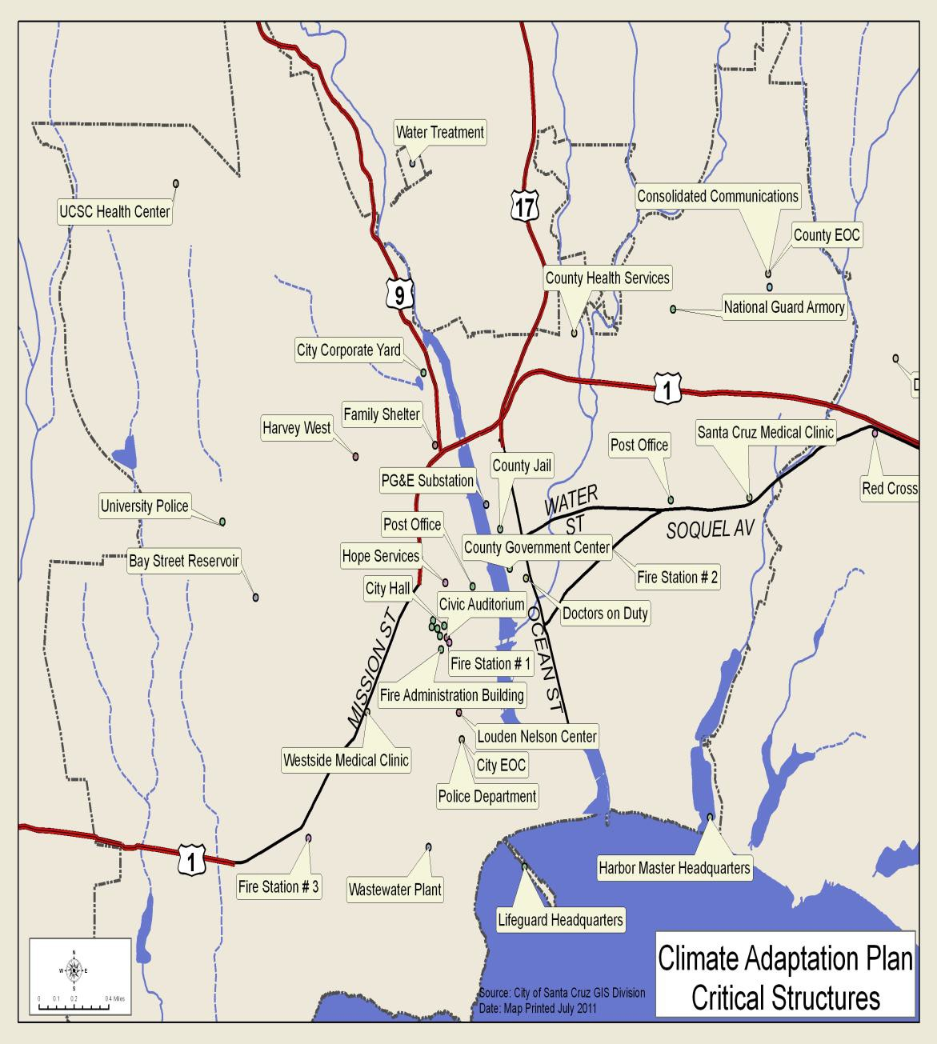

FIGURE 4: MAP OF CRITICAL STRUCTURES

A list of City facilities appears in Appendix D.

City of Santa Cruz-owned infrastructure consists of the following elements:

  - Waste Water Treatment Facility and sanitary sewer system
  - Water Treatment Plant
  - Loch Lomond Reservoir
  - Bay Street Reservoir
  - River levees
  - Roads, alleys, curbs, paths

  - Retaining walls
  - Storm drains
  - San Lorenzo River
  - Creeks, open channels and culverts
  - Water Street Bridge
  - Soquel Avenue Bridge
  - Laurel Street Bridge
  - Highway 1 Bridge
  - City Hall and related buildings
  - Civic Auditorium
  - Police station (including primary Emergency Operations Center)
  - Fire stations (3, including secondary Emergency Operations Center)
  - 25+ parks
  - Extensive network of street trees
  - Municipal Wharf including Marine Safety and Lifeguard Headquarters

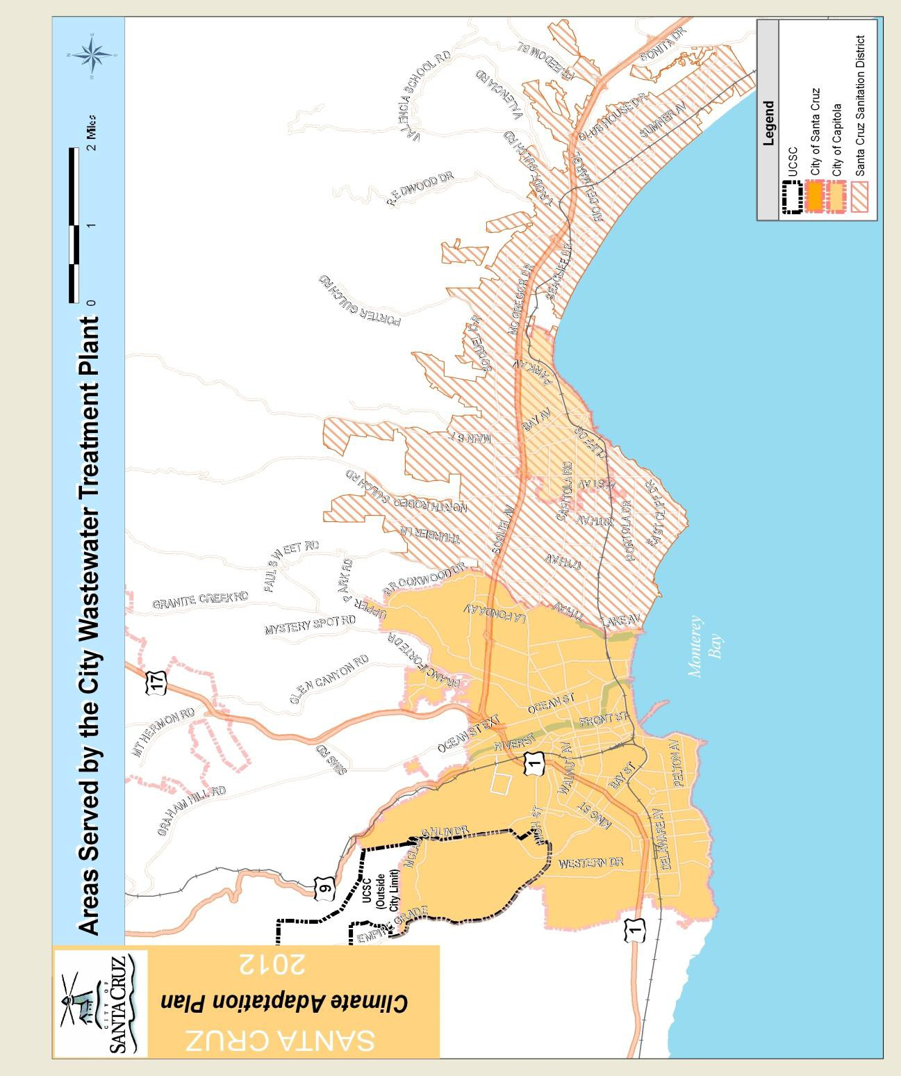
FIGURE 5: WASTEWATER TREATME NT FACILITY SERVICE AREA

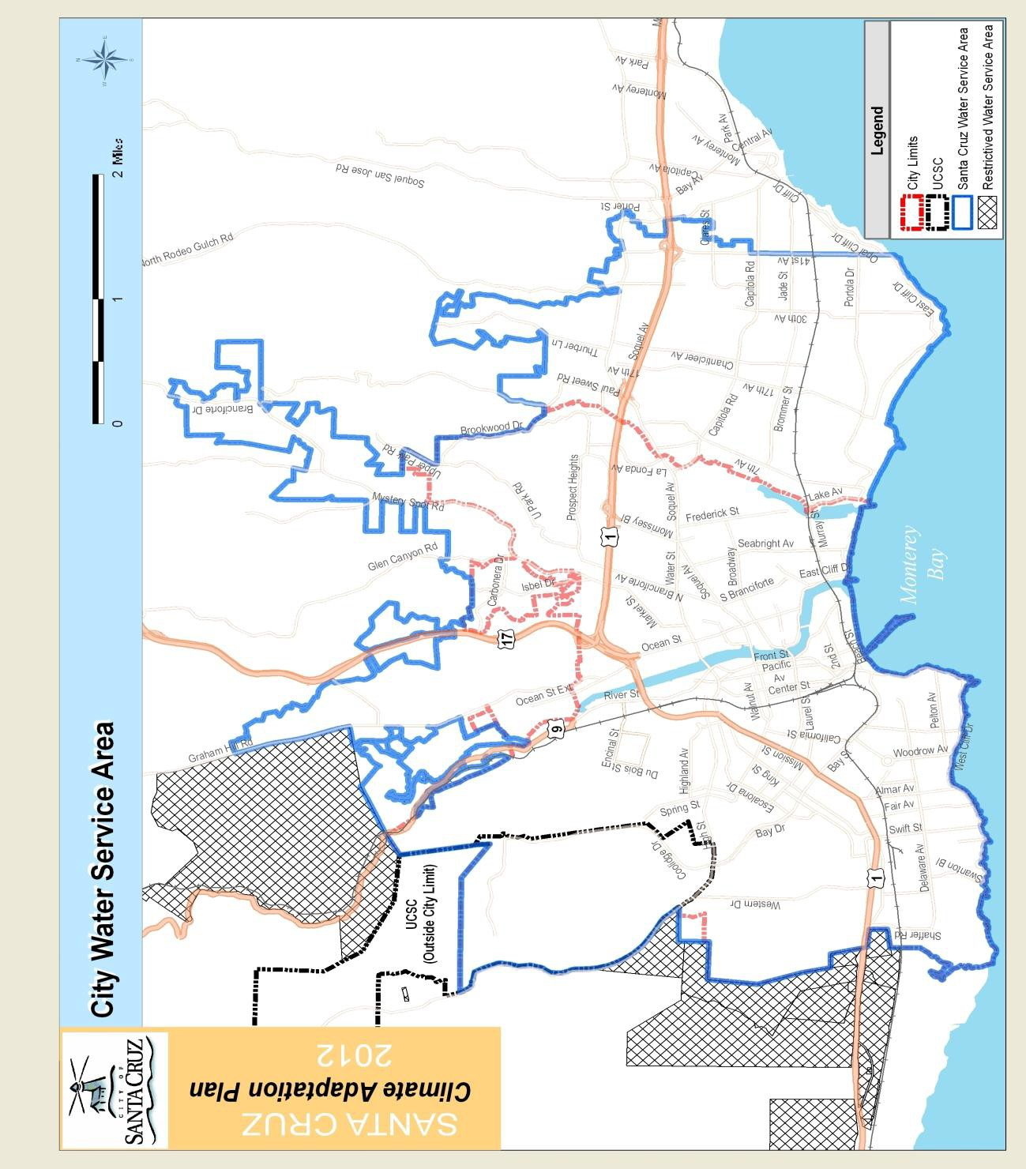
FIGURE 6: WATER SERVICE AREA

CHAPTER 2

THE PLANNING PROCESS
PLAN DEVELOPMENT AND BACKGROUND
T
his Climate Adaptation Plan is intended to assist the City of Santa Cruz in reducing the impacts of climate change by identifying vulnerabilities, resources, information, and strategies for adaptation. Building on a tradition of progressive planning and sustainabil-
ity efforts the City of Santa Cruz Climate Adaptation Team set out to develop a Climate Adapta- tion Plan that would:
- Update the LHMP focusing on potential climate change impacts.
- Coordinate the Climate Adaptation Plan with existing plans and programs so that actions identified as a priority to mitigate or adapt to potential impacts can be funded and implemented. The plan also creates a linkage to the LHMP, Climate Action Plan, General Plan and the Emergency Operations Plan to provide consistency in all mitigation and adaptation efforts.
- Provide a framework for current and future decision makers to build adaptive capacity into all policies programs and infrastructure investments for the purpose of creating a resilient community informed by the best available scientific information.
The City of Santa Cruz‘ Local Hazard Mitigation Plan identified global warming as an increasing threat to the community. As the potential vulnerabilities to climate change in the community be- came more apparent, the City determined that the first priority for the LHMP update was prepar- ing for the impacts of climate change.

Climate Adaptation Team
The first step in developing a Climate Adaptation Plan was forming a climate adaptation team. Those invited to participate included department heads and key staff from departments that would be responsible for identifying and implementing actions to build adaptive capacity.

The Public Works Department took the lead and was assisted by the City Manager‘s Office, Planning Department, Water Department, Fire Department, Economic Development Department, Parks and Recreation Department and Geographic Information Systems (GIS Division- Information Technology). From this group, project team leaders were identified: Cathlin Atchison, Public Works Project Manager, and Robert Solick, Emergency Operations Manager were selected to manage this FEMA grant-funded project and to author, review and edit the Plan. These two lead personnel had previously collaborated on the development of the city‘s 2007 LHMP.

The Team determined that this configuration would bring experience and build consistency be- tween the LHMP and the Climate Adaptation Plan since both team leaders had significant expe- rience working across departments. This significantly contributed to a greater understanding of department organization and responsibilities. The project team was formed as a task group to develop the plan. Meeting dates were set based on progress and focus. The core team was select- ed in September 2008 and the first meeting of the Climate Adaptation Team occurred the follow- ing month.

The Climate Adaptation Team identified the need for the most current climate science infor- mation on risks and vulnerabilities upon which to build the plan along with a process to review and update information on climate change as it became available. A vulnerability and risk assess- ment was identified as the first requirement. A formal scope of work was written during the sub- sequent three months. In February 2009 the City contracted with scientists from the University of California at Santa Cruz, Dr. Gary Griggs and Dr. Brent Haddad, to undertake the initial vulnera- bility study for the city. The City was fortunate to obtain the expertise of scientists who are rec- ognized as leaders in the area of sea level rise, coastal erosion, water resources and other climate change impacts. The scientists became integral members of the Climate Adaptation Team. Their biographies are available in the Vulnerability Study section of this Plan.

Foundations of the Climate Adaptation Plan
Professors Griggs and Haddad reviewed the latest climate science and met with the Climate Ad- aptation Team to define a course of action. In June 2009 they were introduced to department heads and key staff to begin reviewing specific impacts upon departments.

A draft Vulnerability Study was reviewed by the core Climate Adaptation Team in December 2009. Comments and suggestions were incorporated into the draft study by the scientists and a second draft Vulnerability Study was presented in August 2010. This draft was reviewed by the Adaptation Team, department heads and key staff. From this review additional comments were incorporated into the final Vulnerability Study which was completed in January 2011.

This study became the basis upon which the City began to create its Climate Adaptation Plan. Responsible departments were actively involved in the development of the goals, objectives and actions which, in turn, were based on potential risks identified in the Vulnerability Study. Where possible, actions were built upon departmental efforts already underway. Potential actions, in- cluding information related to required resources, environmental concerns and timelines, were defined and then circulated to all departments.

In addition to proposed actions the team also reviewed action items identified in the 2007 LHMP along with other related current or completed programs. The review and status of all 2007 action items is available in Appendix L. This review process identified additional potential adaptation measures that could be implemented immediately or that might be required in the future as scien- tific information is further refined and available. The entire Climate Adaptation Team held a final prioritization meeting to reach consensus on prioritizing potential actions. This prioritization included a low-level review of potential costs and benefits. In depth cost-benefit studies on iden- tified actions have not been completed but will be pursued when funding becomes available.

Prioritization of action items was also informed by the Team‘s utilization and completion of FEMA‘s STAPLEE evaluation which addressed Social, Technical, Administrative, Political, Le- gal, Economic and Environmental dimensions. During the final review process it was determined that several actions identified essentially similar measures, such as protect infrastructure. There- fore, several action items were combined and expanded to limit repetition.

The original list of actions is available along with the STAPLEE evaluation in the Appendix K. The final list of prioritized actions is provided in Chapter Four.

PUBLIC OUTREACH AND COMMUNITY PARTICIPATION
Public input during the development of the Climate Adaptation Plan assisted in shaping the Plan‘s goals and actions, and in integrating the Climate Adaptation Plan with the developing Climate Action Plan and the General Plan Update. After the Vulnerability Study was completed and the initial list of prioritized actions identified, they were placed on the City‘s website along with a mechanism for the community to respond and comment.

The proposed climate adaptation strategy, including goals, objectives and actions, was presented to community members through a series of City Council Advisory Body (commission) meetings and then at an October 4, 2011 City Council Study Session on Climate Adaptation. The Agenda document for that meeting is included in the Appendix O.

On August 29, 2011, the Vulnerability Study, updated Goals, Objectives, Actions, and a Climate Adaptation Power Point presentation describing the process and the Plan along with a public comments form (Appendix O) were placed on the City website.

During the development of the Climate Adaptation Plan, presentations on the process and the Plan were given to the Parks and Recreation Commission, the Transportation and Public Works Commission, the Planning Commission and the Water Commission. After including information and comments from the commission meetings and the public, the draft Climate Adaptation Plan was available for a public comment period from September 27, 2011 through November 1, 2011. Public comments received during this timeframe have been incorporated into the Plan.

The Climate Adaptation Plan was presented, as noted above, at a special Study Session of the City Council on October 4, 2011, offering community members an opportunity to learn about climate adaptation and comment on the draft Plan. Local media were contacted to provide wide area coverage. The City Council Special Study Session was broadcast live on Santa Cruz County Community Television and was rebroadcast on the following dates:

  - 10/11/2011 • 10/12/2011• 10/13/2011 • 10/16/2011

Gary Griggs, co-author of the Adaptation Plan‘s Vulnerability Study presented that study (see Press Release in the Appendix O. A public notice was placed on the website to invite the public to attend the Study Session. Hard copies of the draft Plan were made available at the Central Branch of the Santa Cruz Public Library and at the Public Works Department at City Hall. A draft of the Plan was also posted on the City‘s website with an interactive response option that provided an opportunity for interested members of the public to comment directly from the web- site. Notification of the Climate Adaptation Plan (with links to the draft Plan) was mailed to local and regional agencies. Links to the Plan were posted on the City of Santa Cruz Public Works Facebook page and an article on the Plan and the Process appeared in the Santa Cruz Sen- tinel.

City staff presented the draft Climate Adaptation Plan to community groups upon request includ- ing Transitions Santa Cruz and the Live Oak Grange. Public comments received throughout the process were incorporated into the final document. Upon FEMA approval, the Climate Adapta-

tion Plan will be presented to the City Council on December 13, 2011. A draft Resolution ap- proving and adopting the plan is available in the introductory section of this document.

Coordination with other Plans and Policies
Implementation and monitoring of the plan includes tracking the identified actions that are to be implemented, as well as changes in day-to-day City operations, and continued refinement and updates to the Climate Adaptation Plan based on the best available scientific information. This assessment of the adaptation goals and actions includes a review of the following items:
- Human and technical resources
- Financial resources and funding sources
- Regulatory and legal requirements
- On-going plans and projects
The Climate Adaptation Plan, is an update to the LHMP, and was informed by the General Plan, the draft Climate Action Plan, Emergency Operations Plan, Urban Water Management Plan, the Santa Cruz Water Department‘s Water Conservation Plan, various City ordinances, zoning and building codes and the Capital Improvement Program (CIP.) Consistency between these plans, programs and policies was reviewed using these approved plans and policies as a foundation for the LHMP and through consultation with those departments responsible for the various plans and programs.

The City of Santa Cruz Emergency Operations Center Manager was part of the team leadership and oversaw consistency and review between the Climate Adaptation Plan and the Emergency Operations Plan (April, 2011) including the following appendices:
- County SEMS MOU resolution
- City of Santa Cruz Hazard Analysis Summary
- Wharf Hazard Plan
- Flood Hazard Plan
- Earthquake Hazard Plan
- Dam Inundation Hazard Plan
- Wildland Fire Hazard Plan
- Draft Tsunami Hazard Plan
CLIMATE ADAPTATION PLAN DEVELOPMENT: TIMELINE
The Climate Adaptation planning process began in 2008. Below is the timeline of significant steps in the development of the plan, including the type of event and indications of the key per- sonnel involved in the development and review process.
 | Date | Type
2008
Accepted grant to update LHMP with a Climate Adaptation Plan | August
Core Climate Adaptation Team formed and leader selected | September
Core Team: Scope of project, sought scientific expertise | October
Sought scientific experts as part of the Climate Adaptation Team | November
Selected scientists and offered invitation to participate | December
2009
Scope of work with UCSC determined and agreement drafted | January
Agreement with UCSC signed to draft Vulnerability Study | February
Core Team met with Griggs and Haddad to review scope of work and approach to creating Vulnerability Study | March

 |  | Date | Type
Department Heads invited to participate in Vulnerability Study |  | April
Depts. /key staff required to address climate adaptation identified |  | May
Intro of scientists to Dept. Heads and key staff |  | June
Scientists held multiple meetings with key staff in each department to identify vulnerabilities, potential adaptation measures |  | July to December
2010
Core Team review of draft Vulnerability Study (Dec 2009 draft) | 1-Jan-2010 |  | in house
Core Team review of draft Vulnerability Study (Aug 2010 draft) | August |  | in house
Distribution and review of Vulnerability Study | Sept -Oct |  | in house
Adaptation (LHMP) workshop at Cal EMA | 10-Aug-2010 |  | state
2011
Final Vulnerability Study completed | 10-Jan-2011 |  | in house
Gary Griggs presentation on Climate Adaptation to County EOC | 3-Mar-2011 |  | Public
Climate Team Review of Adaptation Actions | 22-Mar-2011 |  | Public
Grant status review | 28-Mar-2011 |  | in house
Core Team adaptation action review meeting | 19-Apr-2011 |  | in house
Potential adaptation action review by departments | April |  | in house
Managed Meeting: Action Item Prioritization | April 27-2011 |  | In house
STAPLEE evaluation completed by department heads | May 25-2011 |  | in house
Vulnerability Study, Action Items and overview on City Website | July 11 2011 |  | Public
GIS mapping meeting | July 11 2011 |  | in house
Document format meeting | July 28 2011 |  | in house
City assets and critical buildings review | August |  | in house
GIS mapping meeting | August |  | in house
Team meeting on document format | Aug 1 2011 |  | In house
Parks and Recreation Commission | July 11 2011 |  | Public
Waste Water Treatment Facility Adaptation Actions Review | Aug 18 2011 |  | in house
Planning Commission | Aug 18 2011 |  | Public
Water Commission | Aug 22 2011 |  | Public
Transportation and Public Works Commission | Sept 19 2011 |  | Public
City Council Special Study Session: Plan review | Oct 4 -2011 |  | Public
Action Item public comment | Aug 22–Sep 27 |  | Public
Draft Climate Adaptation Plan open for public comment period | Sep 27–Nov 1, 2011 |  | Public
Notification of Climate Adaptation Plan sent to regional agencies and community groups | Oct 1, 2011 |  | Public
Rebroadcast of City Council Special Study Session on Climate Adaptation on Community Television | Oct 10, 2011 |  | Public
Rebroadcast of City Council Special Study Session on Climate Adaptation on Community Television | Oct 11, 2011 |  | Public
Rebroadcast of City Council Special Study Session on Climate Adaptation on Community Television | Oct 12, 2011 |  | Public
Rebroadcast of City Council Special Study Session on Climate Adaptation on Community Television | Oct 13, 2011 |  | Public
Rebroadcast of City Council Special Study Session on Climate Adaptation on Community Television | Oct 16, 2011 |  | Public
Presentation to Transition Santa Cruz and Live Oak Grange | October 18, 2011 |  | Public
City Council meeting — Plan approval and adoption (tentative) | Dec 13 -2011 |  | Public

CHAPTER 3

VULNERABILITY STUDY AND POTENTIAL CLIMATE CHANGE IMPACTS
OVERVIEW AND BACKGROUND OF RISK ASSESSMENT AND VULNERABILITY
I
t is important for a community‘s risk assessment, adaptation and preparedness efforts to be founded on the most current climate science available, in order to determine the types and scale of potential climate impacts which may threaten the community. This section of the
Plan contains descriptions of those risks and vulnerabilities which may occur as a result of cli- mate change and which are identified as potential threats to Santa Cruz. Other threats (not di- rectly related to climate change) are identified in the 2007 LHMP and remain accurate, except that flooding, wildland fires, drought and coastal erosion threats will all be exacerbated by cli- mate change; those potential increased risks are addressed in this Plan. The Local Hazard Mitiga- tion Plan and the Climate Adaptation Plan together address all identified risks to the community and provide a list of potential actions that might be taken by the community to reduce those risks.

To obtain the best scientific information available to inform this plan, the City contracted with the University of California at Santa Cruz (UCSC) and two of the leading scientists in this area, Dr. Gary Griggs, Director, UCSC Institute of Marine Sciences, and Dr. Brent Haddad, UCSC Professor of Environmental Studies. The City of Santa Cruz Vulnerability Study (January 11, 2011) is the result of their review of the potential impacts of climate change that threaten the City of Santa Cruz. This study looks at impacts that have the highest potential to cause loss of life or damage to property. The scientific experts also made recommendations to assist the community in building resilience into planning efforts. The Vulnerability Study looks at the range of poten- tial climate change impacts and at our community‘s ability to cope with and adapt to those pro- jected changes. This Vulnerability Study is the foundation upon which we are building our efforts to understand Santa Cruz‘s climate risks and vulnerabilities, and to identify potential ac- tions that might be implemented to build climate resilience into our physical, ecological, and economic base.
IMPACTS OF CLIMATE CHANGE
The Vulnerability Study and additional research by staff have identified vulnerabilities as a result of both direct and indirect impacts of climate change. In Santa Cruz, sea level rise (SLR) com- bined with changing precipitation patterns, including increased severe storm events and drought, appear to be the greatest threats that we face as a community. In combination with changing temperatures and shifting seasons, these direct impacts lead to increased risks for wildfire, coastal erosion, and damages to community infrastructure, economy, human health and safety, and local ecosystems. Additional but less understood potential impacts include ocean acidifica- tion, salt water intrusion, and food and fuel availability.

Cal-Adapt
We know that sea level is rising but the rate of change is uncertain. There are a number of re- sources available and scientific groups attempting to more accurately define the potential risks. One of these tools specific to California is Cal-Adapt (cal-adapt.org), a web-based climate adap- tation planning tool that allows the user to identify potential climate change risks in specific geo-

graphic areas throughout the state. Users can either query by location, or click on an interactive map to explore what climate impacts are projected to occur in their area of interest.
Scenario: A coherent, internally consistent and plausible description of a possible future state of the world. It is not a forecast; rather, each scenario is one alternative image of how the future can unfold. A set of scenarios is often adopted to reflect, as well as possible, the range of uncertainty in projections.

Cal-Adapt synthesizes volumes of existing climate change scenarios and climate im-
pact research and presents it in an easily available, graphical layout that is intended to benefit local planning efforts. The source data used within the tool are available for download, as well as further information including research organizations that have developed the data, and relevant scientific publications.ii These are not forecasts; they provide potential scenarios which can be used in conjunction with the City of Santa Cruz Vulnerability Study.

Much of the information found at Cal-Adapt is based on downscaled Intergovernmental Panel on Climate Change (IPCC) models to describe how climate may evolve in California.

In addition to the City of Santa Cruz Vulner- ability Study, the City used its GIS database as well as mapping done by the Pacific Insti- tute and information provided by Cal-Adapt to identify those areas that are at greatest risk, and to calculate potential losses that might be incurred. The threats, especially from sea level rise, are uncertain, so impacts under various scenarios (differentials in sea level rise) through the year 2100 were included.
Projection: The term "projection" is used in two senses in the climate change literature. In general usage, a projection can be regarded as any description of the future and the pathway leading to it. However, a more specific inter- pretation has been attached to the term "cli- mate projection" by the IPCC when referring to model-derived estimates of future climate.

The closer the time period is to the present, the more accurate the projections. The further into the future, less certainty is available for projections. This means that we have a fairly accurate understanding of the impacts to the City of Santa Cruz in 2050 but our understanding of potential impacts in the year 2100 is very uncertain.
POTENTIAL IMPACTS OF CLIMATE CHANGE ON THE CITY OF SANTA CRUZ
The following is a list of the potential impact of climate change in our area. More detailed maps of potential impacts on the City of Santa Cruz are available in Appendix F. Each is further dis- cussed below.

- sea level rise
- flood
- severe storm/weather events
- drought
- coastal erosion
- increased wildfires
- ocean acidification
- salt water intrusion
- increasing temperature
- food and fuel availability
- impacts to ecosystems

Sea level rise
―According to a recent report by the California Climate Change Center, nearly half a million people, thousands of miles of roads and railways, major ports and airports, power plants and wastewater treatment plants are at risk from future coastal flooding and inundation. California has the nation‘s largest ocean economy, valued at about $47 billion/year, and with the great ma- jority of this connected to coastal recreation and tourism. Many of the facilities and much of the infrastructure that support these industries, as well as the state‘s many miles of public beaches are within a few feet of present sea level. Sea level is expected to rise significantly over the next century due to global climate change.‖ iii

A large part of the City of Santa Cruz‘s economy is based on coastal recreation and tourism. We also have significant infrastructure within a few feet of sea level. We are, in fact, experiencing some impacts now, such as rising and inconsistent groundwater at the Wastewater Treatment Facility, parts of our tree canopy that are threatened or must be replaced by species better able to adapt to the changing climate, and increased wildfire threats.
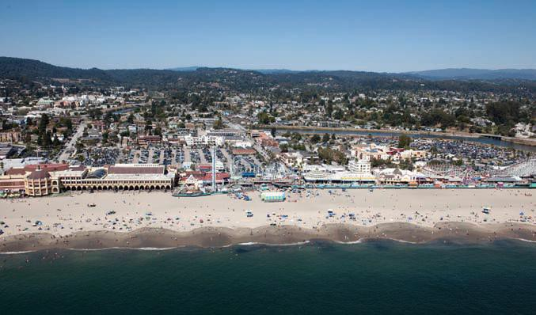
FIGURE 7: MAIN BEACH, SANTA CRUZ, CALIFORNIA
Main Beach, Santa Cruz, California
photo: Kenneth and Gabrielle Adelman, California Records Project: www.californiacoastline.org

Main Beach in Santa Cruz is a principal recreational and tourism center. It is backed by a contin- uous concrete sea wall which protects the adjacent infrastructure but may contribute to loss of the actual beach over time. (see Vulnerability Study).

―By the year 2100, mean sea level may rise by as much as 1 to 1.4 meters along the coast of California, although these projections are being modi- fied as observations continue to be made and additional data become available. The governors of the three western U.S. states recently request- ed that the National Academy of Sciences undertake a study of sea level rise along the west coast.‖ — Adapting to Sea level Rise iv

The California Ocean Protection Council, working with the Coast and Ocean Climate Action Team (CO-CAT), which consists of representatives from 15 different state agencies that have some responsibilities or authority over issues affected by climate change, have adopted interim sea level rise projections for the decades ahead using the high scenarios in all cases for 2030, 2050 and 2100.

Year |  | Average of Models | Range of Models
2030 |  | 7 in (18 cm) | 5– 8 in (13–21 cm)
2050 |  | 14 in (36 cm) | 10–17 in (26–43 cm)
2070 | Low | 23 in (59 cm) | 17–27 in (43–70 cm)
 | Medium | 24 in (62 cm) | 18–29 in (46–74 cm)
 | High | 27 in (69 cm) | 20–32 in (51–81 cm)
2100 | Low | 40 in (101cm) | 31–50 in (78–128 cm)
 | Medium | 47 in (121 cm) | 37–60 in (95–152 cm)
 | High | 55 in (140 cm) | 43–69 in (110–176 cm)
Sea-Level Rise Projections using 2000 as the Baseline adopted by California Ocean Protection Council
FIGURE 8: SEA LEVEL RISE PROJECTIONS

For the dates after 2050, the table above includes three different values for sea level rise — based on low, medium, and high greenhouse gas emission scenarios. These values are based on the Intergovernmental Panel on Climate Change emission.

Flood and severe storm events
The City of Santa Cruz has experienced significant flooding in the past. An increase in the inten- sity and amount of rainfall during winter months would concentrate runoff and could lead to more frequent or larger flood flows. Details of these storm events combined with potential sea level rise are described in the Vulnerability Study and at greater length in the initial LHMP. Flooding and extreme storms present essentially the same risks in the City of Santa Cruz. Ex- treme coastal storms can cause increases in tidal elevations (storm surge), wind speed and ero- sion, as well as flooding. Flooding and extreme storm events are predicted to occur more frequently as a result of climate change impacts including sea level rise.

National Flood Insurance Program
Following the 2002 completion of Contracts 1 and 2 of the Corps of Engineers San Lorenzo Riv- er Flood Control Improvement Project, the Federal Emergency Management Agency National Flood Insurance Program (NFIP) issued a Letter Map Revision for the Downtown and Beach areas of the City designating these areas from its A-11 to an A-99 flood zone classification. This change has had a very significant benefit for these areas.

- Flood insurance premiums for the A-99 flood zone are significantly lower than the previous A-11 flood zone. Depending on the property and amount of required flood insurance, the new rates are approximately 40% lower than those previously paid.

- The FEMA Community Rating System awarded the City a class seven rating, which further reduces the NFIP A-99 flood insurance rates.
- New buildings and improvements are no longer mandated to meet FEMA flood construction requirements but may continue to do so depending on the wishes of the property owner.

The remainder of the City‘s flood prone areas are in the following NFIP flood plain classifica- tions: A, AE, AE Floodway, and VE. The City continues to participate in the NFIP program and is participating in the Risk Map updating program which is using advanced aerial photographic information to produce more topographically accurate flood plains maps for the City‘s and Coun- ty‘s coastal shoreline. This work is expected to result in the issuance of new flood plain maps in several years.

Drought
Santa Cruz does not import external water supplies. The amount of water available from local sources changes from year to year as a function of rainfall and runoff. The San Lorenzo River provides the largest portion of the City‘s water. Loch Lomond Reservoir serves as the City‘s pri- mary storage reservoir.

Changing precipitation patterns that may occur as a result of climate change could significantly alter both the quantity and quality of water available to the City. More intense winter precipita- tion may result in lower summer base flows reducing the time window during which water can be diverted from streams. Elevated winter flows may also limit diversions due to high sediment loads. Climate change potentially impacts both pumping and precipitation patterns and the result- ing ability to store water so it is available during high demand time periods.

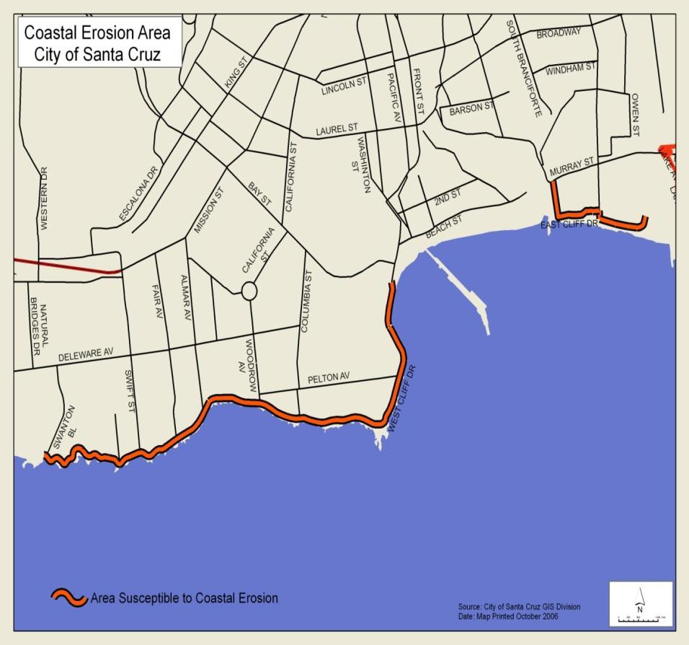Coastal erosion
FIGURE 9: COASTAL EROSION IN SANTAT CRUZ
Santa Cruz has experienced sig- nificant erosion in the past. An increase in coastal storm frequen- cy and/or magnitude would in- crease cliff retreat rates and re- sulting damage to oceanfront property and infrastructure. The Vulnerability Study describes the history and potential impacts as a result of climate change on our cliffs and beach frontage.

The City has a developed coast- line including significant City- owned infrastructure along the cliffs, specifically, roadways, bi- cycle paths, parks and park facili- ties. In addition to City infrastruc- ture there are a few houses, two

hotels and one City museum along the ocean cliff frontage.

The Santa Cruz Harbor, beach frontage, and cliff frontage near the mouth of the San Lorenzo River are also threatened by varying degrees of erosion which may occur more rapidly in the future as a result of climate change impacts. Protecting the natural resources of the area as well as preserving the infrastructure that is already in place, such as the lighthouse and bicycle path, are primary land use objectives.

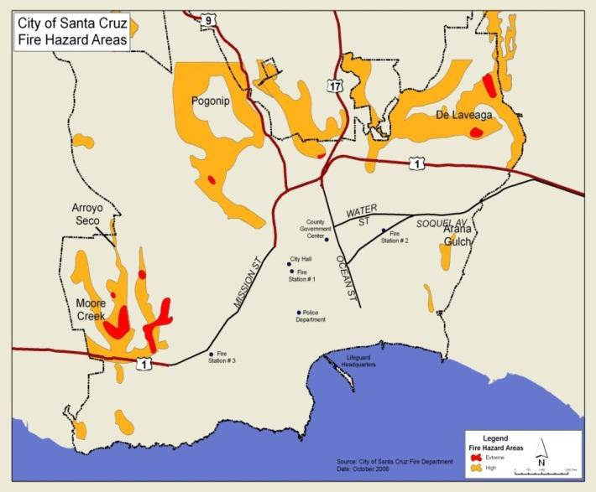
Increased wildfire threat
Wildland/urban interface fires have been recognized as a threat to the City of Santa Cruz in the past. Climate change im- pacts through changing precipi- tation patterns (shorter more severe winters and longer, dryer summers) will exacerbate this wildfire threat.

Rising temperatures may also contribute to increased wild- fires. If temperatures rise into the medium warming range, the risk of large wildfires in Cali- fornia could increase by as much as 55 percent, which is almost twice the increase ex-
pected if temperatures stay in the lower warming range.v
FIGURE 10: URBAN/WILDLAND FIRE HAZARD AREAS
Within the City of Santa Cruz there are five wildland/urban interface areas including three that are designated as mutual threat zones (as shown on the map above.) Mutual threat zones are those areas where a wildfire would threaten property within the Santa Cruz fire protection district as well as property covered by another fire protection service. For major emergencies that require more resources than can be provided by a single agency, the City of Santa Cruz, Santa Cruz County, University of California at Santa Cruz and the State of California have an extensive mu- tual aid and emergency coordination system. Developed and managed in cooperation with the Governor's Office of Emergency Services (CalEMA), this system allows departments and dis- tricts to share personnel and equipment as needed to address and control emergencies.

Wildland fires present a risk to open space areas within the City of Santa Cruz and adjacent to residential homes — the urban interface. It should also be noted that there are City of Santa Cruz water service areas and water infrastructure areas located outside the City limits and they are also potentially threatened by wildland fires.

Ocean acidification
Ocean acidification has been identified as a future climate change impact concern for Santa Cruz. Ocean acidification is further described in the Vulnerability Study. We have limited under- standing of ocean acidification impacts at this time. It appears that ocean acidification could pose threats to sea life, our visitor-serving facilities and our visitor-based economy.

Salt water intrusion
Our ecosystems and water supplies are at risk from rising sea levels. An influx of saltwater would degrade California‘s estuaries, wetlands, and groundwater aquifers. In particular, saltwater intrusion would threaten the quality and reliability of the major fresh water supply that is pumped from the southern edge of the Sacramento/San Joaquin River Delta.vi

The impacts locally are less understood but no less severe. The City relies primarily on the San Lorenzo River as its primary water source but does have some ground well sources. These sources could be impacted through a combination of sea level rise, diminished surface flows and lowered ground water levels. A further complication related to salt water intrusion is that it may raise groundwater levels and that, in turn, leads to additional problems with storm drains and basements becoming flooded

In addition to our water supply, some portions of the City tree canopy could potentially be threatened by salt water intrusion.

Changing temperatures
Overall temperatures are expected to rise throughout the century. Scientists predict a temperature increase of between 3.2 and 5.5 degrees Fahrenheit in our area (see Cal-Adapt chart below).

While Santa Cruz has had a traditionally mild climate, even an increase of 3.2 degrees will im- pact ecosystems, fire risk, water quantity and quality, human and environmental health. As tem- peratures rise there will be a direct impact on the water supply, proliferation of pests, potential outbreak of diseases and overall quality and quantity of produce.vii It should be noted that pre- serving a healthy tree canopy becomes even more important as temperatures rise.

Cal-Adapt temperature projections for the Santa Cruz area

Historical Average: |  | 56.8° F
Low-Emissions Scenario: | 60.0° F | +3.2° F
High-Emissions Scenario: | 62.3° F | +5.5° F

Food and fuel availability
As the impacts of climate change intensify, food and fuel availa- bility will become more important. The City needs to continue to find ways to reduce its own fuel consumption as well as support- ing efforts to reduce fuel consumption within the private sector.

Of particular importance is local sourcing for food. We are fortu- nate to have abundant local and frequently organic, food produc-
FIGURE 11: LOCAL FARMERS' MARKET PRODUCE

ers within Santa Cruz County. Our climate is conducive to a wide range of crops. We have sever- al local farmers‘ markets every week and many of the supermarkets in the area feature local pro- duce. A community goal of ―buying local‖ supports local farmers and producers so that they are able to continue farming, creating the opportunity for long term food availability as well as re- duced fuel consumption in transport of foods. The City recognizes that supporting our local food producers contributes to the economic vitality of our community as well as its long term sustain- ability.

Impacts to ecosystems
Our ecosystems are also threatened by climate change. A healthy ecosystem supports native land and water species, crops, and public health. Programs that promote nature‘s resilience to climate change impacts will protect our natural environment, our food and water sources as well as hu- man health. Incorporating local, regional and statewide efforts to protect ecosystems will build our community‘s resilience. ―... Such ecosystem-based approaches are thereby not simply about saving ecosystems, but rather about using ecosystems to help ―save‖ people and the resources on
which they depend.‖viii

SUMMARY OF POTENTIAL IMPACTS
The Vulnerability Study reviews in more detail the potential hazards faced by the community as a result of climate change, including extreme storm events, drought, flooding, increased wildfire threat, ocean acidification, salt water intrusion and temperature change. The City of Santa Cruz Adaptation Strategy (see Chapter Four) enumerates the goals, objectives and actions identified to respond to those threats.

We have identified a number of potential risks and vulnerabilities that threaten our community as the result of climate change, but the timeframe of these impacts is uncertain. Regardless of this uncertainty, building resilience into policies, projects, programs and infrastructure is good gov- ernment. This Plan is also an opportunity for City leaders to share this information with the community and to assist residents and businesses in preparing for potential climate change im- pacts.

Santa Cruz has historically taken a leadership role in sustainability and environmental protection. This Climate Adaptation Plan is an additional step in those efforts. Working with FEMA and CalEMA it is our intention to prepare within our own community, but also to provide a guide to other communities as they prepare for the impacts of climate change.

CHAPTER 4

ADAPTATION STRATEGY

BUILDING RESILIENCY AND PREPARING FOR IMPACTS
T
he City of Santa Cruz endeavors to be a climate resilient community preparing for poten- tial impacts of climate change, while preserving the diversity and quality of its natural and built environments. The community strives to offer excellent cultural and community ser-
vices as well as to protect, preserve and improve infrastructure, community safety and emergen- cy preparedness. It is the City‘s intention to build resilience into policies, programs, projects and infrastructure. This Climate Adaptation Plan is a part of this effort.

This Climate Adaptation Plan will guide current and future decision makers in developing poli- cies and programs to build resiliency into everyday operations and short and long term infra- structure investments. While City efforts are focused on evaluation and resilience of City-owned structures, particularly those identified as critical facilities, the Plan also encourages the estab- lishment of standards to encourage private property owners to consider incorporating resilience planning as a part of the development process for their own properties in order to reduce the im- pacts of climate change.

Adaptation planning does not stop at the City limits
The City is actively engaged with other local, regional and state organizations to stay informed of the best available scientific data on potential climate change impacts and to collaboratively work towards meeting the City‘s objective of being a climate resilient community as well as pro- tecting the quality of its natural and built environments. City staff currently participate in the Monterey Bay Climate Change Adaptation work group, which includes members from NOAA, the National Marine Sanctuary, Center for Ocean Solutions, California Coastal Conservancy, ICLEI and representatives from local governments. Representatives from these groups meet on a regular basis to share scientific and adaptation planning information to promote adaptation plan- ning throughout the Monterey Bay region.

This Plan focuses on potential actions that might be implemented to reduce or avoid impacts of climate change. Even if the range of climate change impacts is not certain, structural improve- ments to existing buildings, land use decisions that will minimize damage, and ongoing pro- grams such as vegetation management in wildland/urban interface areas, will all contribute to a more climate resilient community.

Adaptation actions already undertaken
The City has implemented or is in the process of implementing a number of actions that will build resilience to the impacts of climate change. The City continues to work with the Army Corps of Engineers to enhance the San Lorenzo River levee. The City, in collaboration with Soquel Creek Water District, has successfully completed a pilot study on desalination. The Water Department is completing the rebuilding of the Bay Street Reservoir Facility which will provide up to three days of water during an emergency. Most of the bridges that have been damaged by or have exacerbated flooding in the past have been replaced. The Highway 1/Highway 9 bridge is the last bridge in the City that requires full replacement. The Fire Department continues its

efforts to minimize risk to the City within the wildland/urban interface through several targeted, as well as ongoing, programs delineated in the Fire Prevention Plan and the Fire Department Strategic Plan. A list of the action items identified in the 2007 LHMP and other projects already completed or currently underway is available in Appendix L.
GOALS, OBJECTIVES AND ACTIONS

Goals
Goals are general guidelines that explain what is to be achieved. They are broad-based, long- term, policy statements, and represent global visions. Goals help define the benefits that the plan is trying to achieve. The success of this Climate Adaptation Plan will be measured by the degree to which its goals are accomplished to yield actual climate impact risk reductions.
OVERARCHING STRATEGIC GOALS FOR THE CITY OF SANTA CRUZ
The City Council recently developed and adopted a Strategic Plan for the next three years. The plan identified five strategic goals for the community which informs this Climate Adaptation Plan:
- To enhance environmental sustainability and resources
- To enhance community safety
- To attract and retain businesses and jobs
- To achieve financial stability and sustainability
- To improve and maintain infrastructure and facilities
The Climate Adaptation Plan is consistent with the three-year strategic plan and each of the iden- tified goals. In support of the goals of sustainability, safety, resilience and protection of infra- structure, the climate adaptation team sought the best climate science available by requesting a Vulnerability Study, defining the scope of that study, and then communicating the scope to the UCSC scientific team. The draft Vulnerability Study was extensively reviewed. After several iterations it was accepted as the basis for development of the goals, objectives and actions neces- sary to build resilience into future policies, programs, projects and infrastructure. Financial sta- bility and sustainability in conjunction with the maintenance of City infrastructure and facilities is best achieved through a careful consideration in advance of potential climate change impacts when making decisions about capital investment, infrastructure and facilities, not when the im- pact is actually occurring.
CLIMATE ADAPTATION PLAN GOALS
- Protect the unique character, scenic beauty and culture in the natural and built environment from being compromised by climate change impacts
- Support initiatives, legislation, and actions to respond to climate change
- Build resilience into all programs, polices and infrastructure
- Encourage climate change resilience planning and actions in private companies, institutions, and systems essential to a functioning City of Santa Cruz
- Support initiatives, legislation and actions for reducing and responding to climate change

- Encourage community involvement and public-private partnerships to respond to potential climate impacts.
- Insure that Santa Cruz remains a safe, healthy and attractive place with a high quality of life for its residents, businesses and visitors

Objectives
The Climate Adaptation Team selected the objectives listed below to meet multiple goals. The objectives were also used to help establish priorities.
The City of Santa Cruz Climate Adaptation Team identified this list of objectives:

- Consider potential climate change impacts in planning and decision making processes
- Coordinate adaptation planning with other planning, including General Plan/ land use codes
- Collaborate with others to raise awareness about climate change impacts
- Seek opportunities to inform the community on potential climate change impacts
- Incorporate ongoing monitoring processes to inform decisions
- Seek opportunities to develop an environmentally sustainable economy
- Continue Green House Gas (GHG) mitigation efforts
- Minimize impacts of future sea level rise
- Maintain and add to the city‘s urban tree canopy and increase tree diversity within urbanized areas
- Support protection of the Monterey Bay Marine Sanctuary IDENTIFICATION AND ANALYSIS OF ADAPTATION ACTIONS Identification of actions
In support of the enumerated goals and objectives, the City of Santa Cruz has identified a num-
ber of potential climate adaptation Actions. The actions were developed through an inclusive departmental and community process. The process included input from, and collaboration, with:
- The Climate Adaptation Team
- UCSC scientists
- Transportation and Public Works Commission
- Water Commission
- Planning Commission
- Parks and Recreation Commission
- Interested community members

The following plans helped to inform the development of this draft Climate Adaptation Plan:
- Draft Climate Action Plan
- City of Santa Cruz General Plan Update
- City Emergency Operations Plan
- Capital Improvement Plan
- Fire Prevention Plan
- Water Shortage Contingency Plan
- NFIP National Flood Insurance Program

The following potential Actions were selected as most beneficial for the City of Santa Cruz and represent the highest priority adaptation actions identified.

Each of these Actions meets an objective or goal listed in the City of Santa Cruz Climate Adapta- tion Strategy. These Actions are not meant to be exhaustive but rather to provide a framework upon which to make current and future decisions to and provide each department with a role in climate adaptation and a baseline of actions backed by a planning process, consistent with the goals and objectives and within the capabilities of the City. City departments created the list based on review of the Vulnerability Study and were then given the opportunity to add to and edit the list. Some identified actions were combined to remove repetition. Actions not included in the action plan were eliminated based on the following:
- Action is currently outside the scope of the defined priority rankings
- Action is addressed or included within another Action Item
- Action has already been implemented
- Estimated cost exceeded estimated benefit
PRIORITIZATION OF ACTIONS
Following is a list of Action items based on the Vulnerability Study that was completed by scien- tific consultants Dr. Gary Griggs and Dr. Brent Haddad. These are adaptation actions that could be undertaken to reduce potential losses or damages to people or property as a result of climate change impacts. The Climate Adaptation Team met and discussed priorities based on risks identi- fied and potential losses as a result of those risks, reviewed in relation to funding, ability to im- plement, and consistency with other plans. To aid in the prioritization process, Department Heads applied the FEMA-recommended STAPLEE method to evaluate costs in relation to benefits of implementing a particular action over another. Results of this process are shown in the Appen- dices.

City staff, Council, Commission and community members had several opportunities to review draft Action prioritization and to comment on the Action items as well as other parts of the Plan. The Plan also provides for ongoing opportunities for community members to contribute during the annual review process.

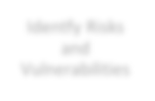
Identfy Risks
and Vulnerabilities
Evaluate
and Learn
Community Involve- ment
Develop,
Prioritize and Implement Actions
Incorporate
latest climate science into ongoing planning
Evaluate
Actions and Update Annually
FIGURE 12: CLIMATE ADAPTATION PLANNING CYCLE

Action items that address climate impacts with the highest risk to the community (as identified in the Vulnerability Study) were given priority rankings. The Vulnerability Study indicates that sea level rise and extreme storm events have the potential to cause the greatest economic and human losses.

Downtown Santa Cruz, the beach and tourist serving areas and the Wastewater Treatment Facili- ty are all at risk from sea level rise and extreme storm events. Replacement of the Highway 1/Highway 9 bridge across the San Lorenzo River has also been identified as a very high priority. The bridge structure acts as a debris barrier during storms, creating a barrier or temporary dam and exacerbating flooding on the upper San Lorenzo River.

Water is essential to the survival of the City so drought and threats to the water system were also ranked as high or very high priorities. Urban/wildland fire is predicted to become a more extreme and significant event as climate conditions change. Finally, availability of funding (identified in the Capital Improvement Program or other source) was a determining factor in prioritization and appears to be the greatest barrier to implementing identified actions.

A formal cost-benefit analysis has not been done for any of the identified Actions. A primary next step in preparing for climate change is a complete cost-benefit analysis of potential actions to increase resilience of our Wastewater Treatment Facilities and supporting structures and re- placement of the Highway 1/Highway 9 bridge. In reviewing the adaptation actions proposed, the costs and benefits of each action were also considered under the following criteria:

Cost ratings
High: Existing funding levels are not adequate to cover the costs of the proposed action and would require an increase in revenue through an alternative source (for example, bonds, grants, and fee increases) to implement.

Medium: The action could be implemented with existing funding but would require a re-apportionment of the budget or a budget amendment, or the cost of the action would have to be spread over multiple years.
Low: The action could be funded under the existing budget. The action is part of, or could be a part of, an existing, ongoing program.

Benefit ratings
High: Action would have a significant impact on the reduction of risk exposure to life and property
Medium: Action would have an impact on the reduction of risk exposure to life and property or action would provide an immediate reduction in the risk exposure to property
Low: Long-term benefits of the action are difficult to quantify in the short term

The City will pursue the implementation of these actions to meet the goals set out above and continue to refine the cost-benefit analysis as funding becomes available.

Action items along with initial suggestions for implementation, identification of lead depart- ments in the City, preliminary estimates of resources required and timeline are listed below. The priorities are three-tiered; however the listing within each tier is not indicative of relative im- portance within that listing category.

Summary of action items by priority |  | Lead dept.
Very High Priority Actions
# A-1 | Upgrade/Relocate City buildings and infrastructure to protect and prepare for sea level rise, flood- ing and storm events from climate change | City Manager
# A-2 | Prepare for potential sea level rise throughout the City | City Manager
# A-3 | Evaluate decisions through a climate change impact lens | City Manager
# A- 4 | Protect wastewater facility from ground water infiltration | Public Works
# A-5 | Seal wastewater pipes throughout system | Public Works
# A-6 | Seal pump gallery at wastewater treatment facility | Public Works
# A-7 | Monitor all wastewater and storm water pumping station sites | Public Works
#A-8 | Replace Highway 1/9 bridge | Public Works
# A-9 | Protect downtown and beach area from San Lorenzo River flooding | Public Works
# A-10 | Protect adjacent neighborhoods and commercial areas from Branciforte Creek flooding | Public Works
# A-11 | Diversify water portfolio | Water
# A-12 | Monitor open space/watershed | Water
# A-13 | Protect coastline-related water infrastructure | Water
# A-14 | Conserve and curtail water usage | Water
# A-15 | Reduce creek and/or river flooding to protect water infrastructure | Water
# A-16 | Protect and Preserve City Buildings, Wharf and Infrastructure | P & R
# A-17 | Protect Visitor Serving Venues and Natural Resources | P & R
# A-18 | Protect and Preserve Tree Canopy | P & R

High Priority Actions
# B-1 | Monitor wastewater facility ground water | Public Works
# B-2 | Engineer a cut off wall to protect wastewater treatment facility | Public Works
#B-3 | Protect adjacent neighborhoods & commercial areas from creek/stream flooding | Public Works
# B-4 | Prepare for water emergency supply for climate related events | Water
# B-5 | Protect watershed land and vegetation | Water
# B-6 | Protect water system infrastructure from landslides and erosion | Water
# B-7 | Minimize risks from dam failure | Water
# B-8 | Prepare for potential changes in water quality due to climate change | Water
# B-9 | Promote and preserve economic base and tourism industry in the face of a changing climate | ED & RD
# B-10 | Prepare for opportunities/challenges in the tourism industry such as an increase in climate refugees | ED & RD
# B-11 | Require setbacks for development adjacent to cliffs | Planning
# B-12 | Protect natural shoreline processes from alteration | Planning
# B-13 | Restrict development in flood plains | Planning
# B-14 | Disseminate flood hazard information - encourage participation in Federal Flood Insurance Program | Planning
# B-15 | Develop flood warning system for Newell Creek dam failure inundation | Water
# B-16 | Wildfire prevention through regulations of new development | Planning
Important Actions
# C-1 | Protect, repair/replace bridges crossing the San Lorenzo River | Public Works
# C-2 | Prepare for Climate Change Related Short-Term Water Shortage | Water
# C-3 | Establish and/or maintain cooperative fire agreements | Fire
# C-4 | Increase vegetation management efforts to reduce wildfire potential | Fire
# C-5 | Increase public awareness, education and enforcement of wildland fire threat | Fire
# C-6 | Increase open space monitoring | Fire
# C-7 | Prevent urban/wildland interface fire hazards in Parks | Fire

CLIMATE ADAPTATION ACTION ITEM: DETAIL
Following is a listing of the Action Items categorized in the table above. Below, they are grouped as Very High Priority, High Priority and Important. The list includes detailed actions informed by lengthy review processes among subject matter experts within City departments and executive management.

Potential hazards ................ Sea level rise; flood; severe storm/weather events; drought, salt water intrusion, coastal erosion; increased wildfires; ocean acidification

Action Items rated “Very High Priority”

A-1...................................... Upgrade or relocate city buildings and infrastructure including Emergency Operations Center to protect and prepare for sea level rise, flooding and storm events occurring as a result of climate change
Proposed Activities ........... Evaluate and upgrade infrastructure, including, but not limited to City Hall, Civic Auditorium, Police Department, Fire Department, Library, Corporation Yard, Wharf, Lighthouse, Wastewater Treatment Facility, water facilities and supply lines, storm water pipes, dams, roads, bridges, intakes, or pumps. Relocate or upgrade any facilities or infrastructure that may be impacted by ongoing or increased storm events, such as sea level rise, permanent coastline or cliff erosion, repetitive flooding or salt water intrusion. Conduct engineering evaluation of the City's primary Emergency Operations Center (located in Police Department building) for long term protective measures against sea level rise and flooding impacts.
Hazard .................................. Flood, sea level rise, storm surge damage, erosion
Environmental concerns .... State and local agency review, information needs, community concerns
Lead department ................. City Manager, Public Works, Water, EOC
Additional departments...... Planning, Redevelopment, Police, Fire, Parks and Recreation
Timeline ............................... Ongoing
Resources required ............ Technical consultants (geologist, hydrologist, geotechnical and civil engineering) and engineering contractor, County Public Works, NFIP
Funding Source................... Federal, state, local funds
Priority ................................. Very high

A-2...................................... Prepare for potential sea level rise throughout the City
Proposed activities ............. Install permanent tide gauges to monitor sea level or work conjunctively with agencies that intend to install gauges; install ground water monitoring wells to track water table rise; upgrade infrastructure to adapt to higher sea level and water table. Protect freshwater resources from saltwater intrusion. Prepare for redistribution of groundwater pumping away from coastal areas susceptible to salt intrusion.
Hazard .................................. Sea level rise, higher water table, flooding Lead department ................. City Manager, Public Works and Water Additional departments...... All departments; Port District
Timeline ............................... Ongoing
Resources required ............ Technical and engineering consultants, materials Funding source ................... Federal, state and local funds, operating budget Priority ................................. Very high

A-3...................................... Evaluate decisions through a climate change impact lens
Proposed activities ............. Evaluate project, program and infrastructure, and land use decisions in light of best available cli- mate science. Ask, "What are the potential climate impacts and adaptation actions that might be considered,” just as every proposed program or project defines potential fiscal impacts to the City. Address the effects of climate change through changes in land use and building codes for low-lying areas that may be flooded by increases in sea levels and storm violence.
Hazard .................................. Sea level rise; flood; severe storm/weather events; ocean acidification salt water intrusion; coastal erosion; increased wildfires
Environmental concerns .... Protection of natural environment. Coastal and riparian habitat
Lead department ................. City Manager, Planning Department
Additional departments...... All departments
Timeline ............................... Ongoing
Resources required ............ Staff time, technical and engineering consultants, materials
Funding source ................... Federal, state and local funds, operating budget, General Plan Maintenance Fund
Priority ................................. Very high

- 4 .................................... Protect wastewater facility from ground water infiltration
Proposed activities ............. Rehabilitate the City’s wastewater facility to isolate and dewater continuing water table rise beneath facility from the rest of Neary Lagoon area.
Hazard .................................. Flood, storm surge, sea level rise infrastructure damage to process units and associated equipment.
Environmental concerns .... Ability to treat raw sewage to required discharge standards for safe ocean disposal
Lead Dept............................. Public Works
Timeline ............................... Ongoing
Resources required ............ $3 – 6 million; regulatory review
Funding source ................... Unidentified grant funds, sewer fund, storm water fund
Priority ................................. Very high

A-5...................................... Seal wastewater pipes throughout system
Proposed activities ............. Seal wastewater pipes throughout system that are at or below existing groundwater levels to protect system against rising groundwater.
Hazard .................................. Sea level rise, flooding, storm surge
Lead department ................. Public Works Additional departments...... Water Timeline ............................... 2010 – 2020
Resources required ............ Approximately $1 – 2 million/year
Funding source ................... Operating budget and unidentified outside funding
Priority ................................. Very high

A-6...................................... Seal pump gallery at wastewater treatment facility
Proposed activities ............. Seal pump gallery under the wastewater treatment facility to protect against a rise in groundwater, plus possible improvement to secondary clarifiers to protect against groundwater rise.
Hazard .................................. Sea level rise, flooding, storm surge
Lead department ................. Public Works
Timeline ............................... 2010 – 2020
Resources required ............ $40,000 per year with possible $1 – 5 million onetime expenditure to secondary clarifiers within next 10 years.
Funding source ................... Operating budget and unidentified outside funding
Priority ................................. Very high

A-7...................................... Monitor all pumping station sites
Proposed activities ............. Monitor, repair enhance and replace (when necessary) all system pump stations including
the one at Neary Lagoon as well as five storm water pump stations along the San Lorenzo River
Hazard .................................. sea level rise, flood, storm surge
Environmental concerns .... Habitat preservation Lead department ................. Public Works Additional departments...... Parks and Recreation Timeline ............................... 2010 – 2020
Resources required ............ $50,000 per year plus possible capital expenditure at Pump Station 2 of $200,000 within next 10 years.
Funding source ................... Operating budget, Measure E funds, unidentified outside funds
Priority ................................. Very high

A-8...................................... Replace Highway 1/9 Bridge
Proposed activities ............. Work with Caltrans to replace and raise bridge to reduce flooding hazard potential due to its low flood clearance, and number and angle of piers in the river.
Hazard .................................. Flood
Environmental concerns .... Habitat maintenance , community concerns
Lead department ................. Public Works , Caltrans
Additional departments...... Redevelopment, federal, state and local agencies,
Timeline ............................... 5 – 20 years
Resources required ............ Funding, staffing, technical consultants and engineering contractor, NFIP
Funding source ................... State, Federal and Redevelopment funds
Priority ................................. Very high

A-9...................................... Protect downtown and beach area from San Lorenzo River flooding
Proposed activities ............. Evaluate and raise levees and/or dredge river to improve water flow and protect the downtown and beach area from flooding.
Hazard .................................. Flood, sea level rise, extreme storm/surge events, erosion
Environmental concerns .... Habitat maintenance, community concerns
Lead department ................. Public Works, Army Corps of Engineers
Additional departments...... Water, Redevelopment, Parks and Recreation, federal, state and local agencies
Timeline ............................... Ongoing project
Resources required ............ Funding, staffing, technical consultants and engineering contractor, NFIP
Funding source ................... Federal, state, local funds
Priority ................................. Very high

A-10................................... Protect adjacent neighborhoods and commercial areas from Branciforte Creek flooding Proposed activities ............. Evaluate Branciforte Creek flooding potential, and monitor and improve natural creek conditions to
improve flood flow, reduce erosion, improve habitat and protect the adjacent neighborhoods and commercial areas. Raise improved concrete creek channel to improve flood flow and protect the adjacent neighborhoods and commercial areas.
Hazard .................................. Flood, sea level rise, erosion
Environmental concerns .... Habitat maintenance , community concerns, restrictive permit requirements
Lead department ................. Public Works
Additional departments...... Water, Redevelopment, Parks and Recreation, federal, state and local agencies
Timeline ............................... Ongoing
Resources required ............ Funding, staffing, technical consultants and engineering contractor, NFIP
Funding source ................... Federal, state, local funds
Priority ................................. Very high

A-11 ................................... Diversify water portfolio
Proposed activities ............. Enhance or improve current water supply by providing a reliable water supply that meets long term needs while ensuring protection of public health and safety; desalination facility.
Hazard .................................. Drought, climate change-related altered precipitation, seawater intrusion into groundwater, changing air temperature
Environmental concerns .... Wildlife habitat, energy consumption, growth inducement
Lead department ................. Water
Additional departments...... Soquel Creek Water District
Timeline ............................... Estimated timeline to be operational 2016
Resources required ............ Estimated $60 million, 3 – 5 full time positions, plus team of outside technical consultants (engineering and environmental)
Funding source ................... Water fund, water system development fees fund, shared funding with Soquel Creek Water District and external funding
Priority ................................. Very high

A-12................................... Monitor open space/watershed
Proposed activities ............. Review and revise usage of open space to reduce incidence of human-caused wildfire; increase surveillance or security measures to ensure prompt response to emergencies, such as fire or flood; add weather monitoring stations to track temperature rise; increase ability to monitor fuel moisture content in all watershed and water department asset areas.
Hazard .................................. Fire, flooding
Environmental concerns .... Vegetation Management Plan approval
Lead department ................. Water
Additional departments...... Fire, Parks and Recreation, Police, CalFire, County Sheriff
Timeline ............................... Ongoing
Resources required ............ Citywide effort, consultant, personnel, equipment
Funding source ................... Various, operating budget, general fund, unidentified outside funds
Priority ................................. Very high
A-13................................... Protect coastline and infrastructure
Proposed activities ............. Protect current infrastructure or assets through coastal restoration efforts as related to reinforcing, replacing, relocating, or otherwise safeguarding current and future pipelines, assets, or other water department holdings.
Hazard .................................. Flood, sea level rise, storm damage, coastal erosion Environmental concerns .... Coastal Commission review, community concerns Lead department ................. Water
Additional departments...... Public Works
Timeline ............................... Ongoing
Resources required ............ Technical consultants (geologist, hydrologist, geotechnical and civil engineering) and engineering contractor, County Public Works
Funding source ................... Federal, state, local funds
Priority ................................. Very high
A-14................................... Conserve and curtail water usage
Proposed activities ............. Reduce near term drought shortages through water conservation and curtailment of water use; revise Emergency Water Rationing Plan; review and revise water department emergency plans to reflect climate change-related hazards.
Hazard .................................. Drought, climate change impacts on resources, long-term water shortages
Lead department ................. Water
Timeline ............................... Conservation: ongoing, curtailment: during water shortages/drought
Resources required ............ Conservation: outside consultants, $100K; Curtailment temporary additional staff depending on level of curtailment
Funding source ................... Water fund, Water system development fees fund, and external funding
Priority ................................. Very high

A-15................................... Reduce creek and/or river flooding
Proposed activities ............. Provide flood protection for key water facilities and assets. Reduce flooding hazard potential along creeks, river, or other flowing water sources; stabilize, augment, raise levees or floodwalls, improve structures or features at water department sites; minimize debris that could increase flood potential where permitted and applicable. Protect vulnerable assets in flood risk or low-lying areas, such as the Coast Pump Station and Tait Wells.
Hazard .................................. Flood
Environmental concerns .... Land use issues
Lead department ................. Water
Additional departments...... Public Works, California Department of Fish and Game
Timeline ............................... Ongoing
Resources required ............ Technical consultants (geologist, hydrologist, geotechnical and civil engineering) and engineering contractor, NFIP
Funding source ................... Federal, state, local funds, grants and loans
Priority ................................. Very high

A-16................................... Protect and preserve city buildings, wharf and infrastructure
Proposed activities ............. Protect, preserve and reinforce City buildings, Municipal Wharf and infrastructure from impacts of climate change
Hazard .................................. Sea level rise, increased storm events, flood, drought, coastal erosion, ocean acidification and salt water intrusion
Lead department ................. Parks and Recreation
Additional departments...... Public Works, Redevelopment and Economic Development
Timeline ............................... Ongoing with annual status reviews
Resources required ............ Staff time, outside experts and consultants, funding Funding source ................... General Fund and unidentified outside funding Priority ................................. Very high

A-17................................... Protect visitor serving venues and natural resources
Proposed activities ............. Protect, maintain and preserve visitor serving venues, museums, facilities, parks, beaches and other natural resources including the lighthouse and West Cliff Drive, pathways, infrastructure, open space and parks
Hazard .................................. Coastal erosion, flooding, sea level rise, increased storm events, flood, ocean acidification, salt water intrusion and heat
Environmental concerns .... Coastal impacts
Lead department ................. Parks and Recreation
Additional departments...... Redevelopment and Economic Development, Public Works
Timeline ............................... Ongoing with annual status reviews
Resources required ............ Staff time, outside experts and consultants, funding Funding source ................... General Fund and unidentified outside funding Priority ................................. Very high

A-18................................... Protect and preserve tree canopy
Proposed activities ............. Evaluate, preserve and protect tree canopy including species evaluation and replacement with resilient trees that can withstand extreme weather events, salt water intrusion, and drought.
Hazard .................................. Drought, salt water intrusion, extreme weather events, sea level rise, and heat
Environmental concerns .... Animal habitats
Lead department ................. Parks and Recreation
Additional departments...... Redevelopment and Economic Development, Planning
Timeline ............................... Ongoing with annual status reviews
Resources required ............ Staff time, outside experts and consultants, funding Funding source ................... General Fund and unidentified outside funding Priority ................................. Very high

Action Items rated “High Priority”

B-1...................................... Monitor wastewater facility ground water
Proposed activities ............. Provide ground water monitoring wells to monitor level of ground water rise.
Hazard .................................. Sea level rise
Environmental concerns .... Ability to treat raw sewage to required discharge standards for safe ocean disposal
Lead department ................. Public Works
Timeline ............................... Ongoing
Resources required ............ $1 – 2 million
Funding source ................... Unidentified grant funds, sewer fund, storm water fund
Priority ................................. High

B-2...................................... Engineer a cut off wall to protect wastewater treatment facility
Proposed activities ............. Engineer a cut-off wall such as a steel sheet pile barrier or grout curtain and pump system to isolate ground water beneath the wastewater treatment facility from Neary Lagoon.
Hazard .................................. Sea level rise, flooding, storm surge
Lead department ................. Public Works
Timeline ............................... 4 – 10 years
Resources required ............ $5,000,000 onetime expenditure within next 10 years if needed.
Funding source ................... Operating budget and unidentified outside funding
Priority ................................. High

B-3...................................... Protect adjacent neighborhoods and commercial areas from creek and stream flooding Proposed activities ............. Evaluate creek flooding potential, and monitor and improve natural creek conditions to improve
flood flow reduce erosion, improve habitat and protect the adjacent neighborhoods and commercial areas.
Hazard .................................. Flood, sea level rise, erosion
Environmental concerns .... Habitat maintenance , community concerns, restrictive permit requirements
Lead department ................. Public Works
Additional departments...... Water, Redevelopment, Parks and Recreation, Federal, State and Local Agencies
Timeline ............................... Ongoing
Resources required ............ Funding, staffing, technical consultants and engineering contractor, NFIP
Funding source ................... Federal, state, local funds
Priority ................................. High

B-4...................................... Prepare for water emergency supply for climate related events
Proposed activities ............. Ensure completeness and availability of identified emergency supplies and resources; including, but not limited to items such as water main repair parts, generators, pumps, sandbags, road clearing, medical, and communication. Identify/catalogue current supply; procure additional items/services to ensure preparedness in the event of a climate event.
Hazard .................................. All
Lead department ................. Water
Timeline ............................... Ongoing
Resources required ............ Staff time, funds for emergency supplies
Funding source ................... Operating budget
Priority ................................. High

B-5...................................... Protect watershed land and vegetation
Proposed activities ............. Increase efforts to reduce fire risk in watershed, near water supply lines where applicable, and around water department assets to mitigate potential increase in wildfire risk due to climate change; replant post-wildfire to decrease risk of erosion or landslide.
Hazard .................................. Wildfire, wildfire-caused erosion or landslide Environmental concerns .... Vegetation Management Plan approval Lead department ................. Water
Additional departments...... Fire Departments, CalFire
Timeline ............................... Ongoing
Resources required ............ Outside forestry consulting services, staff time, contractor, materials/supplies/equipment
Funding source ................... Unidentified outside funding
Priority ................................. High

B-6...................................... Protect water system infrastructure
Proposed activities ............. Protect water system infrastructure, access roads, and reservoirs from landslides and other failure; implement or continue landslide monitoring and stabilization; evaluate and/or improve access roads, relocate infrastructure where applicable.
Hazard .................................. Landslide, mudslide, slope erosion
Environmental concerns .... Geologic, hydrologic
Lead department ................. Water
Timeline ............................... Ongoing
Resources required ............ Technical consultants (geologist, hydrologist, geotechnical and civil engineering) and engineering contractor
Funding source ................... Federal, state, local funds, grants and loans
Priority ................................. High

B-7...................................... Minimize risks from dam failure
Proposed activities ............. Monitor dams, diversions, and infrastructure to protect water resources and
minimize risks to people and property resulting from a failure of any of these structures.
Hazard .................................. Landslide, fire, or any disaster that could cause structure failure
Environmental concerns .... Flooding, habitat impacts
Lead department ................. Water
Additional departments...... CA Division of Safety of Dams
Timeline ............................... Ongoing
Resources required ............ $150k/year, outside consultants (geologists, geotechnical and civil engineers)
Funding source ................... State and local funds
Priority ................................. High

B-8...................................... Prepare for potential changes in water quality due to climate change
Proposed activities ............. Evaluate options for mitigating future water quality problems, such as increased turbidity in flowing sources due to intensifying storm activity or salt intrusion into groundwater due to advancing sea levels. Examine potential need to relocate intake pipelines. Evaluate potential changes or increases needed in treatment levels, new technology to handle poorer quality raw water.
Prepare for increase in nuisance algae blooms in Loch Lomond. Prepare for redistribution of groundwater pumping away from coastal areas susceptible to salt intrusion.
Hazard .................................. Decreased source water quality
Environmental concerns .... Water use rights, habitat or sensitive species protections
Lead department ................. Water
Additional departments...... Parks and Recreation
Timeline ............................... Ongoing
Resources required ............ Consulting engineers for water treatment improvements, chemical supplies and services
Funding source ................... Operating budget
Priority ................................. High

B-9...................................... Promote and preserve economic base and tourism industry in the face of a changing climate
Proposed activities ............. Promote and preserve economic base and tourism in the face of a changing climate through collaboration with Visitor Center, Downtown Association and other community groups to promote tourism. Monitoring and proactive steps should be taken as information becomes available.
Hazard .................................. Sea level rise, extreme heat events
Lead department ................. Redevelopment and Economic Development Additional departments...... Public Works, Parks and Recreation Timeline ............................... Ongoing
Resources required ............ Staff time; possibly consultants
Funding source ................... Unknown
Priority ................................. High

B-10................................... Prepare for new opportunities and challenges in the tourism industry such as an increase in climate refugees
Proposed activities ............. Prepare for new opportunities and challenges in the tourism industry such as an increase in climate refugees including review of properties available for lodging and other new development. Continue to work with Parks and Recreation Department and the lodging industry to insure that a variety and adequate quantity of lodging and camping options are provided.
Hazard .................................. Extreme storm and temperature events, sea level rise Environmental concerns .... Unknown until prospective properties are identified Lead department ................. Redevelopment and Economic Development Additional departments...... Parks and Recreation
Timeline ............................... Ongoing with a view to 20 – 25 years out Resources required ............ Staff time, consultants, unidentified funding partners Funding source ................... Unknown
Priority ................................. High

B-11 ................................... Require setbacks adjacent to cliffs
Proposed activities ............. For development adjacent to cliffs, require setbacks for buildings equal to 50 years of anticipated cliff retreat.
Hazard .................................. Coastal erosion Environmental concerns .... Coastal habitat Lead department ................. Planning
Additional departments...... Coastal Commission
Timeline ............................... 2005 – 2030
Resources required ............ Staff time
Funding source ................... Permit fee revenue, general fund
Priority ................................. High

B-12................................... Protect natural shoreline
Proposed activities ............. Allow construction that alters natural shoreline processes only when required to serve coastal- dependent uses or to protect existing structures or public beaches from erosion, and when designated to eliminate or mitigate adverse impacts on local shoreline sand supply.
Hazard .................................. Coastal erosion Environmental concerns .... Coastal habitat Lead department ................. Planning
Additional departments...... Coastal Commission
Timeline ............................... 2005 – 2030
Resources required ............ Staff time
Funding source ................... General Fund/General Plan Maintenance Fund
Priority ................................. High

B-13................................... Restrict development in flood plains
Proposed activities ............. Restrict or prohibit uses in underdeveloped flood areas, and maintain flood plain and floodway regulations in developed flood areas.
Hazard .................................. Flood
Environmental concerns .... Riparian habitat
Lead department ................. Planning
Additional departments...... Federal Emergency Management Agency
Timeline ............................... 2005 – 2030
Resources required ............ Staff time, NFIP
Funding source ................... General Fund, General Plan Maintenance Fund
Priority ................................. High

B-14................................... Disseminate flood hazard information and encourage participation in Federal Flood Insurance Program
Proposed activities ............. Ensure that flood information is made available to property owners, potential buyers, and residents living in flood plains and coastal inundation areas, and encourage them to participate in the Federal Flood Insurance Program.
Hazard .................................. Flood
Environmental concerns .... None
Lead department ................. Planning
Additional departments...... Federal Emergency Management Agency, Coastal Commission, Redevelopment
Timeline ............................... 2005 – 2030
Resources required ............ Staff time.
Funding source ................... General Fund, General Plan Maintenance Fund
Priority ................................. High

B-15................................... Develop flood warning system for Newell Creek dam failure inundation
Proposed activities ............. Institute a flood warning system for developed areas in floodplains, tsunami inundation areas, and areas affected by Newell Creek dam failure.
Hazard .................................. Flood severe storm events
Environmental concerns .... None
Lead department ................. Water
Additional departments...... Public Works, Fire, Police, Planning
Timeline ............................... 2005 – 2030
Resources required ............ Staff time and capital for warning system Funding source ................... General Fund, General Plan Maintenance Fund Priority ................................. High

B-16................................... Wildfire prevention through regulations of new development
Proposed activities ............. Regulate development in and adjacent to areas with steep canyons, arroyos and fire prone vegetation. Require new development in areas susceptible to wildfires to be responsible for fire prevention activities (visible house numbering and use of fire-resistant and fire retardant building and landscape materials) and to also provide a defensible zone to inhibit the spread of wildfires.
Hazard .................................. Urban wildland interface fires Environmental concerns .... Woodland and riparian habitat Lead department ................. Planning
Additional departments...... City Fire, Cal Fire
Timeline ............................... 2005 – 2030
Resources required ............ Staff time
Funding source ................... Permit fee revenue, general fund, General Plan Maintenance Fund
Priority ................................. High

Action Items rated “Important”

C-1...................................... Protect, repair/replace bridges crossing the San Lorenzo River
Proposed activities ............. Evaluate and raise bridges or implement other methods to improve water flow as needed to reduce flooding hazard potential along the San Lorenzo River, Water Street, Soquel Avenue, Laurel Street, Riverside Avenue, and two pedestrian bridges.
Hazard .................................. Flood
Environmental concerns .... Federal, State and Local Agencies, habitat maintenance, community concerns
Lead department ................. Public Works, Army Corps of Engineers ongoing project
Timeline ............................... Long Term
Resources required ............ Funding, staffing, technical consultants and engineering contractor
Funding source ................... Grants, Gas Tax and Storm Water funds
Priority ................................. Important (bridges have been raised in the past)

C-2...................................... Prepare for climate change related short-term water shortage
Proposed activities ............. Develop multi-agency response protocol for emergency drinking water procurement and distribution; coordinate with county, regional, state, and/or federal entities to create response plan for emergency — such as a flood or storm event — or short-term water shortage — potentially caused by hazards such as blackouts due to heat waves or supply disruption due to weather change.
Hazard .................................. Drought, water supply disruption, water shortage
Environmental concerns .... None
Lead department ................. Water
Additional departments...... Local, county, regional, state, federal agencies
Timeline ............................... Ongoing
Resources required ............ Staff time
Funding source ................... Unidentified outside funding
Priority ................................. Important

C-3...................................... Establish and/or maintain cooperative fire agreements
Proposed activities ............. Continue to maintain and/or establish agreements with local fire agencies for emergency response to increased Wildland incidents which may occur as the result of climate change.
Hazard (potential threat)..... Wildland fire
Environmental concerns .... None
Lead department ................. Fire Department Additional departments...... County Fire Agencies Timeline ............................... Ongoing
Resources required ............ Administrative staff time
Funding source ................... General Fund
Priority ................................. Important

C-4...................................... Increase vegetation management efforts
Proposed activities ............. Increase efforts to reduce the increased fire risks a result of climate change in wildland/urban interface areas through vegetation management and code enforcement.
Hazard (potential threat)..... Wildfire
Environmental concerns .... Vegetation Management
Lead department ................. Fire Department
Additional departments...... Public Works, Parks and Recreation
Timeline ............................... Ongoing
Resources required ............ Staff time, outside resources, funding Funding source ................... General Fund, outside grants Priority ................................. Important

C-5...................................... Increase public awareness, education and enforcement of wildland fire threat
Proposed activities ............. Educate the public in the maintenance of adequate clearance of residential property as outlined in the LHMP; enforce adequate clearance through codes and ordinances.
Hazard (potential threat)....... Fire
Environmental concerns .... Vegetation Management Plan approval, continued approval and enforcement of the California Fire Code
Lead department ................. Fire Department Additional departments...... Parks and Recreation Timeline ............................... Ongoing
Resources required ............ Staff time Funding source ................... General Fund Priority ................................. Important

C-6...................................... Increase open space monitoring
Proposed activities ............. Review and revise usage of open space to reduce incidence of human caused wildland fire
Hazard (potential threat)....... Fire risk increases as the result of climate change
Environmental concerns .... Vegetation Management Plan approval
Lead department ................. Fire
Additional departments...... Parks and Recreation, Police
Timeline ............................... Ongoing
Resources required ............ Staff time
Funding source ................... General Fund, outside grants
Priority ................................. Important

C-7...................................... Prevent urban/wildland interface fire hazards in Parks
Proposed activities ............. Protect parks and facilities from the increased risk of urban/Wildland fire through increased underbrush clearing, perimeter protection, adequate patrol and staffing
Hazard .................................. Urban/wildland fire
Environmental concerns .... Threats to forest and animal habitat Lead department ................. Parks and Recreation, Fire Department Additional departments...... Water, Public Works, Police
Timeline ............................... Ongoing with annual status reviews Resources required ............ Staff time, outside consultants, funds Funding source ................... General Fund and unidentified outside funding Priority ................................. Important

CHAPTER 5

PLAN MAINTENANCE PROCESS

KEEPING THE CLIMATE ADAPTATION PLAN ACTIVE AND RELEVANT
T
he plan maintenance section of this document details the formal process that will ensure that the City of Santa Cruz Climate Adaptation Plan remains an active and relevant doc- ument informed by the best available scientific information. The Climate Adaptation Plan
will be reviewed and evaluated annually and updated every five years. As a part of the monitor- ing process the Climate Team will incorporate climate science updates across departments, de- velop measures of resilience, review implementation of identified actions, and track either quantitatively or qualitatively how well the implementation meets the established resilience goals. The City will continue to invite public participation throughout the plan maintenance and implementation process. Finally, this chapter explains how the City intends to incorporate the strategies outlined in this Climate Adaptation Plan into existing planning mechanisms and pro- grams, such as the Climate Action Plan, the General Plan, the Capital Improvement Program and other ongoing City policies and programs. The City will continue to review and update specific strategies and actions as more conclusive scientific data becomes available; incorporating proce- dures that allow revisions based on the best available scientific data to insure that the Plan will remain current and relevant and will contribute to the long term sustainability and resilience of the City of Santa Cruz.

Evaluation of the Plan
The City Climate Adaptation Team will be tasked with the evaluation of the Climate Adaptation Plan, staying current with the climate science including participation in regional and state plan- ning climate adaptation groups, and using those resources incorporating the most recent available scientific data. This review will include the following:
  - Summary of climate change impacts that occurred during the year.
  - Development of measures of resilience to evaluate actions.
  - Review of successful actions identified and implemented.
  - Review of barriers to targeted strategies identified but not completed.
  - Re-evaluation of Timelines as information on impacts and funding is updated.
  - Recommendations for new action items.
  - Identification of potential new funding options (grant opportunities).
  - Participation in climate adaptation work groups
  - Integration of new scientific data including GIS data and mapping used to inform the Plan.
  - Review of other planning programs or initiatives within the City that may be impacted by climate change.
The Climate Adaptation Team will create a template to guide staff in preparing a formal annual report on the progress of the Climate Adaptation Plan. This report will be used as follows:

  - Distributed to Department Heads for review.
  - Posted on the City website Climate Adaptation Plan page.
  - Presented in the form of a council report to the Santa Cruz City Council.

Method and schedule for updating the Plan within 5 years
The City of Santa Cruz intends to update the Climate Adaptation Plan in conjunction with the LHMP on a five-year cycle from the date of initial plan adoption. This cycle may be accelerated to less than five years based on the following triggers:
  - A Presidential Disaster Declaration that impacts the City of Santa Cruz.
  - A climate change impact that causes loss of life.
It is not the intent of this update process to start from scratch and develop a new complete hazard mitigation plan for the City of Santa Cruz. Based on needs identified by the Climate Adaptation Team, this update will, at a minimum, include the elements below:
  - The update process will be convened through a Climate Adaptation Team appointed by the City Manager and will consist of at least one member of
the General Plan Update committee or staff to insure consistency between plans.
  - The Vulnerability Study will be reviewed and updated using best available scientific information and technologies on an annual basis.
  - The evaluation of critical structures and mapping will be updated and improved as funding becomes available.
  - The proposed action items will be reviewed and revised to account for any actions completed, dropped, or changed and to account for changes in risk assessment or new City policies identified under other planning mechanisms, as appropriate (such as the General Plan).
  - The draft update will be sent to appropriate agencies for comment.
  - The public will be given an opportunity to comment prior to adoption.
  - The Santa Cruz City Council will adopt the updated plan.

Implementation through existing programs
The effectiveness of the City‘s LHMP including the Climate Adaptation Plan is dependent upon the incorporation of the outlined action items into existing City plans, policies, and programs. The Climate Adaptation Plan includes a range of action items that, if implemented, would reduce loss from potential climate change impacts in the City of Santa Cruz. Together, the action items in the Climate Adaptation Plan provide the framework for decision makers in building a more resilient community based on the best available climate science information. The Climate Adap- tation Team has prioritized the plan‘s goals and identified actions that may be implemented (re- sources permitting) through existing plans, policies, and programs.

The Planning Department has taken on the responsibility for overseeing the Plan‘s implementa- tion and maintenance through the City‘s existing programs. The Director of Planning or appoin- tee will assume lead responsibility for facilitating Climate Adaptation implementation and

maintenance meetings. Although the Planning Department will have primary department respon- sibility for review, coordination, and promotion; plan implementation and evaluation will be a shared responsibility among all departments identified as the lead departments in the Climate Adaptation Plan. The Planning Department will continue to work closely with the Emergency Operations Manager to insure consistency in Plans.

Planning mechanisms for incorporating the requirements of the Plan
The information on risks, vulnerabilities and potential adaptation actions contained in this plan is based on the best information and technology available to the Climate Adaptation Team at the time the Climate Adaptation Plan was prepared. As previously stated, the City‘s General Plan is considered to be an integral part of this plan. The City views the General Plan, the LHMP, the draft Climate Action Plan and the Climate Adaptation Plan as complementary documents that work together to achieve the ultimate goal of the reduction of risk exposure and increased resili- ence to the citizens of Santa Cruz. Many of the recommended action items in this Plan are also recommended by the General Plan, the Urban Water Management Plan, The Fire Department Strategic Plan, The Capital Improvement Program and other adopted plans. Accordingly, the City will continue to coordinate the recommendations of the Climate Adaptation Plan with other planning processes and programs including the following:
  - Emergency Operations Plan
  - General Plan Update
  - Capital Improvement Program
  - City of Santa Cruz Municipal Code
  - Community design guidelines
  - Water-conservation guidelines
  - Storm Water Management Program
  - Fire Department Strategic Plan
  - Fire Prevention Plan
Most action items do not need to be implemented through regulation. Instead, these items can be implemented through upgrades to infrastructure, updates to policies and programs, creation of educational programs, continued interdepartmental and interagency coordination, and improved public participation.

Continued public involvement
The public will continue to be apprised of Climate Adaptation efforts through the City website and updates to responsible commissions. Copies of the Climate Adaptation Plan will be distribut- ed to the Santa Cruz Library System. Upon initiation of the Climate Adaptation update process, a new public involvement strategy will be initiated based on guidance from the Climate Adaptation Team. This strategy will be based on the needs and capabilities of the City at the time of the up- date. At a minimum, this strategy will include the use of local media outlets and posting to the City‘s website.

i Pew Center on Global Climate Change — Adaptation Planning — What U.S. States and Localities are Doing, 2/13/2008www.pewclimate.org/docUploads/State_Adapation_Planning_02_11_08.pdf
ii Cal-Adapt FAQs Cal-Adapt.org
iii Adapting to Sea Level Rise: A Guide for California‘s Coastal Communities for the California Energy Commission Public Interest Environmental Research Program August 2011 Nicole Russell and Gary Griggs University of California Santa Cruz
iv Adapting to Sea level Rise
v CAL-ADAPT.org
vi CAL-ADAPT.org
vii CAL-ADAPT.org
viii http://data.iucn.org/dbtw-wpd/edocs/2010-054.pdf
Burgiel, S.W. and A.A. Muir. 2010. Invasive Species, Climate Change and Ecosystem-Based Adaptation: Addressing Multiple Drivers of Global Change. Global Invasive Species Programme (GISP), Washington, DC, US, and Nairobi, Kenya.

