Onshore Wind
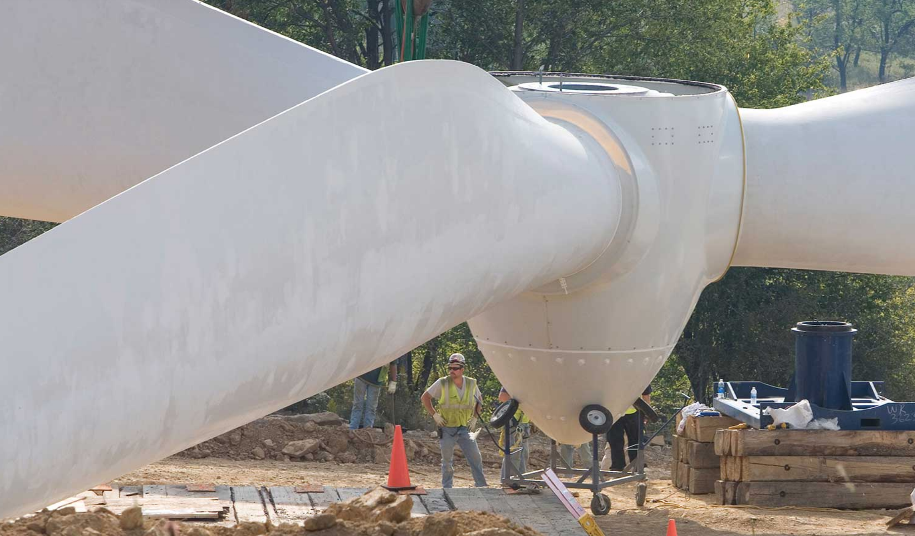

Food Waste

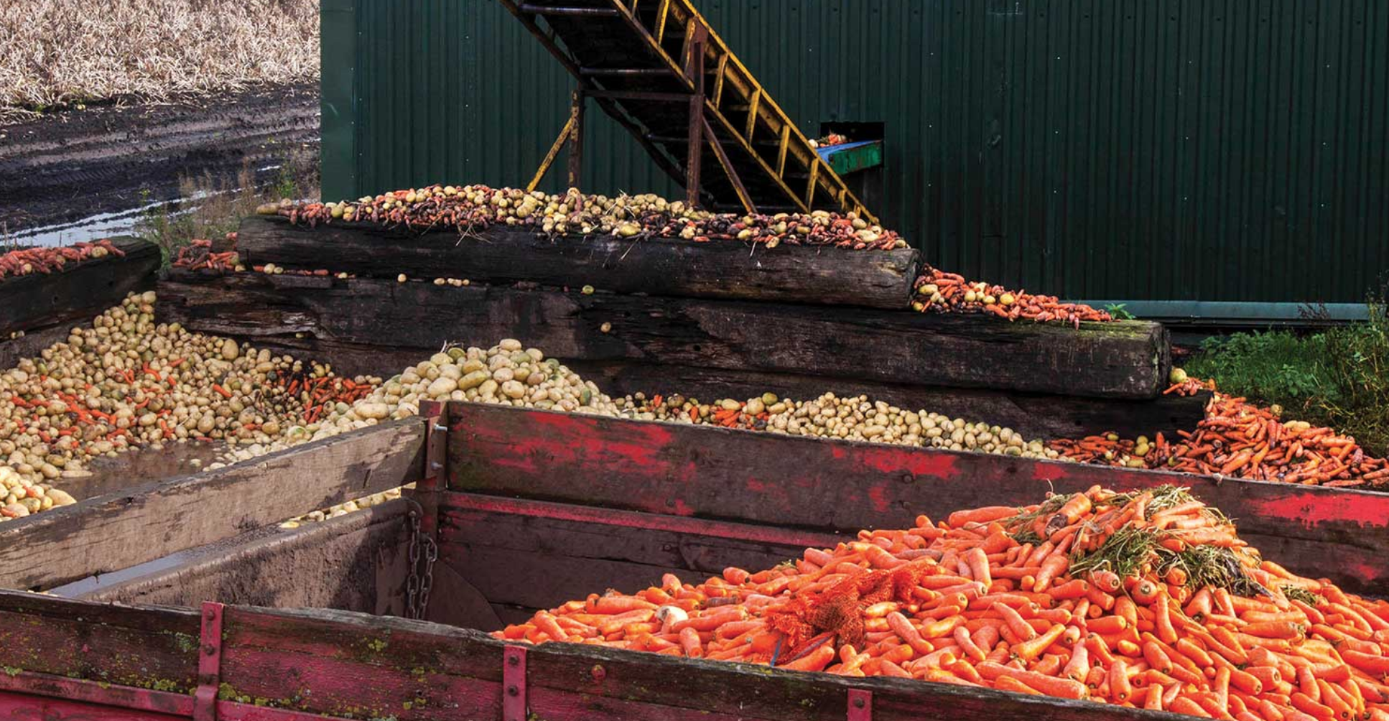
Onshore Wind Energy is growing rapidly
and it’s become one of the cheapest forms of energy.

One disadvantage is that the wind doesn’t always blow, so energy storage is needed.

Food Waste

One third of food grown in the fields is never eaten.
There is waste in farms, wholesalers, stores, restaurants and homes.
Stopping this would greatly reduce global warming.

Plant Rich Diet - Eat Less Meat
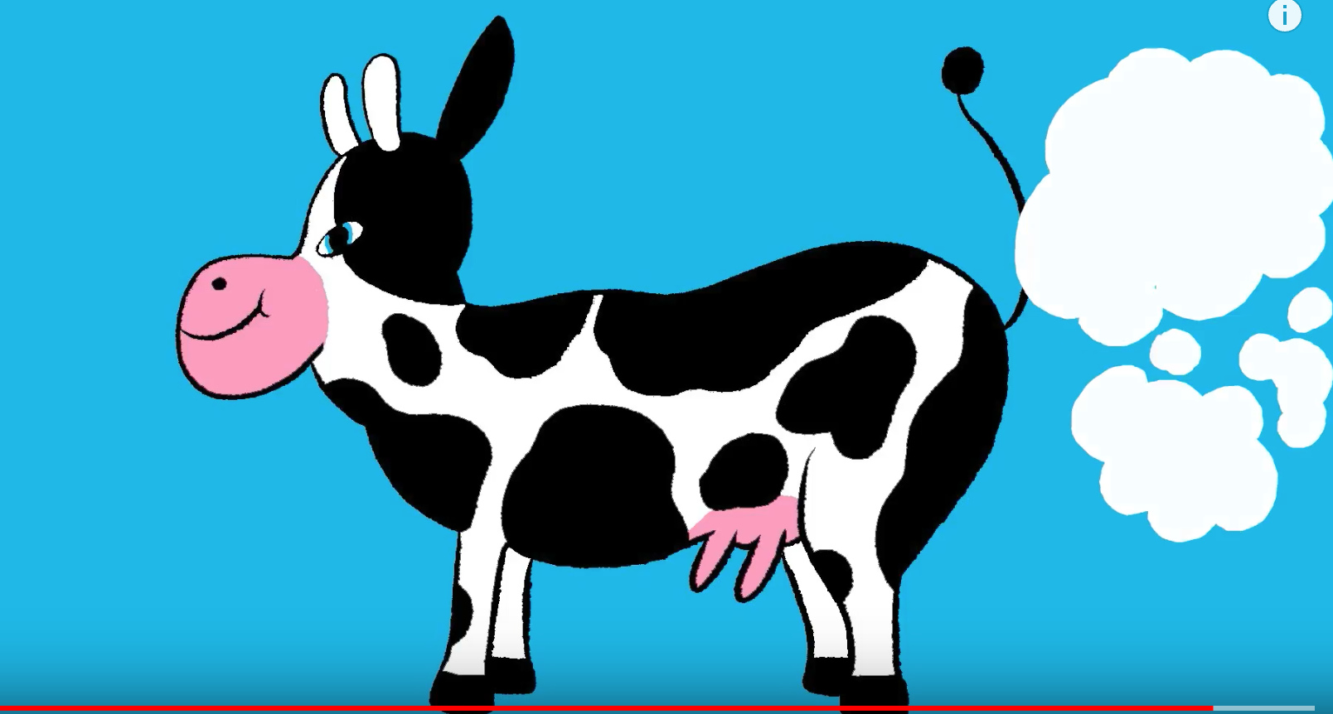

Tropical Forests

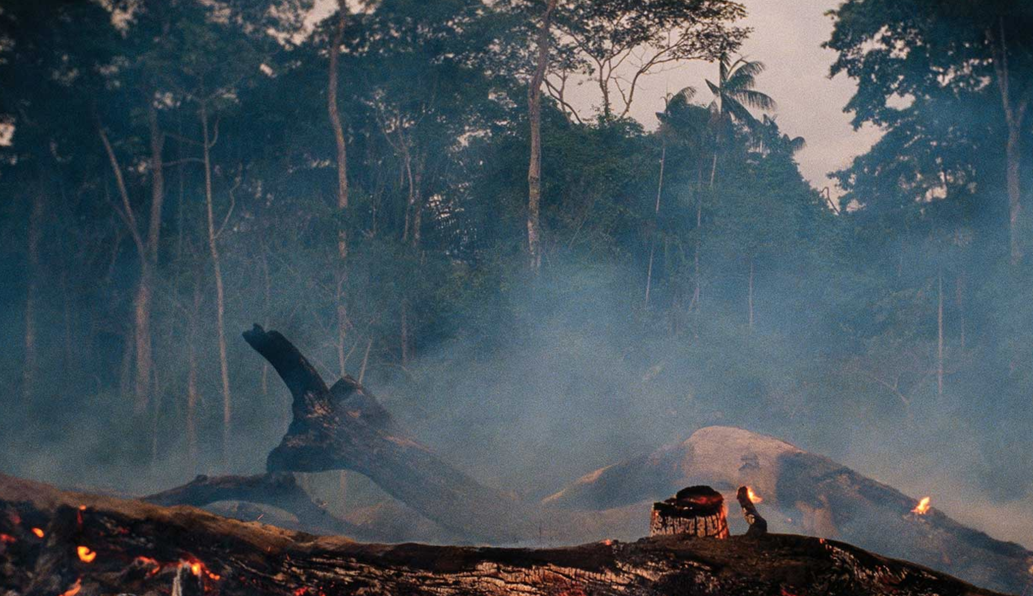

Eat Less Meat
Changing your diet a little will help the planet a lot. The production of beef results in way more GreenHouse Gases (GHGs) than chicken or vegetables.
It also uses more water and needs more land.

Tropical Forests

Clearing tropical forests puts tons of carbon dioxide into the air.

Restoring the forest will take carbon dioxide back out of the air.

Educating Girls
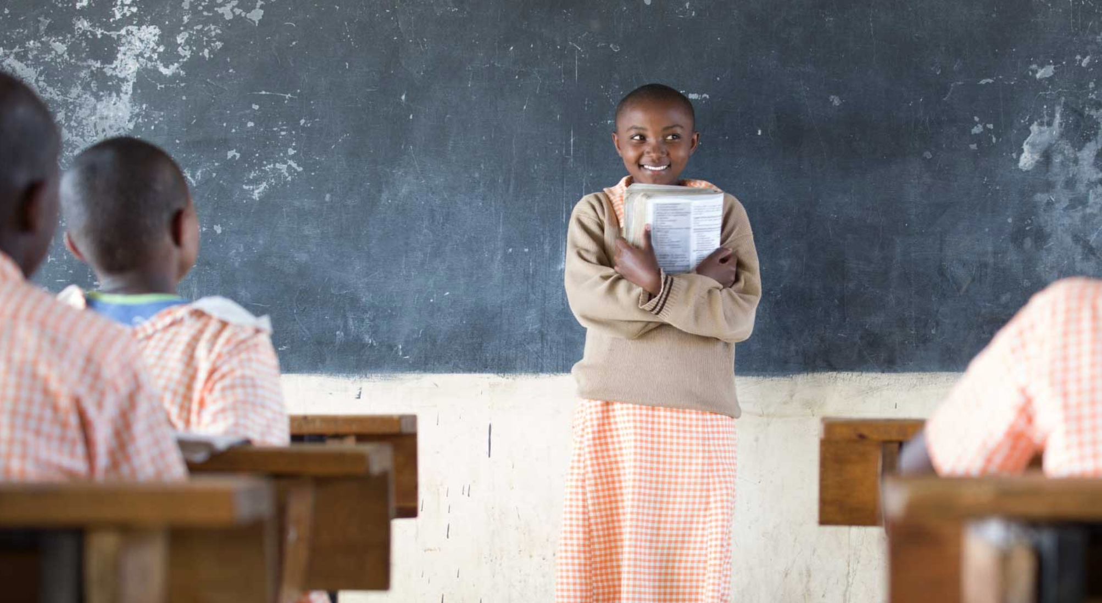

Birth Control
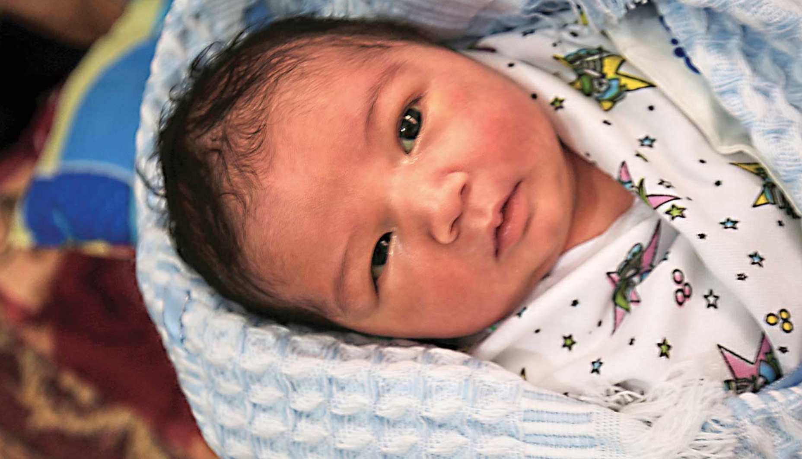
Educating Girls
In many countries poor people cannot afford to send their girls to school.

The girls have to deal with early pregnancy and household drudgery.

Educated girls choose to get pregnant later and have fewer children - less impact on the planet.

Birth Control

When birth control is readily available family size goes down and there is less impact on the planet.

Solar Farms
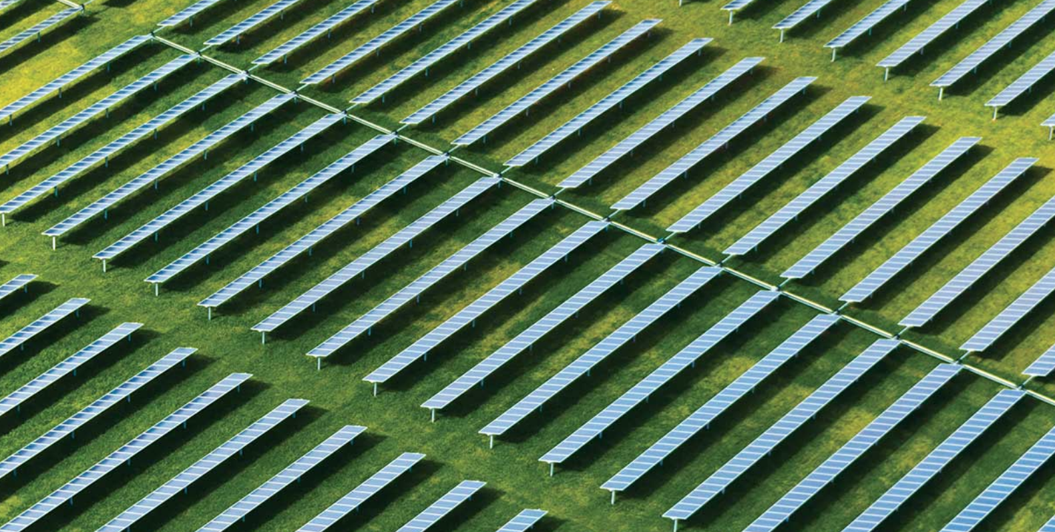

Silvo Pasture

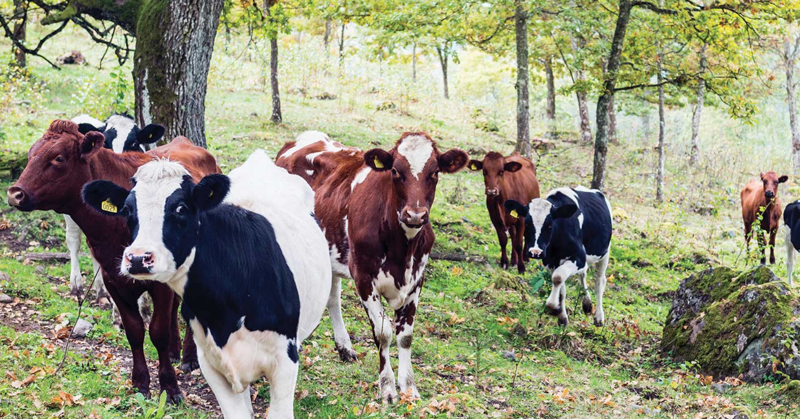

Solar Farms
These huge arrays of solar panels produce lots of clean energy and the cost is now already less than dirty coal energy and will be even cheaper in the future.

Silvo Pasture
Grazing cows amongst trees turns out to work very well for both. The cows fertilize the trees and benefit from the shade.
The scratching of the soil with the animals' hoofs
helps the soil retain moisture and absorb carbon.

Rooftop Solar

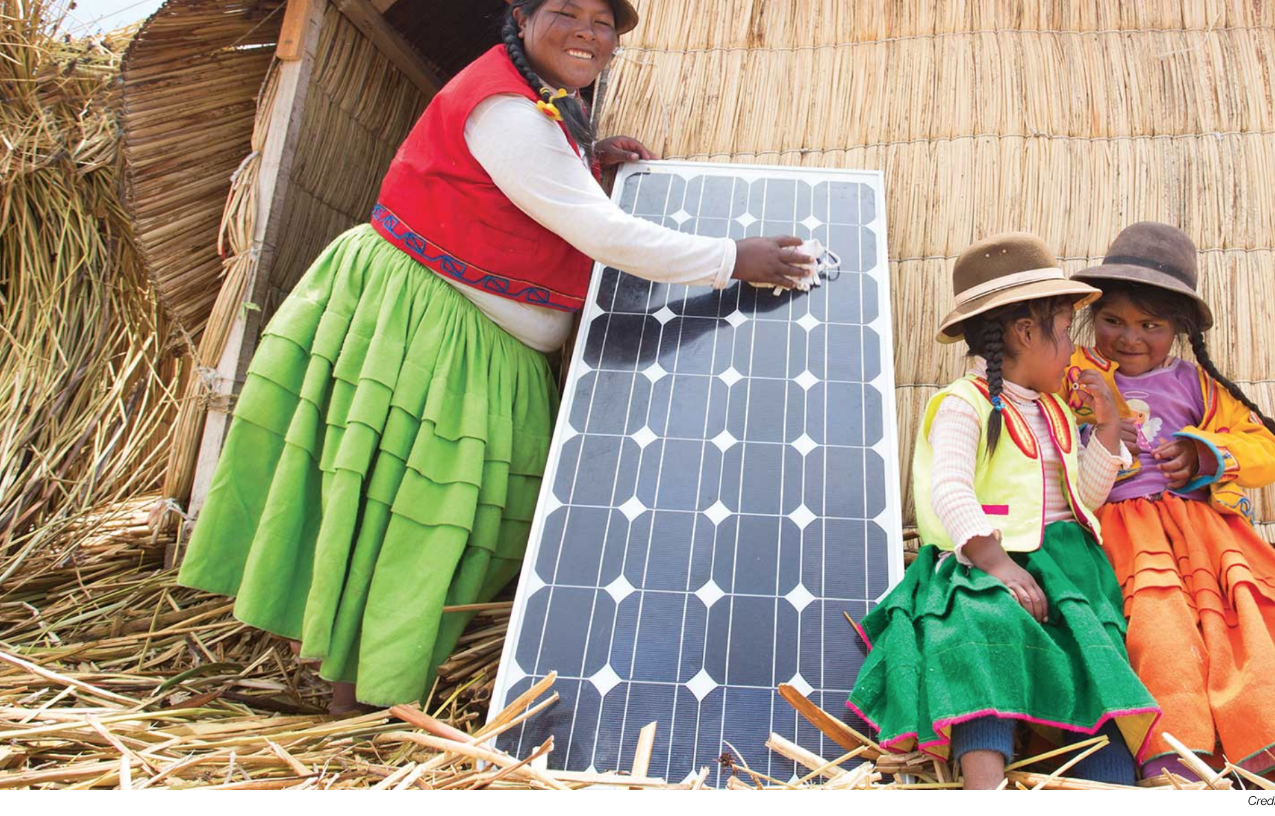
Regenerative Agriculture

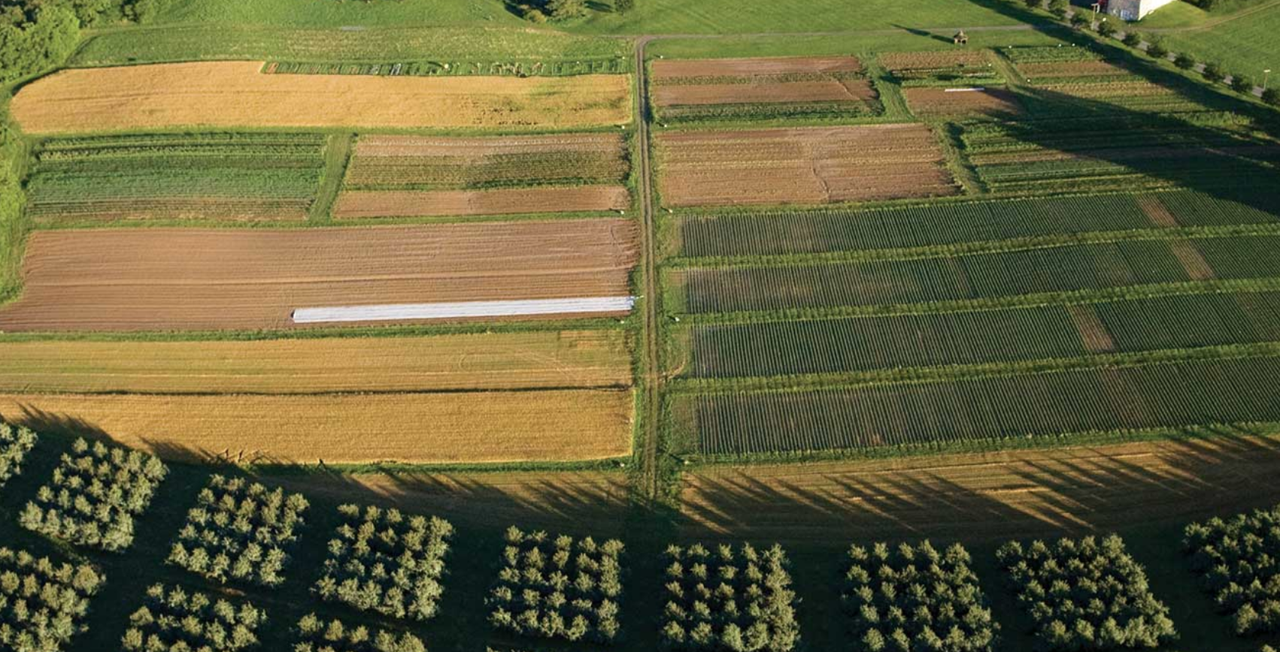

Rooftop Solar

Rooftop solar is now quite cheap and beneficial in rich and poor countries. It’s great in rural areas where there are no power lines.

Regenerative Agriculture

These methods restore degraded land.
They include no tillage, cover crops, no artificial chemicals, crop rotation and other techniques.
All this puts carbon BACK INTO THE SOIL and increases water retention and soil health.

Managed Grazing

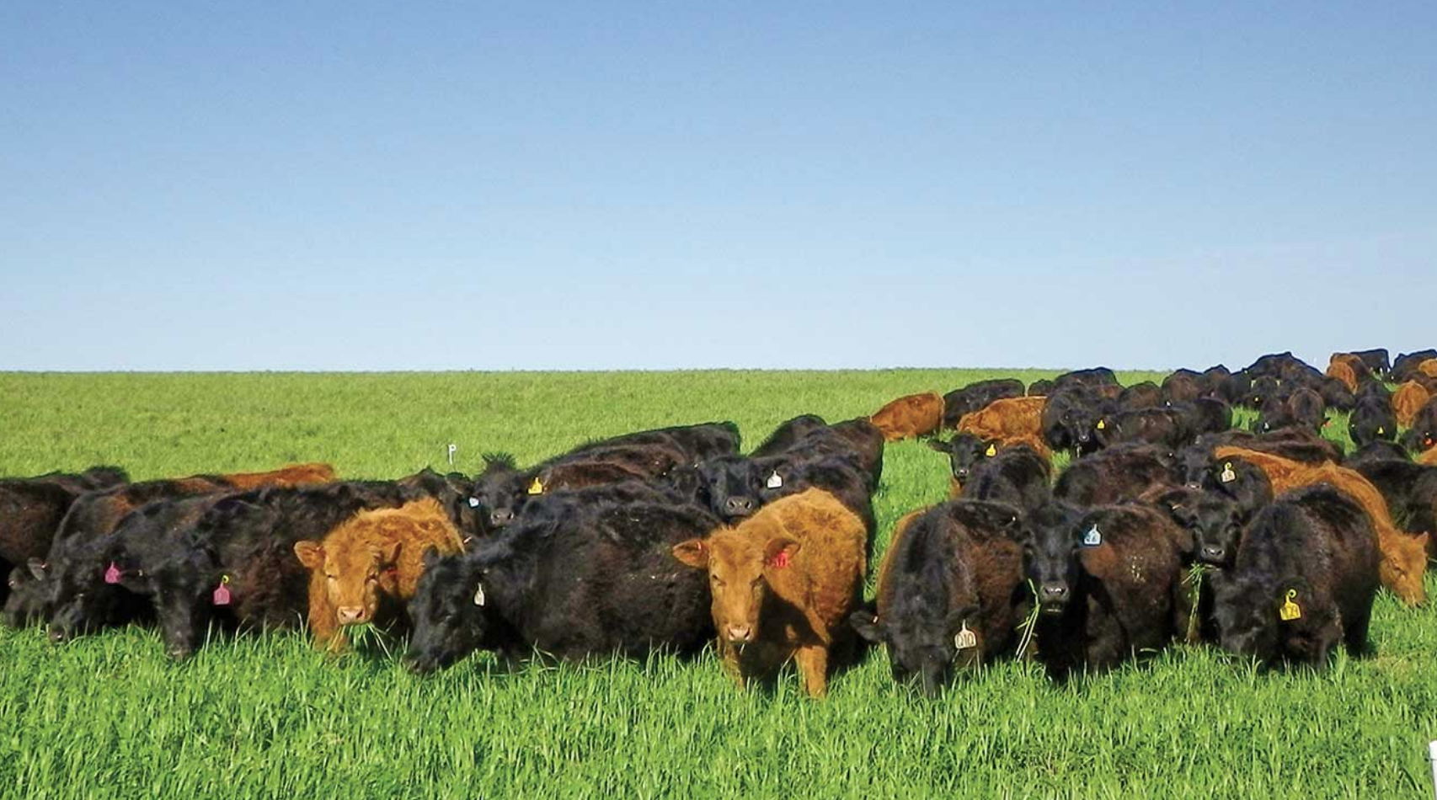

Off shore Wind Turbines

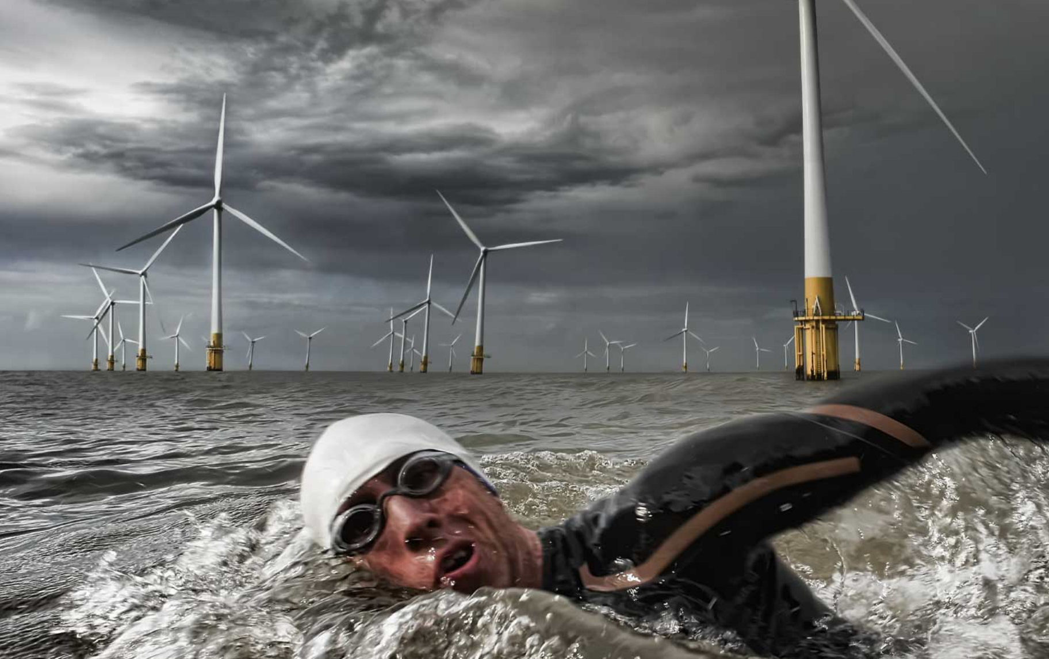
Managed Grazing

Moving a herd of cattle frequently turns out to benefit the land through the natural fertilizer from the animals (their poop and urine) and through the scratching of the soil with the animals' hoofs.
(If the cows are left too long in one area the land gradually gets damaged, so this method requires extra work by the ranchers)

Off shore Wind Turbines - Electricity Generation

Many countries are finding the oceans a great place for wind turbines. The wind is stronger out on the water, and the turbines don’t take up space on land.

Concentrated Solar
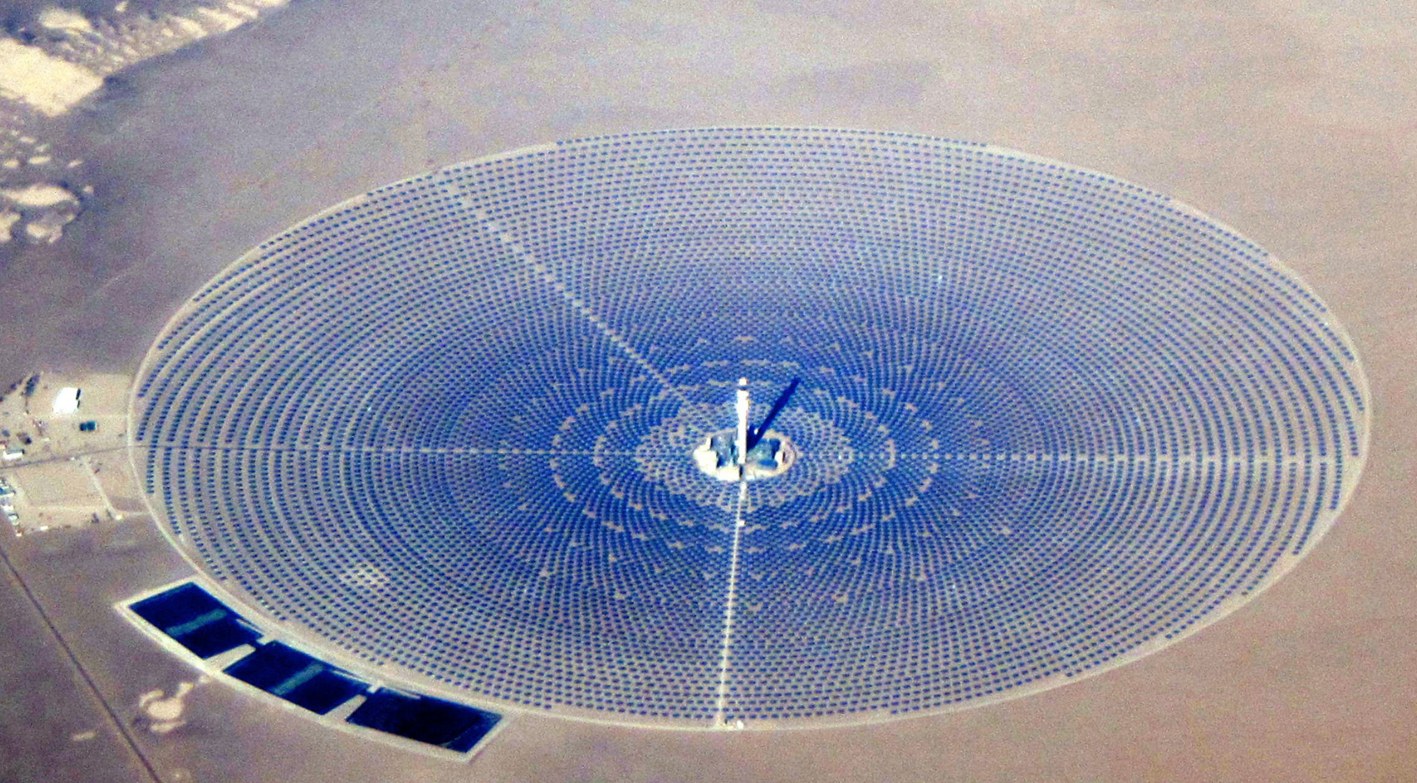

Electric Vehicles

Concentrated Solar
This type of solar power plant often uses molten salt. Mirrors beam the sun’s energy to the center of the installation, where it’s converted into electricity.
These work well in desert areas with lots of sun.

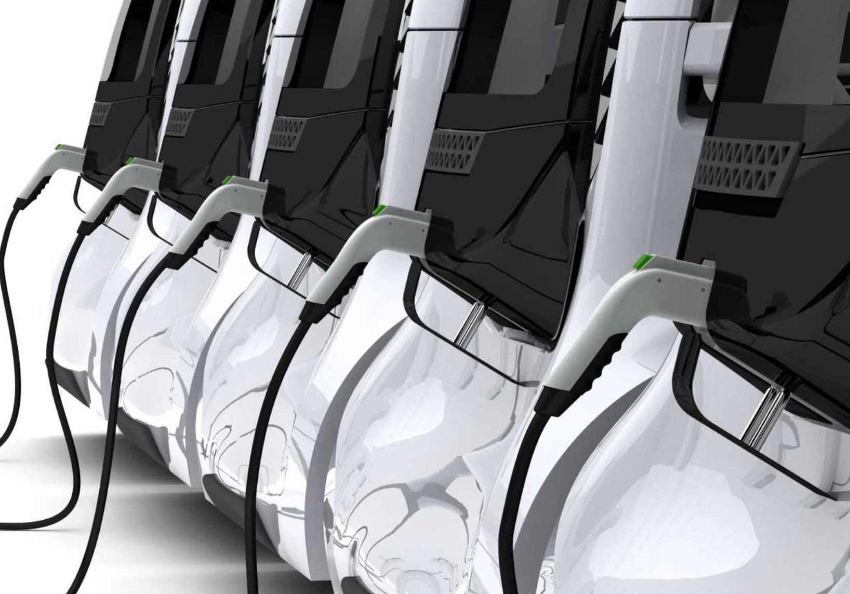
Electric Vehicles

Electric vehicles emit no green house gases (GHGs) while they are running. However, GHGs are emitted during the production of the vehicles.

Used ones are now available fairly cheaply.
Range is increasing and used models are now inexpensive.

Wave and Tidal

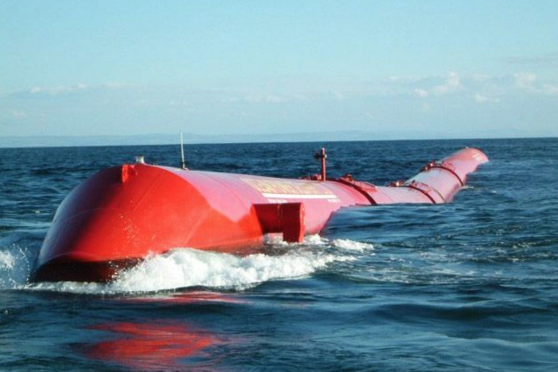

Led Lighting

Wave and Tidal Energy
They transform the energy of the waves (energy of movement - kinetic) into electricity.
There are lots of systems in development and a few already working.
This one is called Pelamis and is in the Atlantic ocean near Portugal.

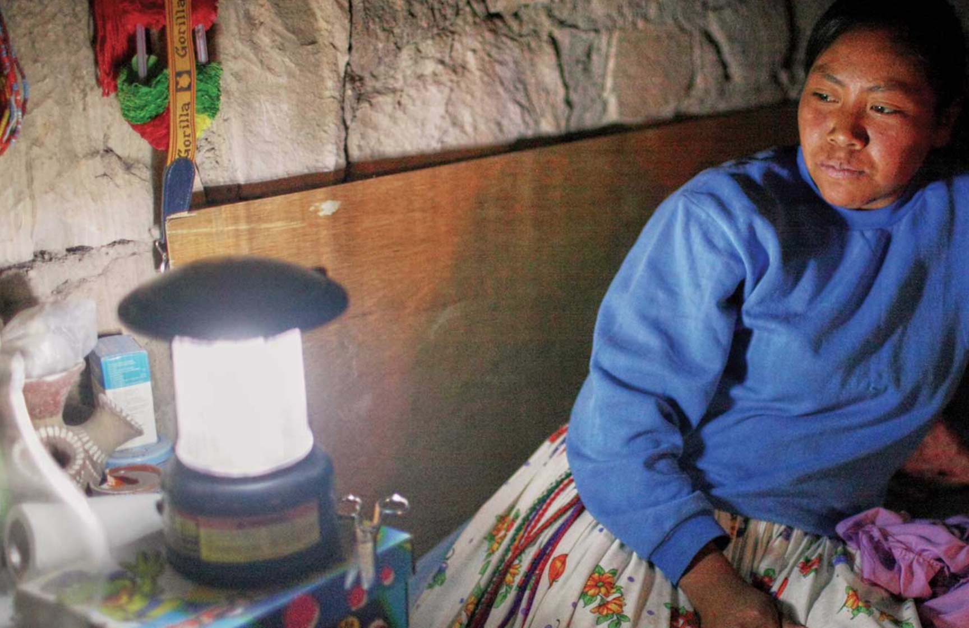
LED Lighting

Led lights are great for rich and poor countries as they use way less energy than old-fashioned incandescent bulbs and less than compact fluorescent also.

Electric Bikes

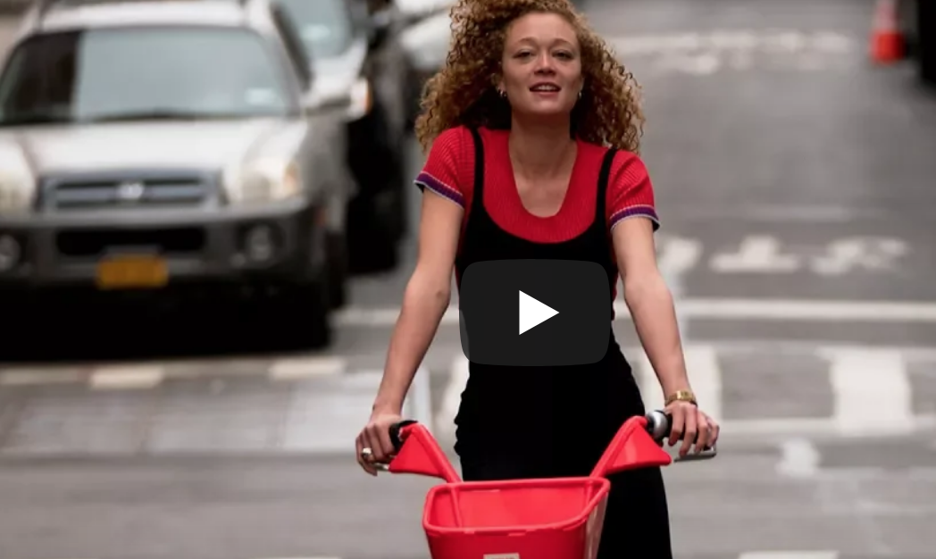

Mass Transit
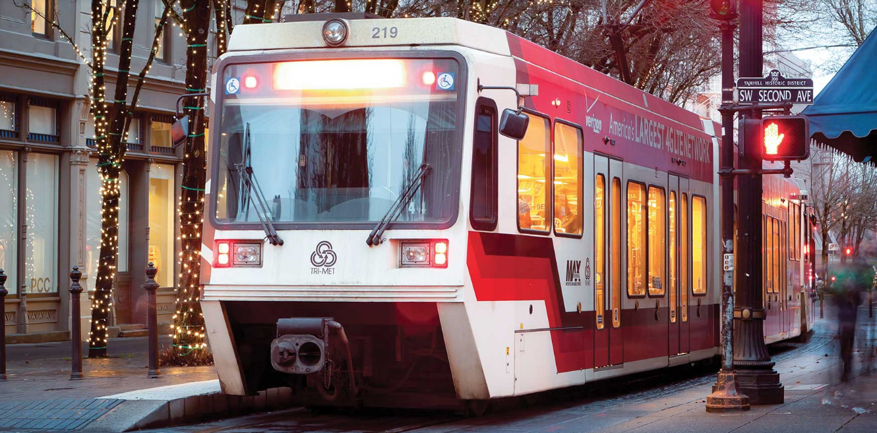

Electric Bikes
ALL BIKES are a great form of transport -
Good for the rider and the Climate!
The new electric bikes are very easy to use.

BUT DON’T FORGET YOUR HELMET!

Mass Transit

We need more frequent electric buses and more routes and special faster bus routes.
Maybe one day we’ll have a train from Watsonville to Santa Cruz.

