Santa Cruz Schools Sea Level Rise Activity Teacher Guide

Water Heat Capacity Demo materials balloons, lighter, water
This is an engaging demo useful sometime during the unit as it illustrates the heat capacity of water
Two balloons A - blown fairly full B - plenty of water and some air
Take out the lighter - kids will react - after a little kidding put the lighter under Balloon A - will pop of course!
Now take the lighter to balloon B - after 30 secs of heating it should still not pop.
Ask kids why - briefly explain heat capacity of water and its effect on weather.
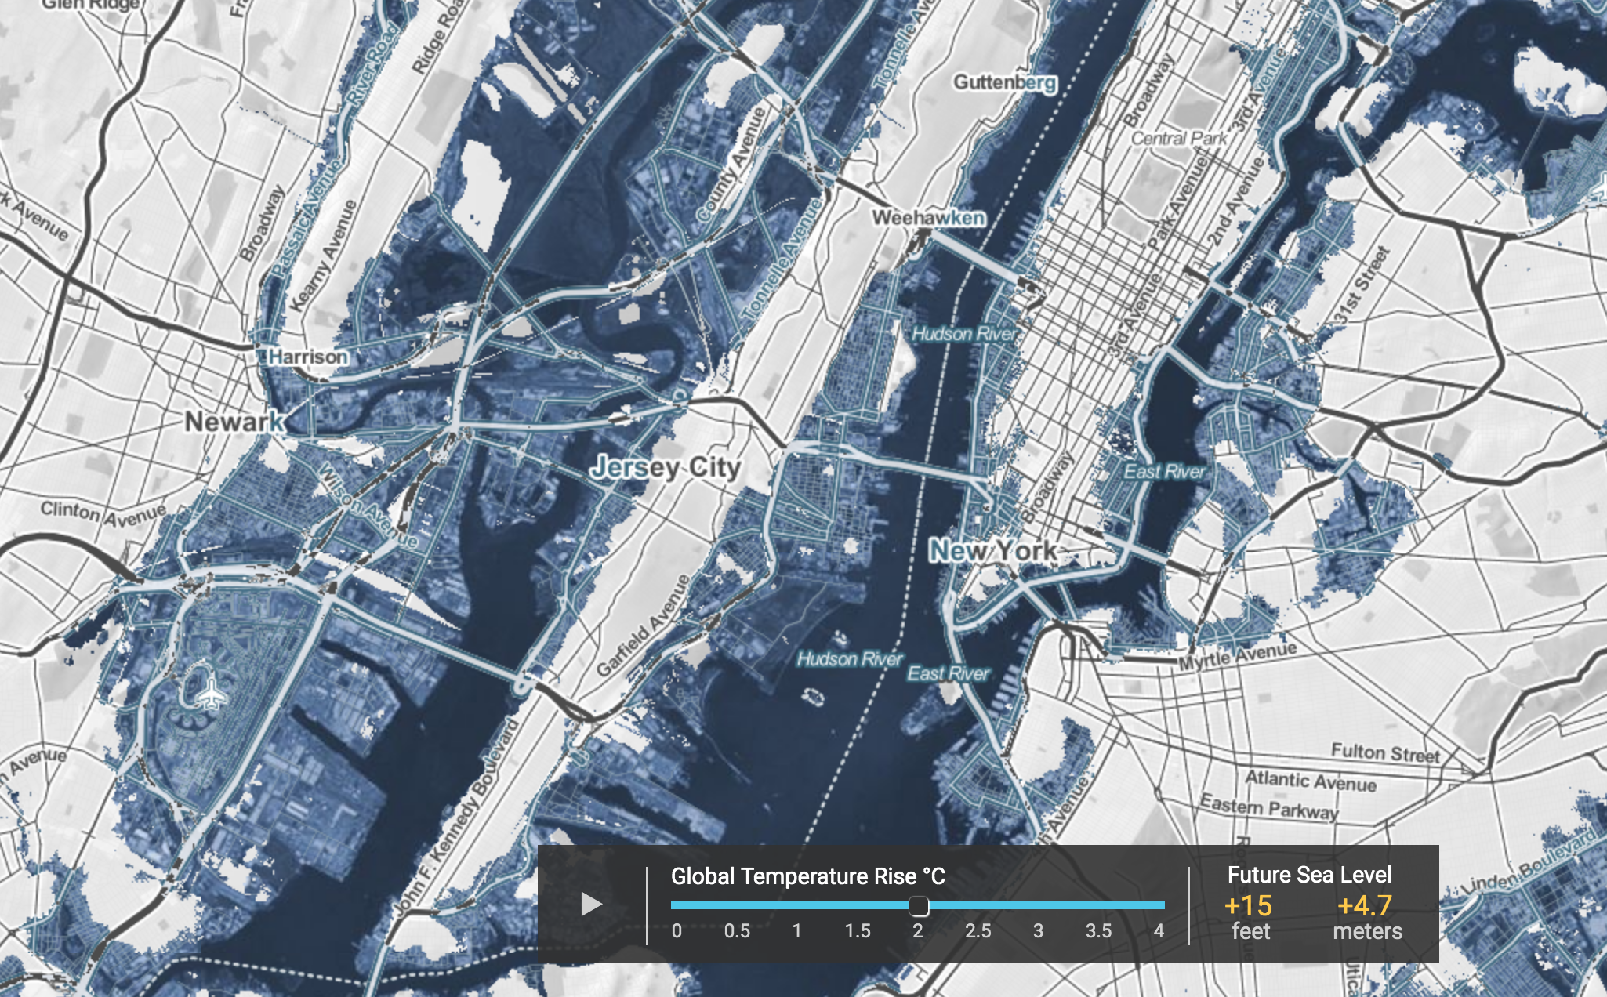
Part 1 Sea Level Rise open sealevel.climatecentral.org basic info
Part 2 Top menu click on Maps and tools select Seeing Choices
Students chart feet of sea level rise versus temp increase, while viewing flooding in New York area.
Also collect more info on timing of sea level rise and what’s causing it

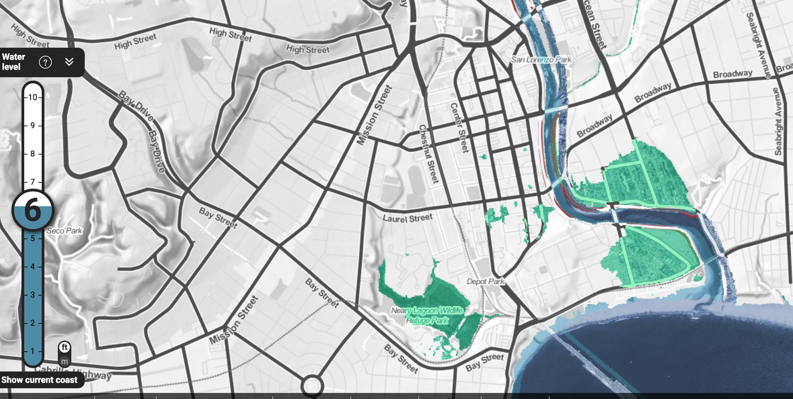
Part 3 click on Maps and Tools , Risk Zone Map in the box ”enter global ...” type Santa Cruz
Use the + to zoom in 3 times
*** For other areas pick your nearest low lying coastal area

They will record new flooded streets at each water level

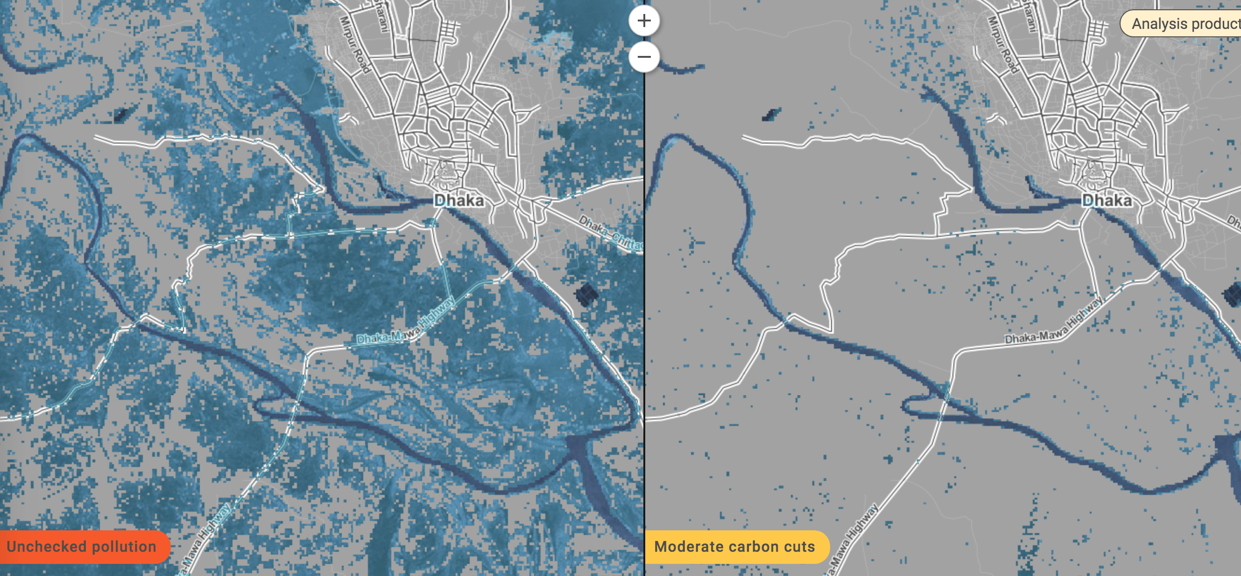
Part 4 click on Maps and Tools , Mapping Choices country box Bangladesh
change temperatures to scenarios
click on Map 2 and choose Moderate carbon cuts and APPLY
They will see how devastating sea level rise will be for this entire county!
Part 5 - open exploration

