Drawdown Activity Teacher guide - for Student worksheet DDownActWS

Guiding Question How do various climate change solutions rank globally and which are most important locally.

NGSS
Disciplinary Core Ideas : MS - ESS3-D Global Climate Change
(Connections to ESS 3-C Human Impacts, ESS2-D Weather & Climate
Science and Engineering Practices - 1,4,6,7,8,
Crosscutting Concepts - 1,2,3,5,7

Science Practice
Students will explore and discuss various solutions to Climate change as outlined by Project Drawdown.

Materials: See each worksheet

Handouts
A handout per student or pair if they are sharing computers

Time - approx. one 55 min period - or slightly longer depending on time used for preparation

Preparation
Students should be introduced to basic science of Climate Change through either
videos, powerpoint presentations or a computer exploration of climate.nasa.gov WS ClimNasa_Ice
Suggested powerpoint - Apr19 - this will Engage the students

Energy | Food | Transportation | Other
DrawDown Activity - Engage/Explore/Explain/Elaborate
each group of 4 students will review a set of 4 solution cards

Each card has a picture on the front and a simple explanation on the back

The set has different cards so a double set works for 36 students
Print twice, back to back, from this file DDown ActCards

These solutions were selected from drawdown as they are relevant both globally and locally
Note - they are NOT the top 18 global solutions

Each student will explain their own to the group and explain its advantages (& problems if any)

The group will then vote for the top solution for the table.

Then the teacher will ask for an example from one of these groups and compile a chart on the board

Example 1


Example 2
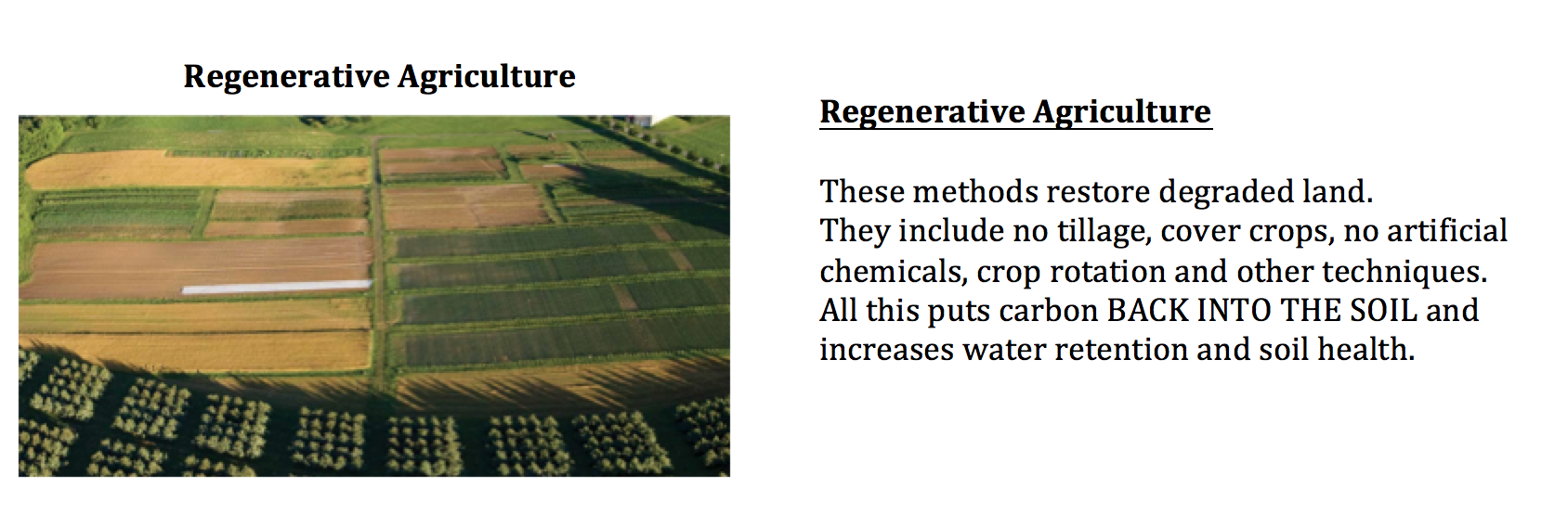

Entire class review - teacher will show official drawdown data for the 18 solutions reviewed
(File DDownActiv.pptx) and discuss why just the top 18 were not used.

IMPORTANT to stress that ALL solutions are important and necessary.

Students will enter details of drawdown rank and CO2 saved for the four at their table and write down some questions they have.

Then use computers and the drawdown website drawdown.org to answer the questions

Evaluate
Finally we’ll review which solutions might be especially important in our area.

Extension
Students do further research on one drawdown topic and prepare a short report or presentation

