Solar Activity Teacher guide - for Student worksheets Solarshrt, SolTech

Guiding Question
How do solar cells work and how can they help reduce climate change?

NGSS
Disciplinary Core Ideas : MS - ESS3-D Global Climate Change
(Connections to ESS 3-C Human Impacts, ESS2-D Weather & Climate
Science and Engineering Practices - 1, 3, 4, 6,7
Crosscutting Concepts - 1,2,3,5,6

Science Practice
Students learn about how solar cells work through 2 short videos
Then they will experiment with batteries, lights, motors and solar cells

Vocabulary
Metal, non-metal, semiconductor, silicon, photo-voltaic, photon, electric current, renewable

Materials: See each worksheet

Handouts: SolTech or short version Solarshrt,

Time - about 45 min - or slightly longer depending on time used for preparation

Preparation
Students should be introduced to basic science of Climate Change through either
videos, powerpoint presentations or a computer exploration of climate.nasa.gov WS ClimNasa_Ice
Suggested powerpoint - Apr19 - this will Engage the students

Explore -
Part 1
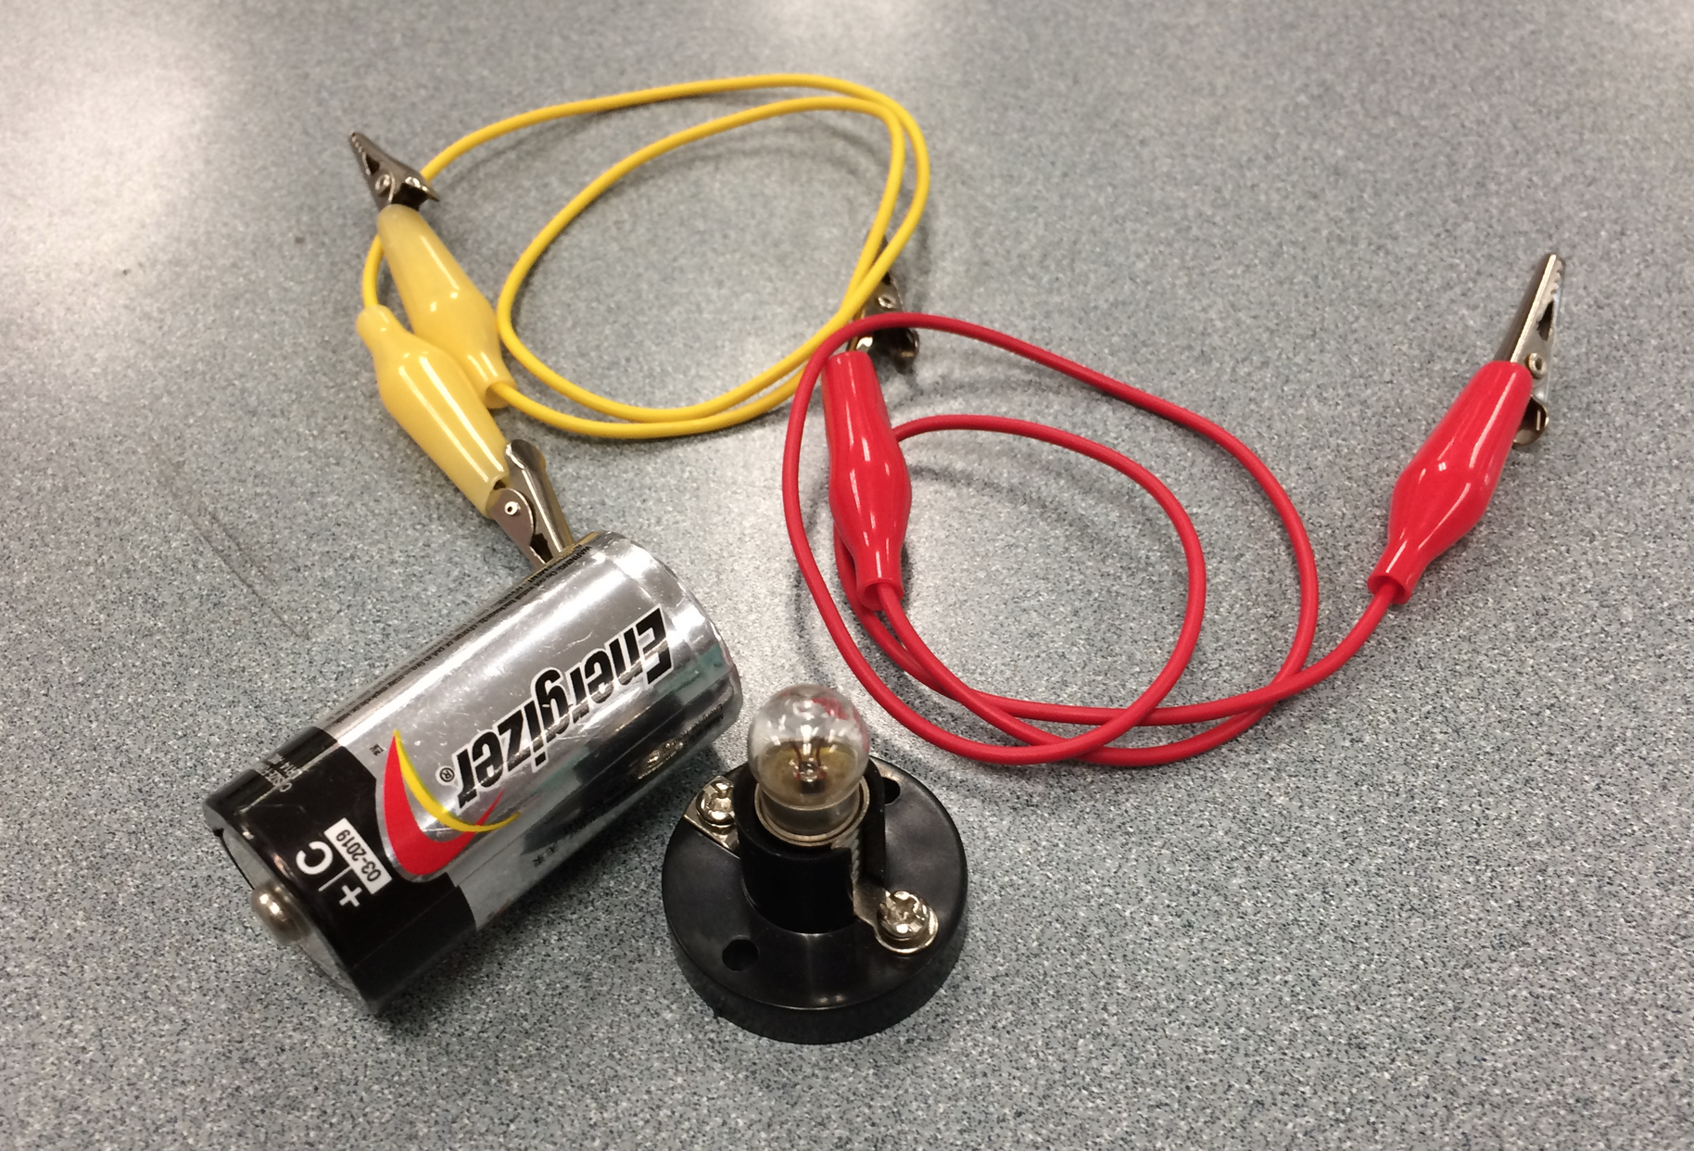
Hands On Activity

Step 1 - Light the bulb and draw a diagram

This ensures that students understand the basic concept of a circuit

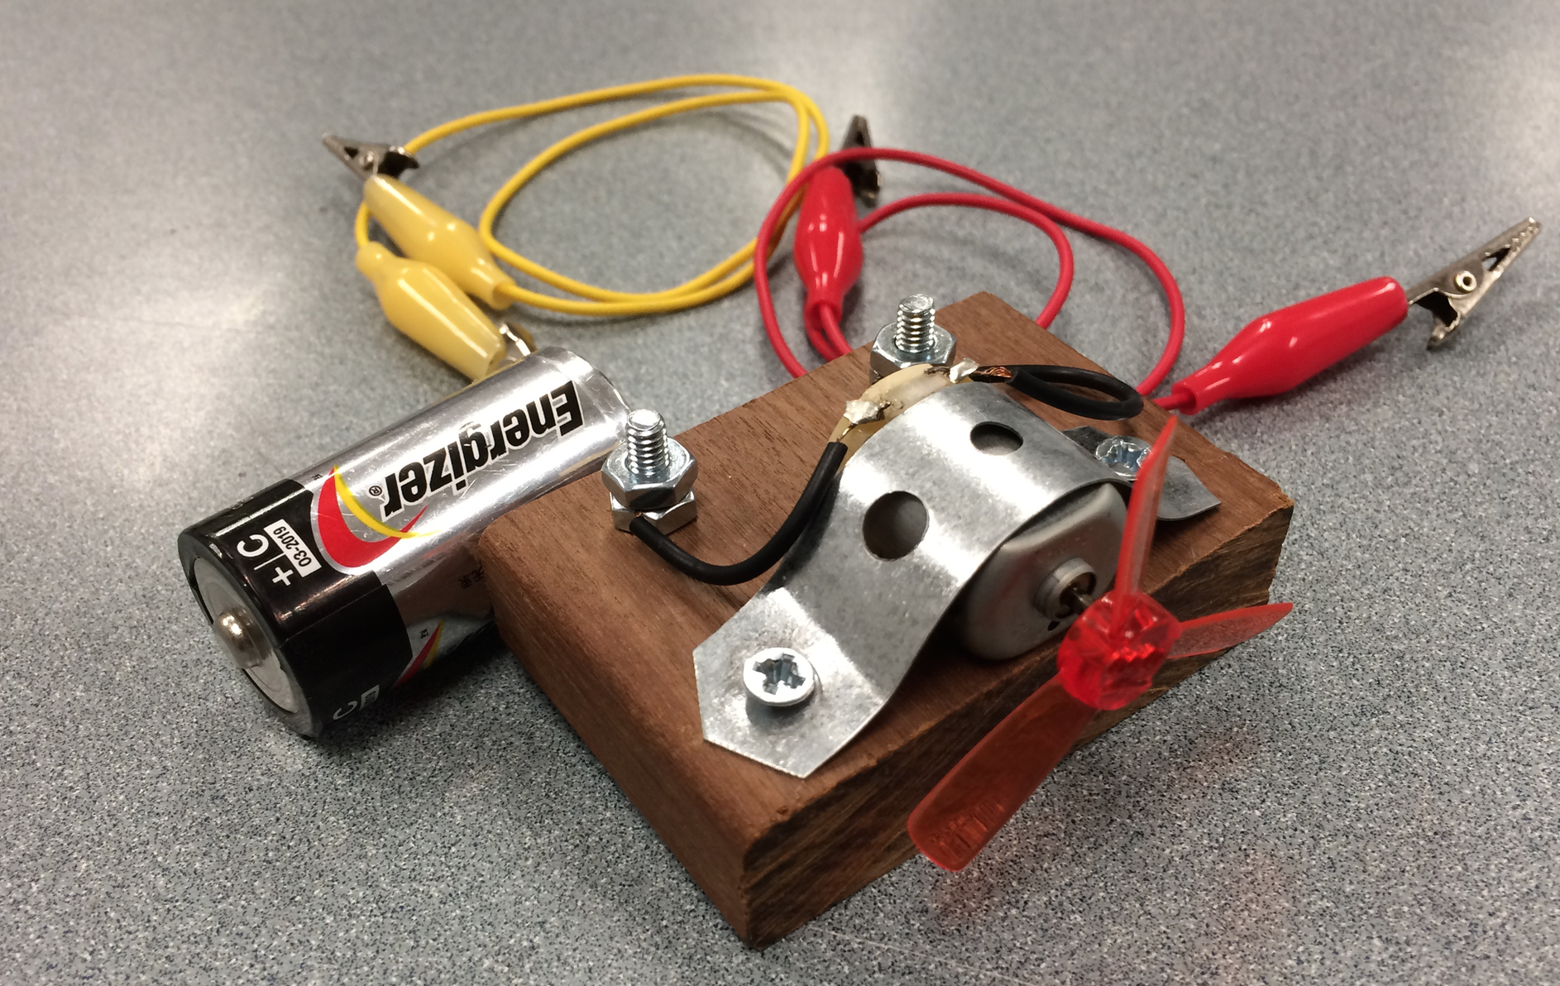
Part 2 - Power the motor with the battery

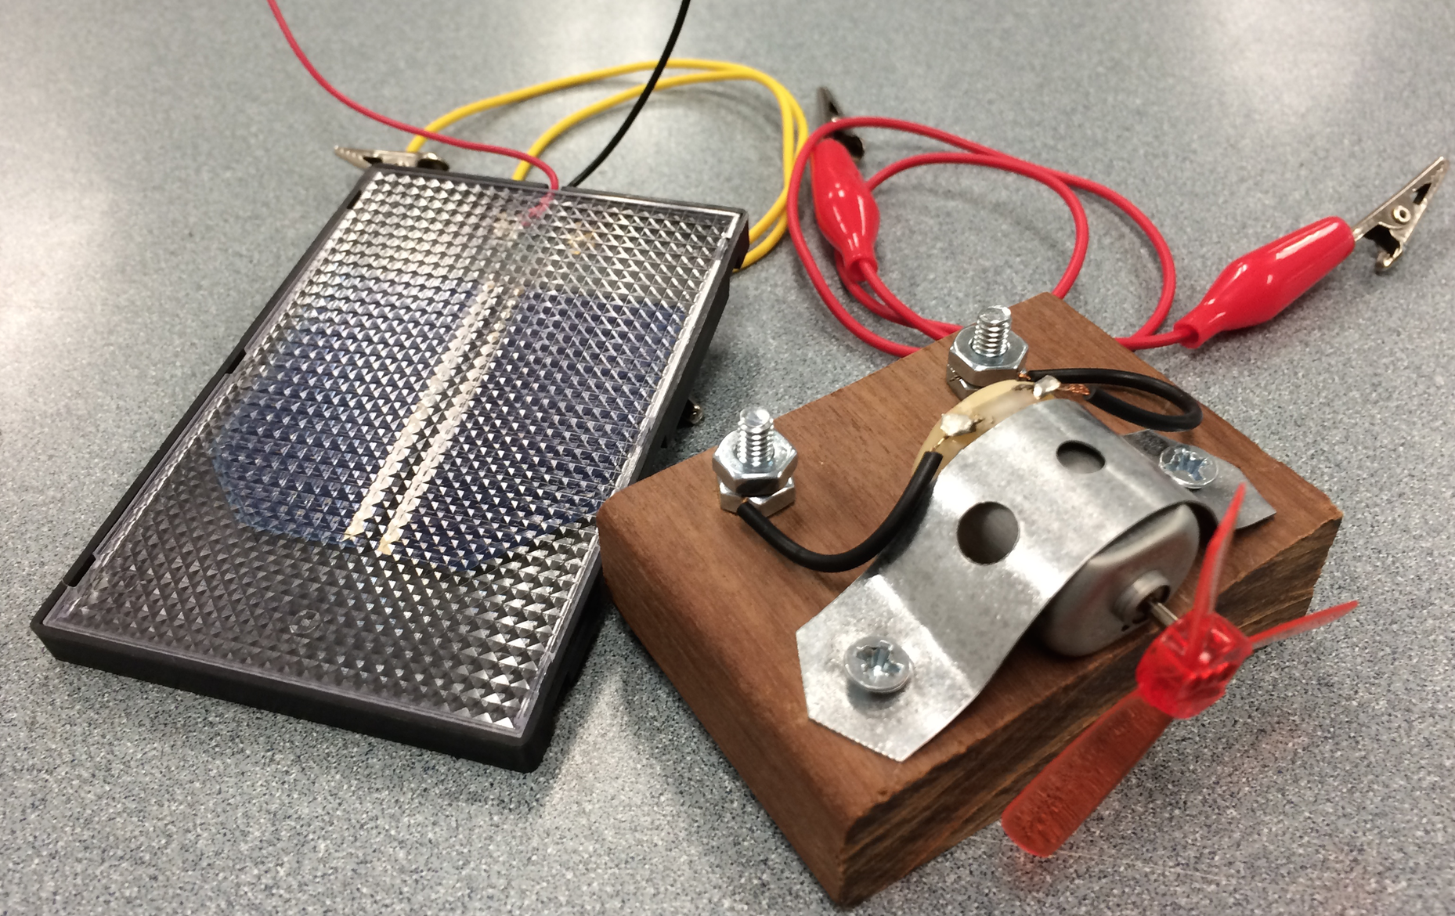
Part 3

Use the Solar cell to power the Motor
OUTSIDE
(Does not work with heavy overcast but thin clouds are OK)

They investigate how the fan speed changes with shading and angling of the solar cell

Evaluate - student discussions and conclusions

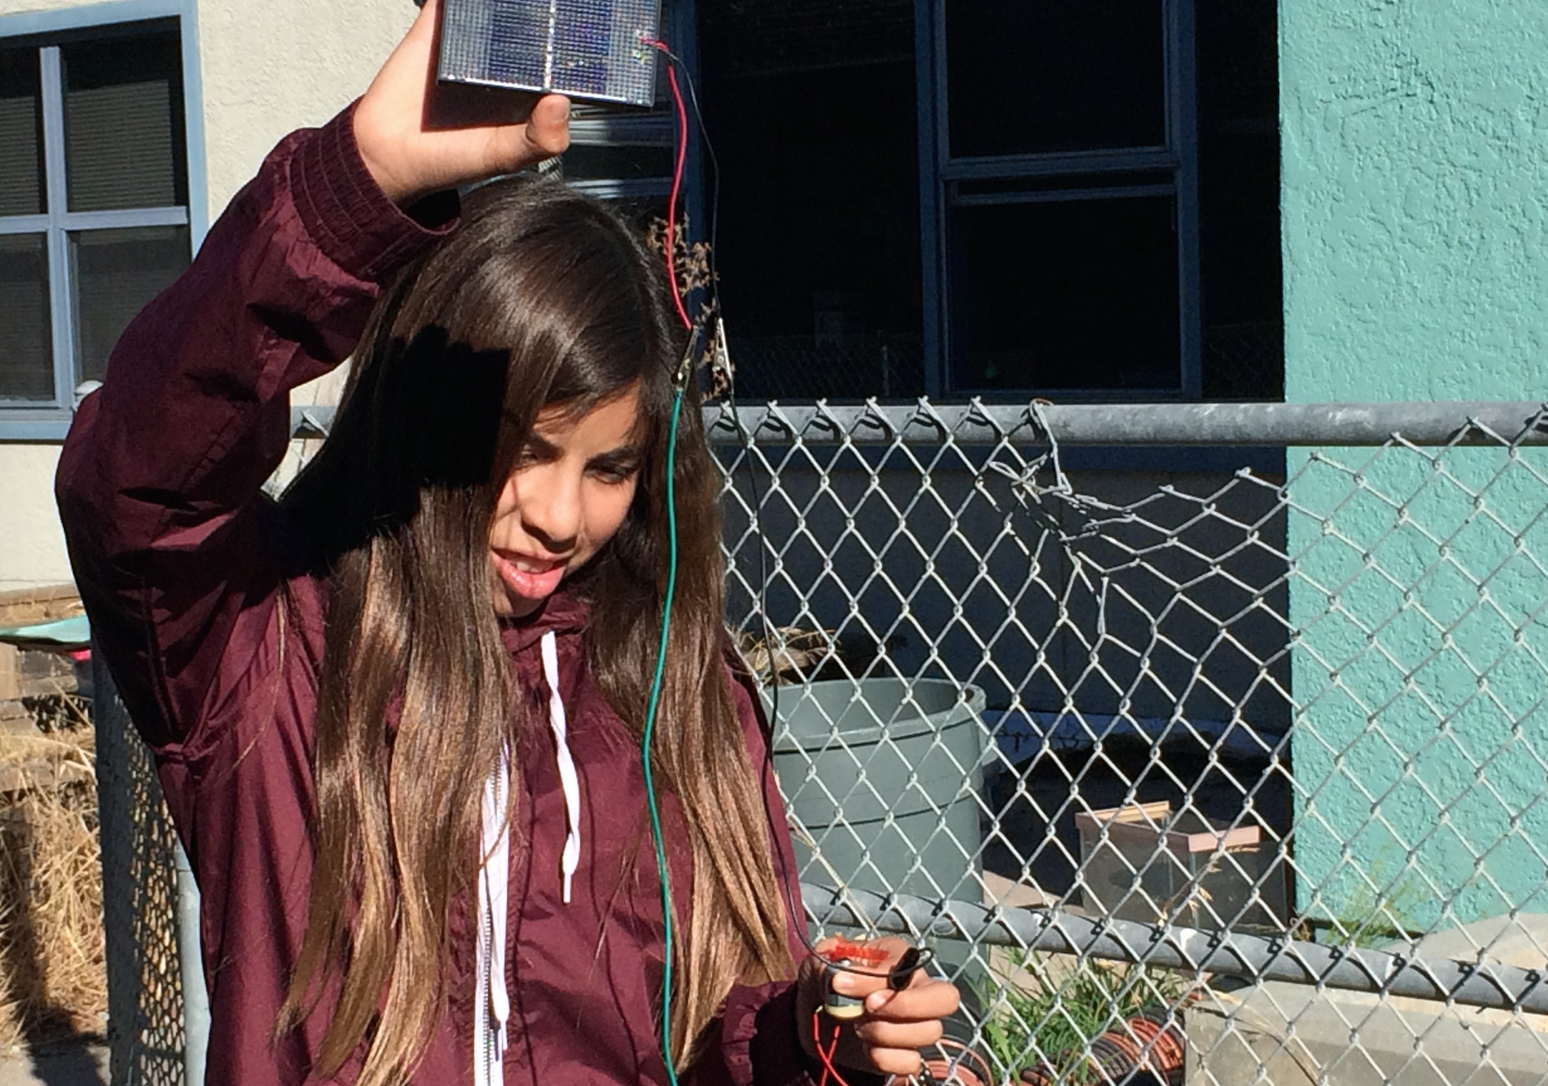

Shoreline 8th grade student using the equipment

