6.2 Notes Greenhouse Effect
How is weather different than climate?

Example of weather: Example of climate:

How does the greenhouse effect work?
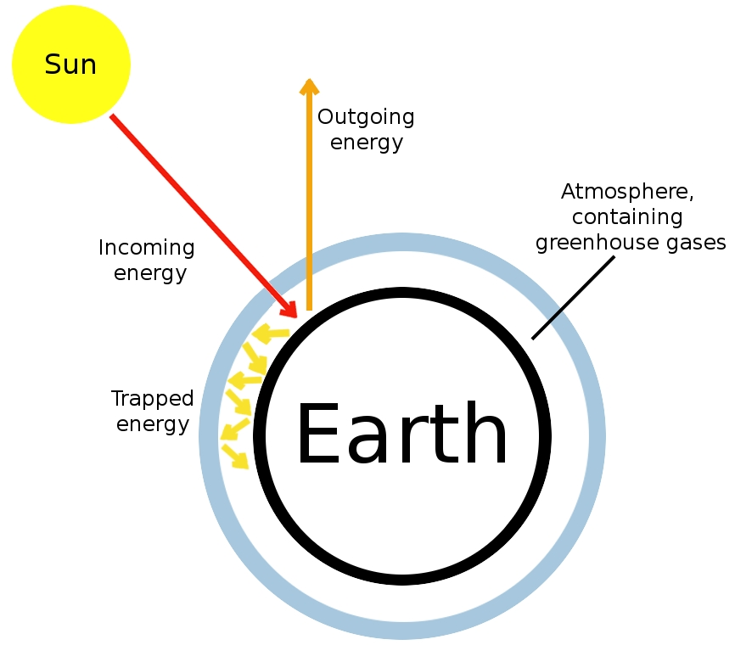
1.

2.

3.
Label where #s 1-3 happen on the diagram

What is a greenhouse gas (GHG)?
- Any gas that:
- __________________________ determines how much heat energy a gas can absorb
- 5 most common greenhouse gases are:
- GHGs are produced ____________________ and_______________________________
How do we benefit from the greenhouse effect?

What impact are humans having on the greenhouse effect?

