Intro to Climate Change Activity - Teacher Guide for student WS ClimNasa_Ice

Guiding Questions
1. What are the current effects of climate change on the world?
2. What is the effect of melting land ice compared to melting sea ice?

NGSS
Disciplinary Core Ideas : MS - ESS3-D Global Climate Change
(Connections to ESS 3-C Human Impacts, ESS2-D Weather & Climate)
MS - PS1.A Structure and Properties of Matter
Science and Engineering Practices - 1, 3, 4, 5, 6, 7, 8
Crosscutting Concepts - 1, 2, 3, 4, 7

Science Practice
In this lesson students use a NASA website - climate.nasa.gov - to explore current effects of climate change.
Concurrently they set up an experiment to explore the effect of floating ice on water level.
All of this helps them have a better understanding of the current climate change situation and especially Sea Level Rise.
This will set the stage for future lessons on Solutions

Vocab: Arctic, Antarctic, atmosphere, Carbon Dioxide, Glacier

Materials: Chrome books or similar small computers. No more than 2 students to one device.
Per group or table - 2 similar tall glasses (150ml beakers work fine) , a tray to catch spilled water
for the class - Masking tape, markers and ice
Handout / Worksheet
A handout per student or pair if they are sharing computers

Time - approx. one 55 min period - possibly continue a second day depending on time needed for introduction

Preparation
If this is the first activity on Climate Change you could start ppt CurrSci thu slide 7 - ask students if they know anyone affected by recent fires, floods, hurricanes etc.

Ice /Water Activity - Use the file IceActDiag to show the setup. Explain that the 2 beakers will get equal amounts of ice
A Artic - it’s all floating at the start
G Greenland - it gets added a third at a time - it’s sliding down off the mountain gradually
If the ice pieces are small they will need to increase the amounts -
If so modify the instructions in the IceActDiag and have students make edits on their own sheets
A - 6 , G - 2+2+2
Make sure that water from the Ice /Water activity is in no danger of spilling on the computers

Explore
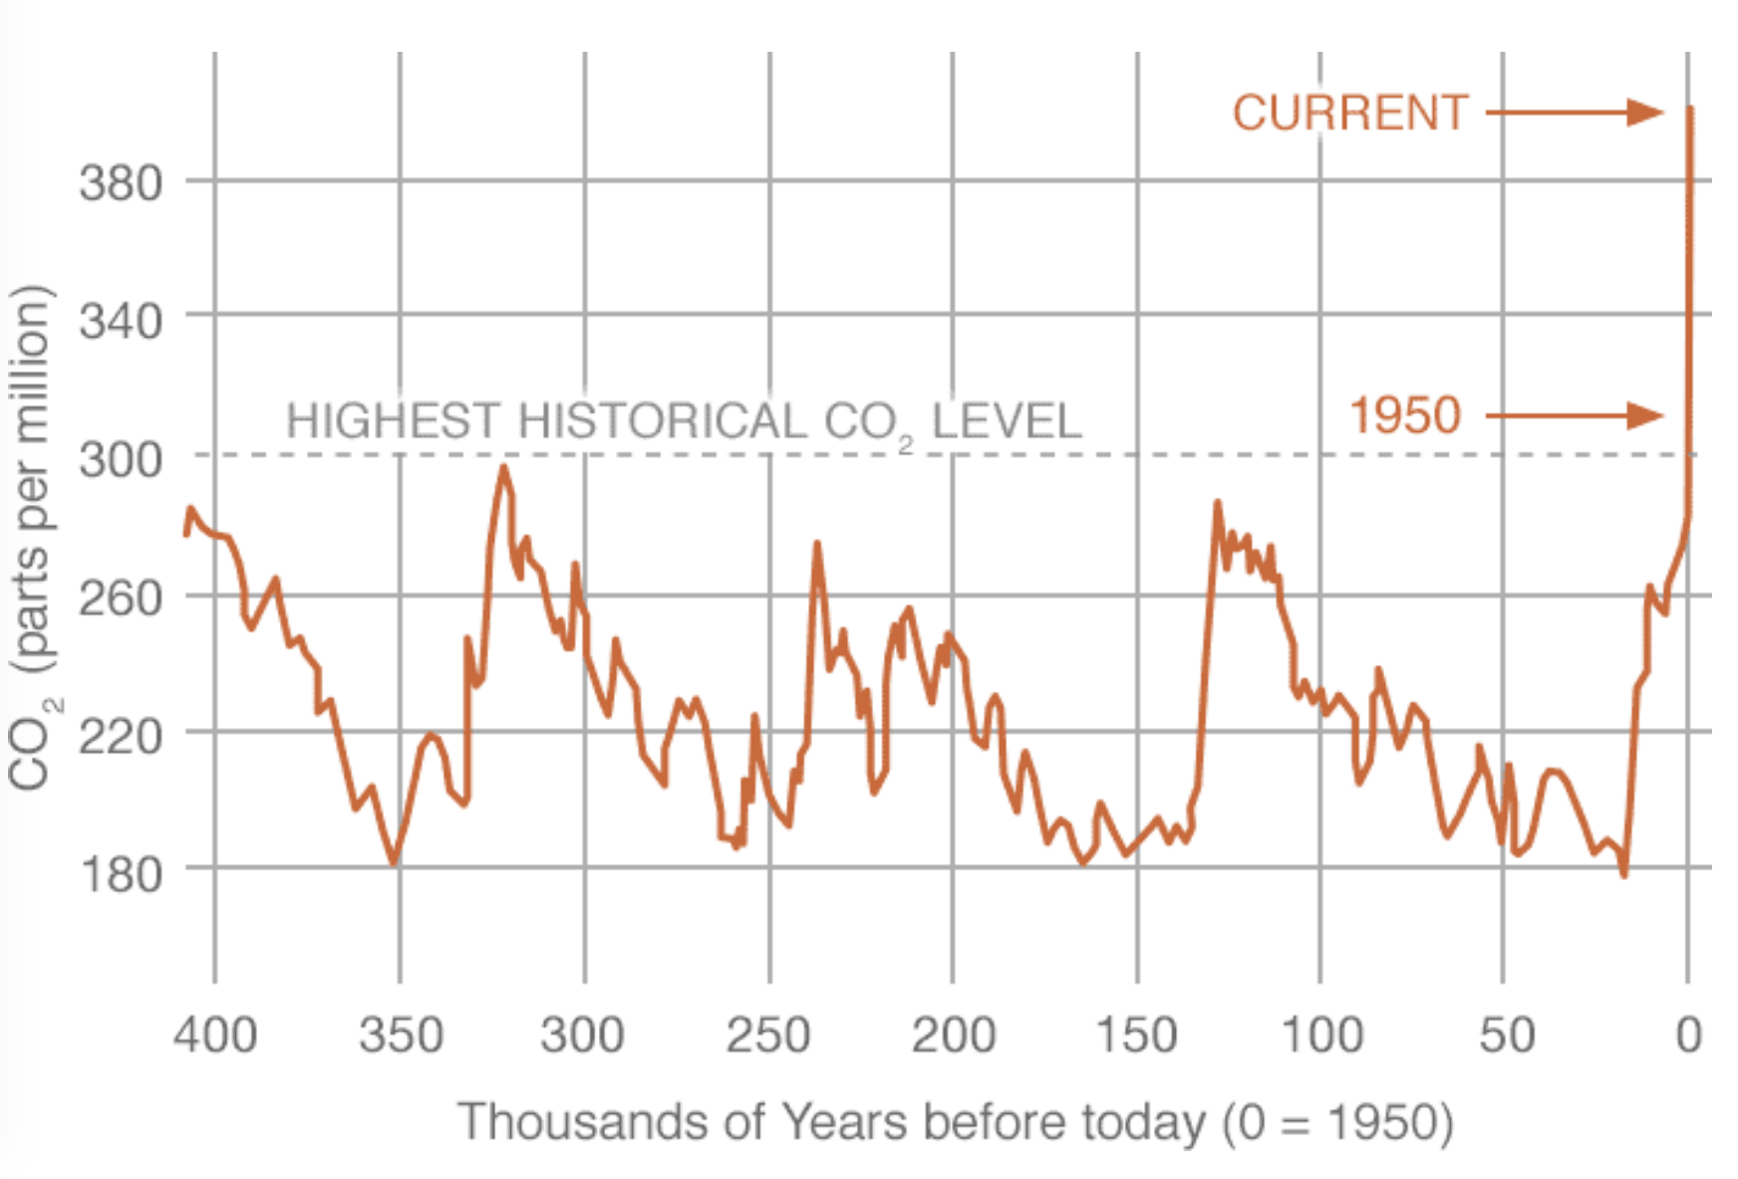
NOTE : The intro part of the NASA website is changed regularly. A teacher could write specific questions or just use the general prompt on the worksheet.

As the students work through the data and questions they will be interpreting graphs, maps and other presentations - not merely reading text. Some may need a little help, which is fine.
Be prepared to demo a particular question if many of them seem confused. (Depends on grade level and experience reading graphs)

Q 6,7 CO₂ Graph -------->>>>
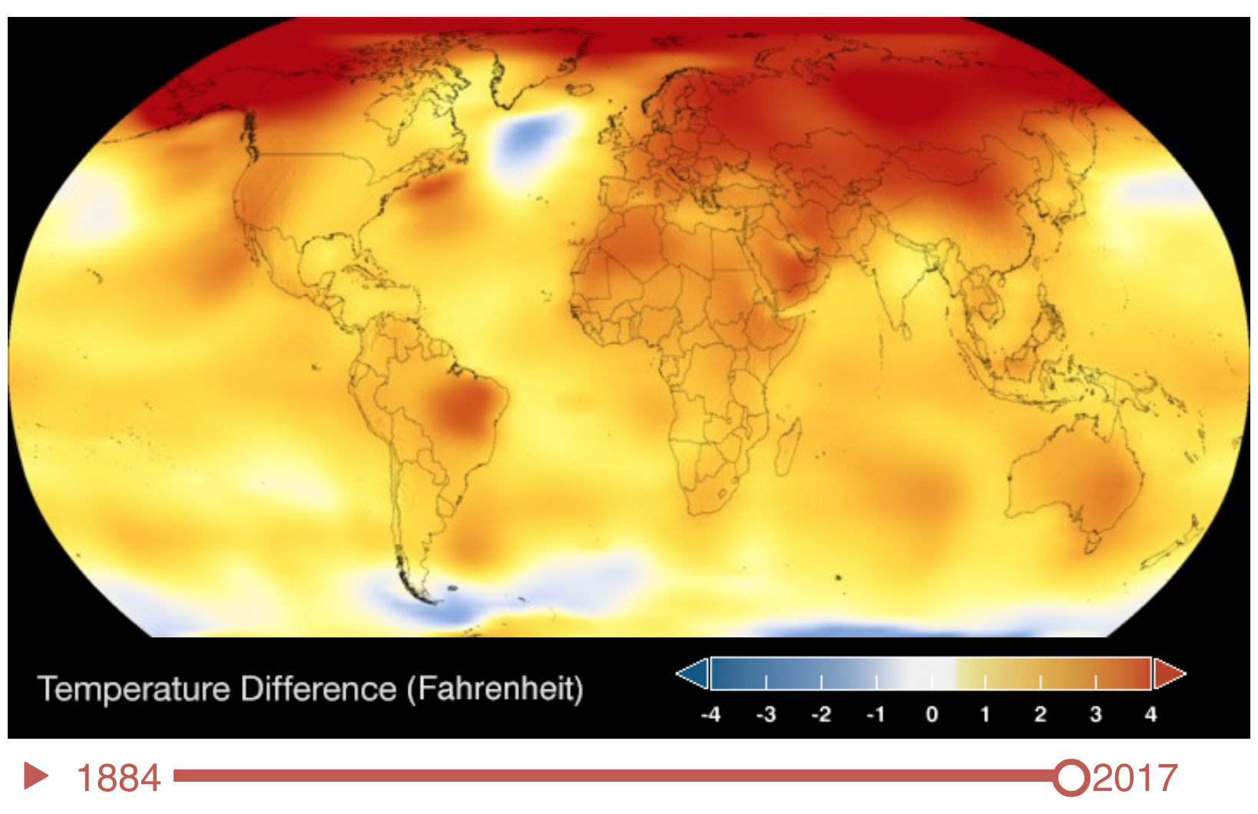
Q 9 Global Temperature Changes

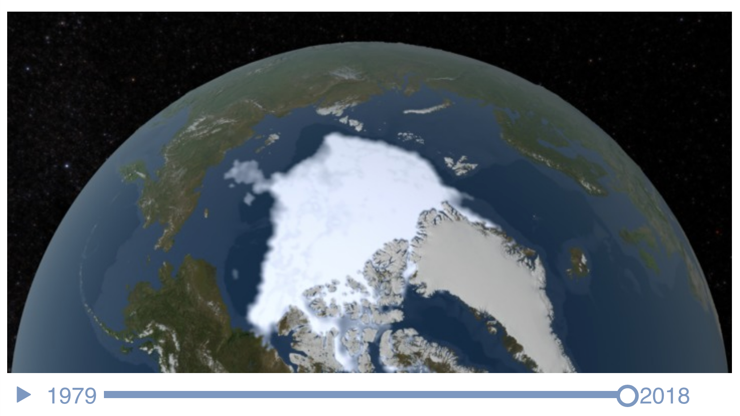
Arctic Ice Sheet History Q 11, 12 , 13
Only the Bright White is Sea Ice - the adjacent dull white are Greenland and Northern Canada

(Note - just a rough approximation is requested and the “Right Answer is not important”
The concept is to realize that if the area is less and the thickness is also less the volume is WAY LESS

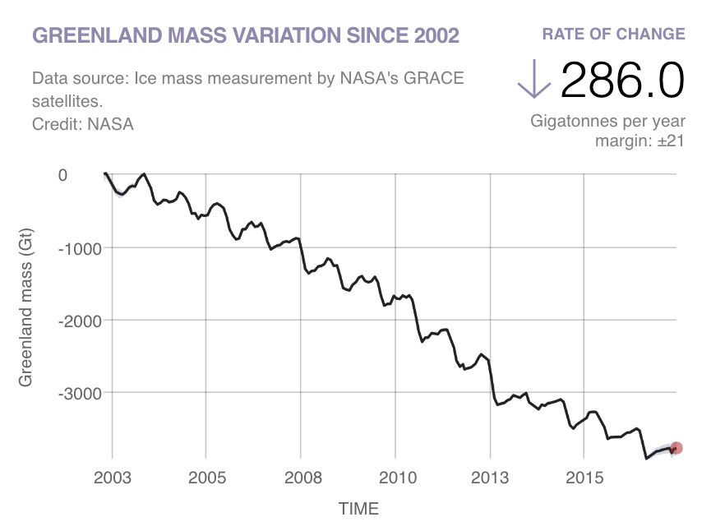

In comparing the ice loss graphs for Greenland and Antarctica students will hopefully realize that the scales are different
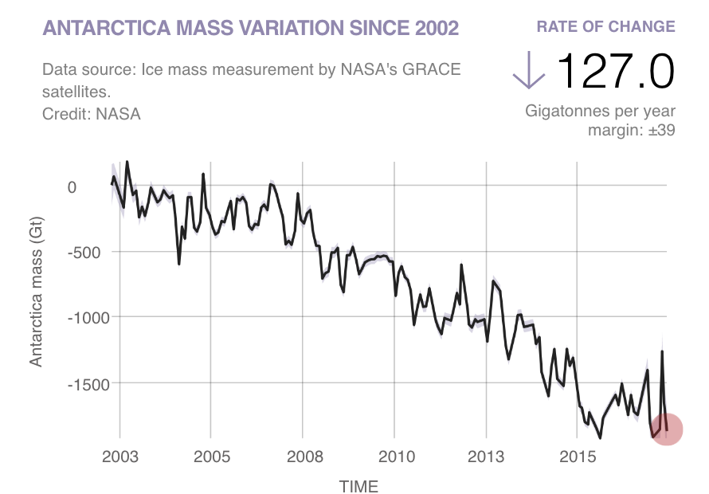
Q 14, 15, 16

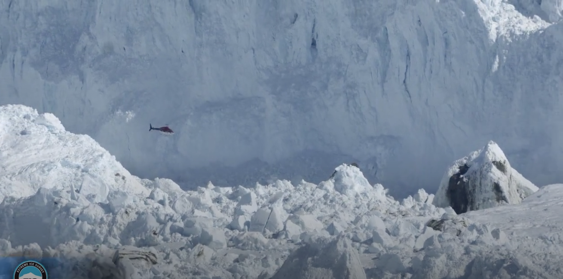
The video from the llulissat glacier (Q23) STUNNING!

I like play this for the whole class and point out the helicopter before the camera zooms out the helicopter disappears. This helps to show the immense scale of what is happening.
Could save this for the Evaluate Questions

Ice and Water
The main point of the water/ice part is to show that when ice from a glacier moves down into the ocean it immediately raises the sea level - it does not need to melt - and will not raise sea level any more when it does melt.
Recent data shows that the downhill movement of ice, enabled by gravity and lubrication from just a little melt water, is the most serious cause of sea level rise. It could not be predicted until scientists had observed and collected data.
You can explain this to the students and compare it to a boardwalk log ride - frozen solid or with a little water underneath.

Elaborate and Evaluate
Students can discuss with each other and ask the teacher questions as they work on these answers. You might want to replay the Illuissat Glacier video as you review this.

PLEASE plan to follow this lesson with additional lessons on Solutions.

Prepared by Pauline Seales paulineseales120@gmail.com
All questions and constructive suggestions are welcomed More resources at scruzclimspeakers.pbworks.com

