Ice/Water Activity

Beaker A Arctic

Add water and
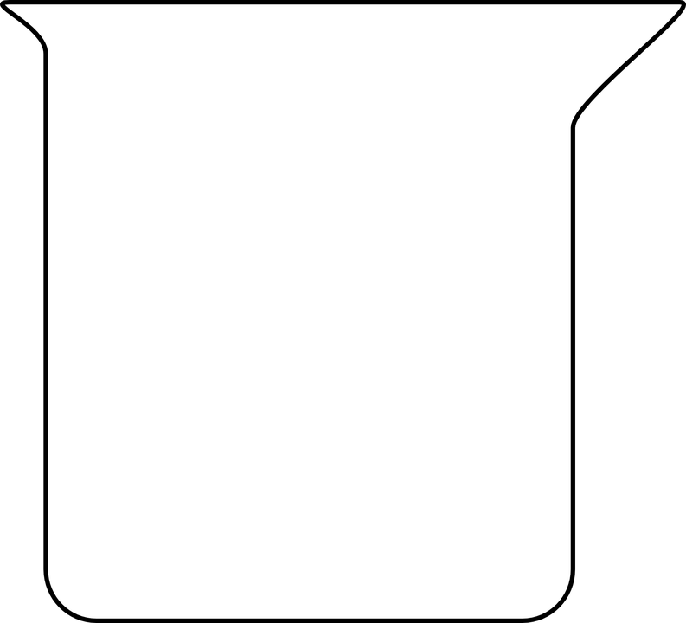
3 large ice cubes

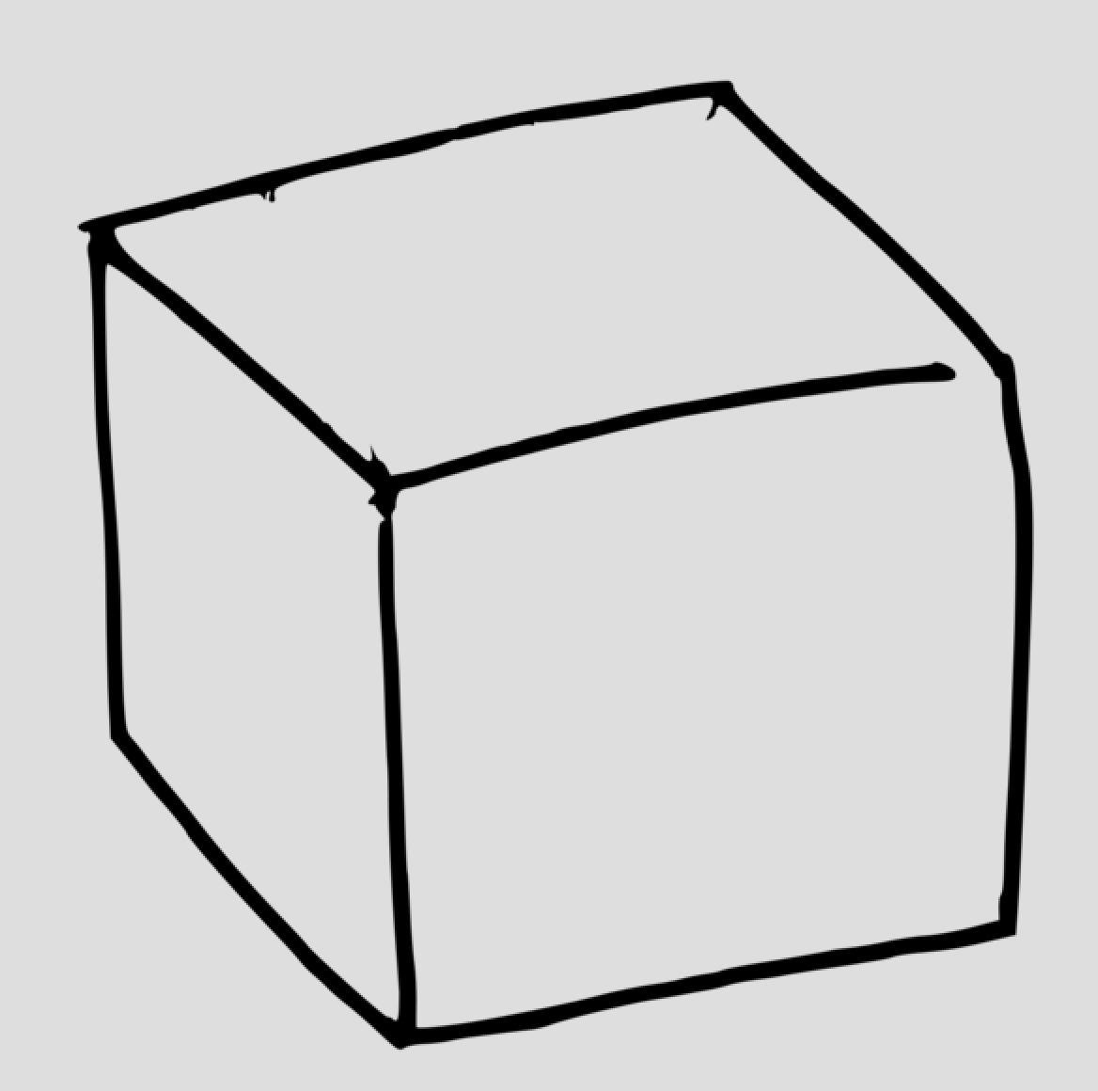

Mark water level

Mark FINAL WATER Level

per group - 2 clear containers for water and ice,
2 smaller ones to hold ice
6 BIG ice cubes or equivalent
adjust for smaller ice
Tape
Water

Ice/Water Activity

Beaker G
Greenland/Glaciers
Start with just water

Mark water level
add one Ice cube

20 mins later
add one Ice cube

20 mins later
add one Ice cube

Mark FINAL WATER Level

