Carbon - Teacher Guide for student WS CarbCaf

Using resources from Carbon Cafe Activity - Cal Academy of Science presented at CSTA San Jose Nov 2019
and https://calacademy.org/educators/lesson-plans/how-much-water-do-you-eat

NOTE this is a Climate Solutions Activity - after covering some basic science
see https://scruzclimate.org/k-12-lesson-plans/

Guiding Questions
1. How does our diet affect the atmosphere?
2. How can we make improvements?
NGSS
Disciplinary Core Ideas : MS - ESS3-D Global Climate Change
(Connections to ESS 3-C Human Impacts, ESS2-D Weather & Climate)
MS - PS1.A Structure and Properties of Matter
MS - LS2.B Cycle of Matter and Energy Transfer in Ecosystems
Science and Engineering Practices - 1, 3, 4, 5 ,6 ,7 ,8
Crosscutting Concepts - 1, 2, 3, 4, 5,7
5E’s see below
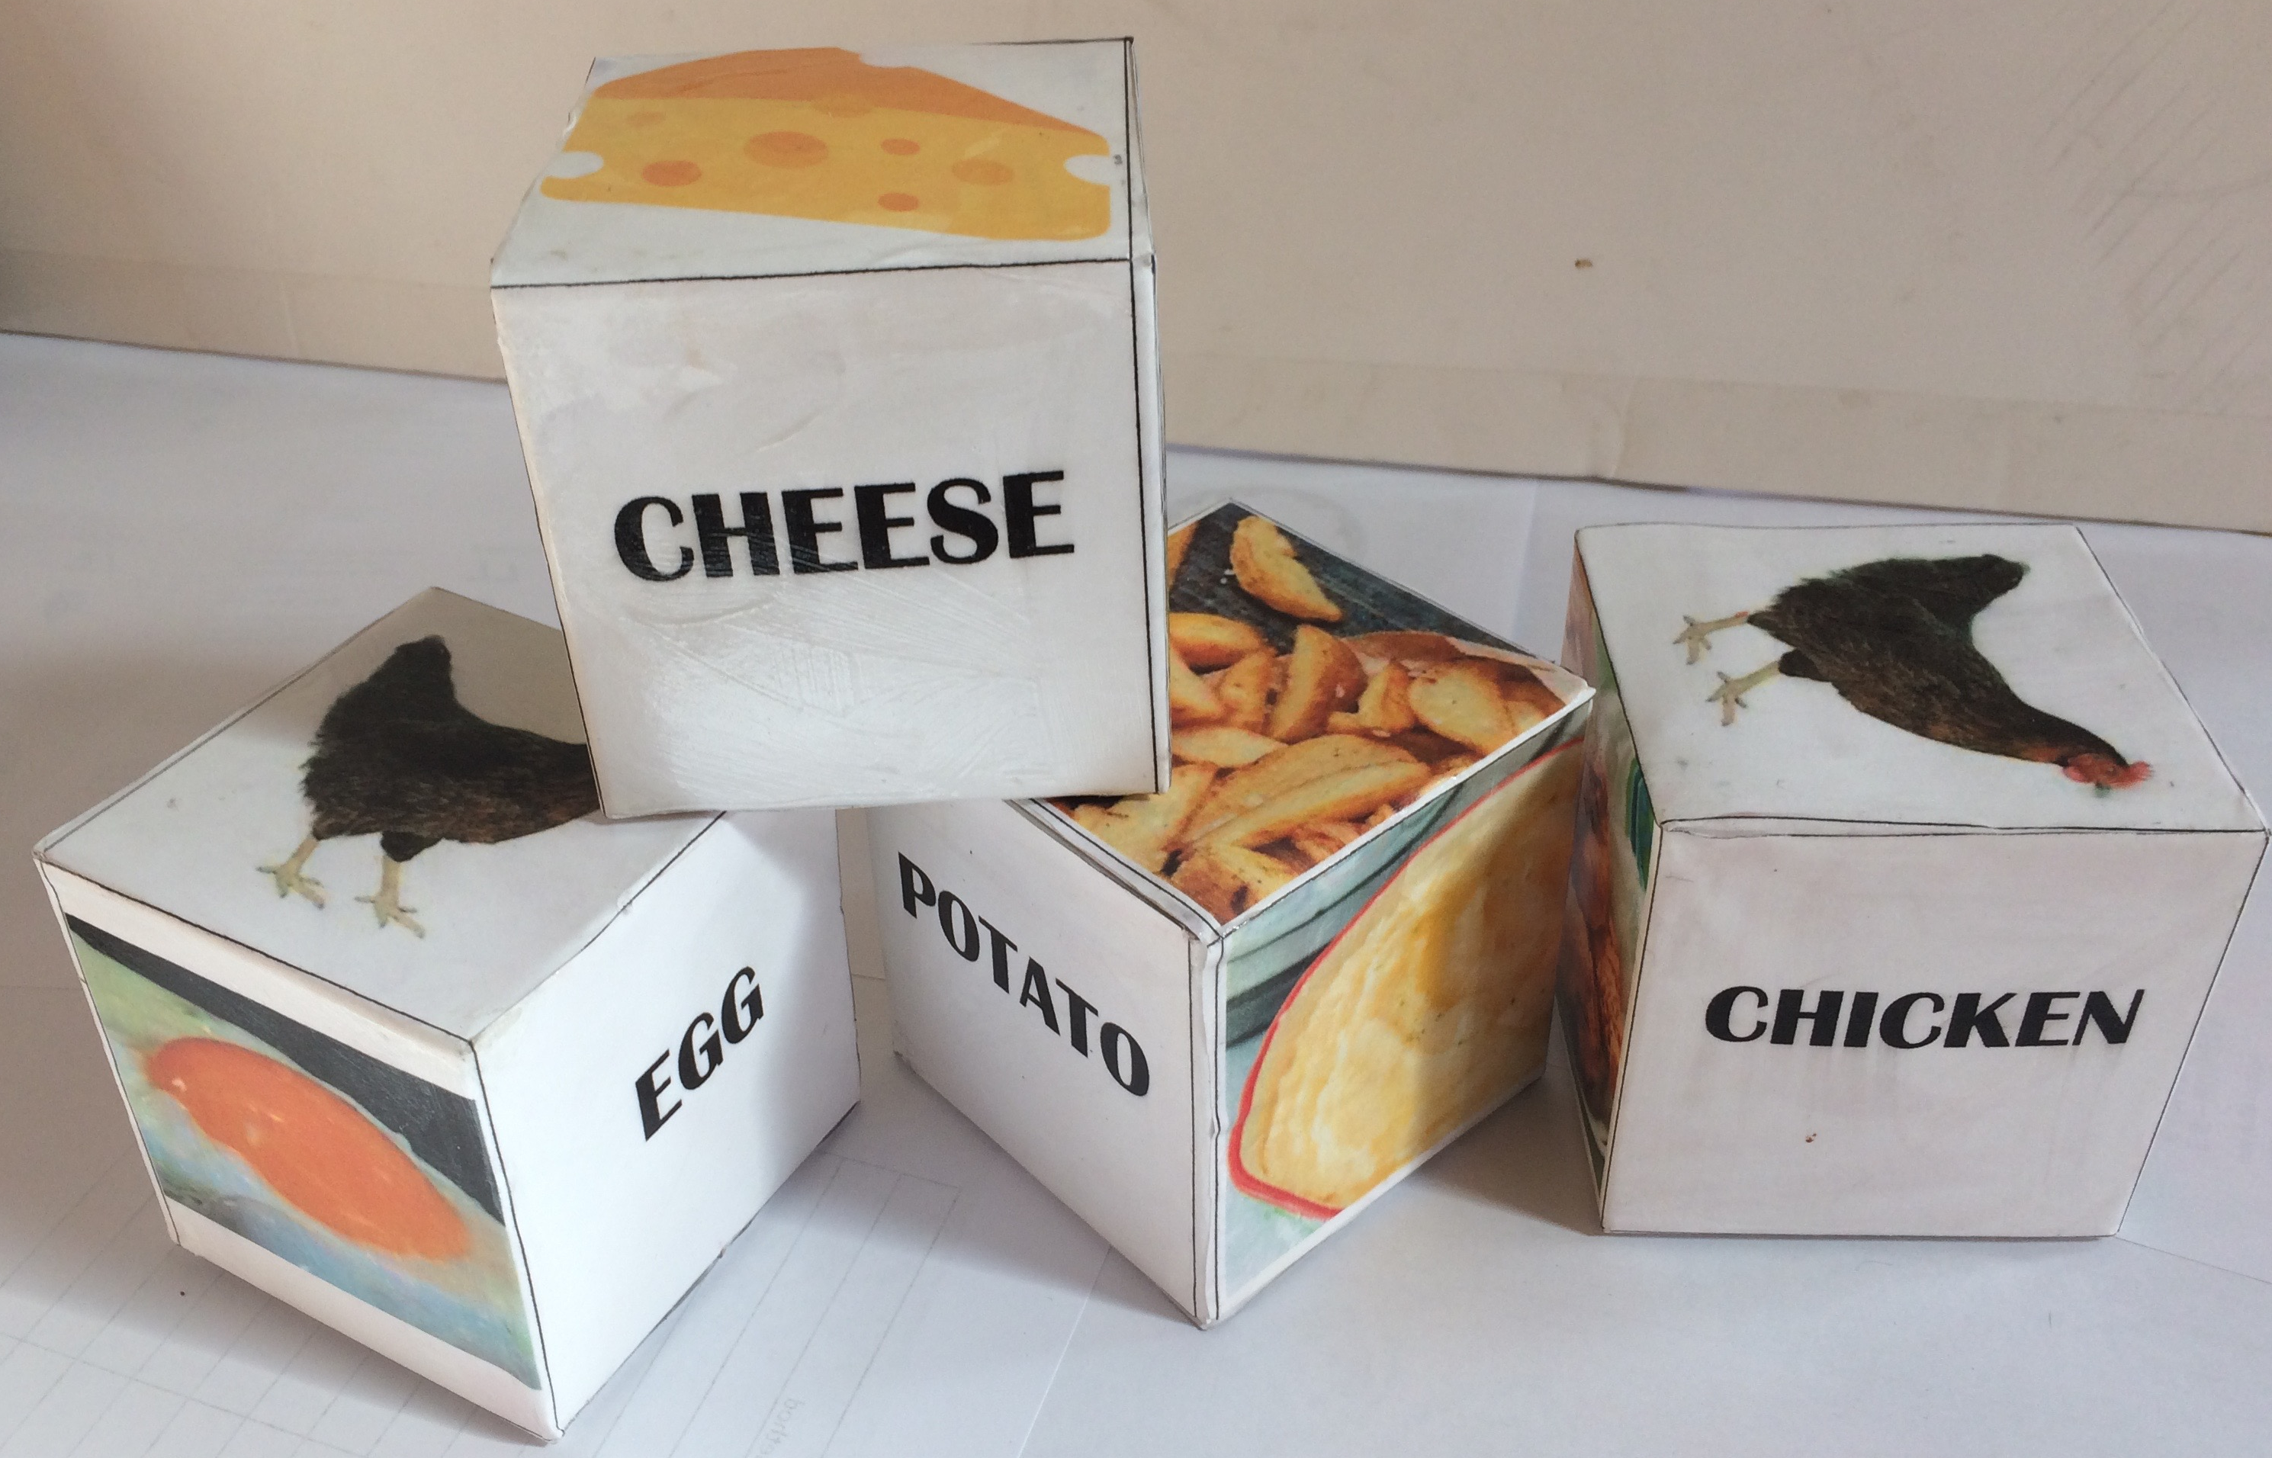
Engage/Explore Food Weight
The food weight activity will really engage the students. Actually holding the different cubes is much more real than just looking at numbers. Start by asking a student to come pick up spinach and beef. Then have someone pick-up beans and cheese. They will be amazed and the rest of the class will be interested.
The class activity can be organized differently depending on how many scales are available. The BEEF, Cheese and pork might be TOO HEAVY for some scales so check the limits first. Pork ~ 600g, Cheese~830g, Beef ~2000g
- a home cooking scale might work for these.
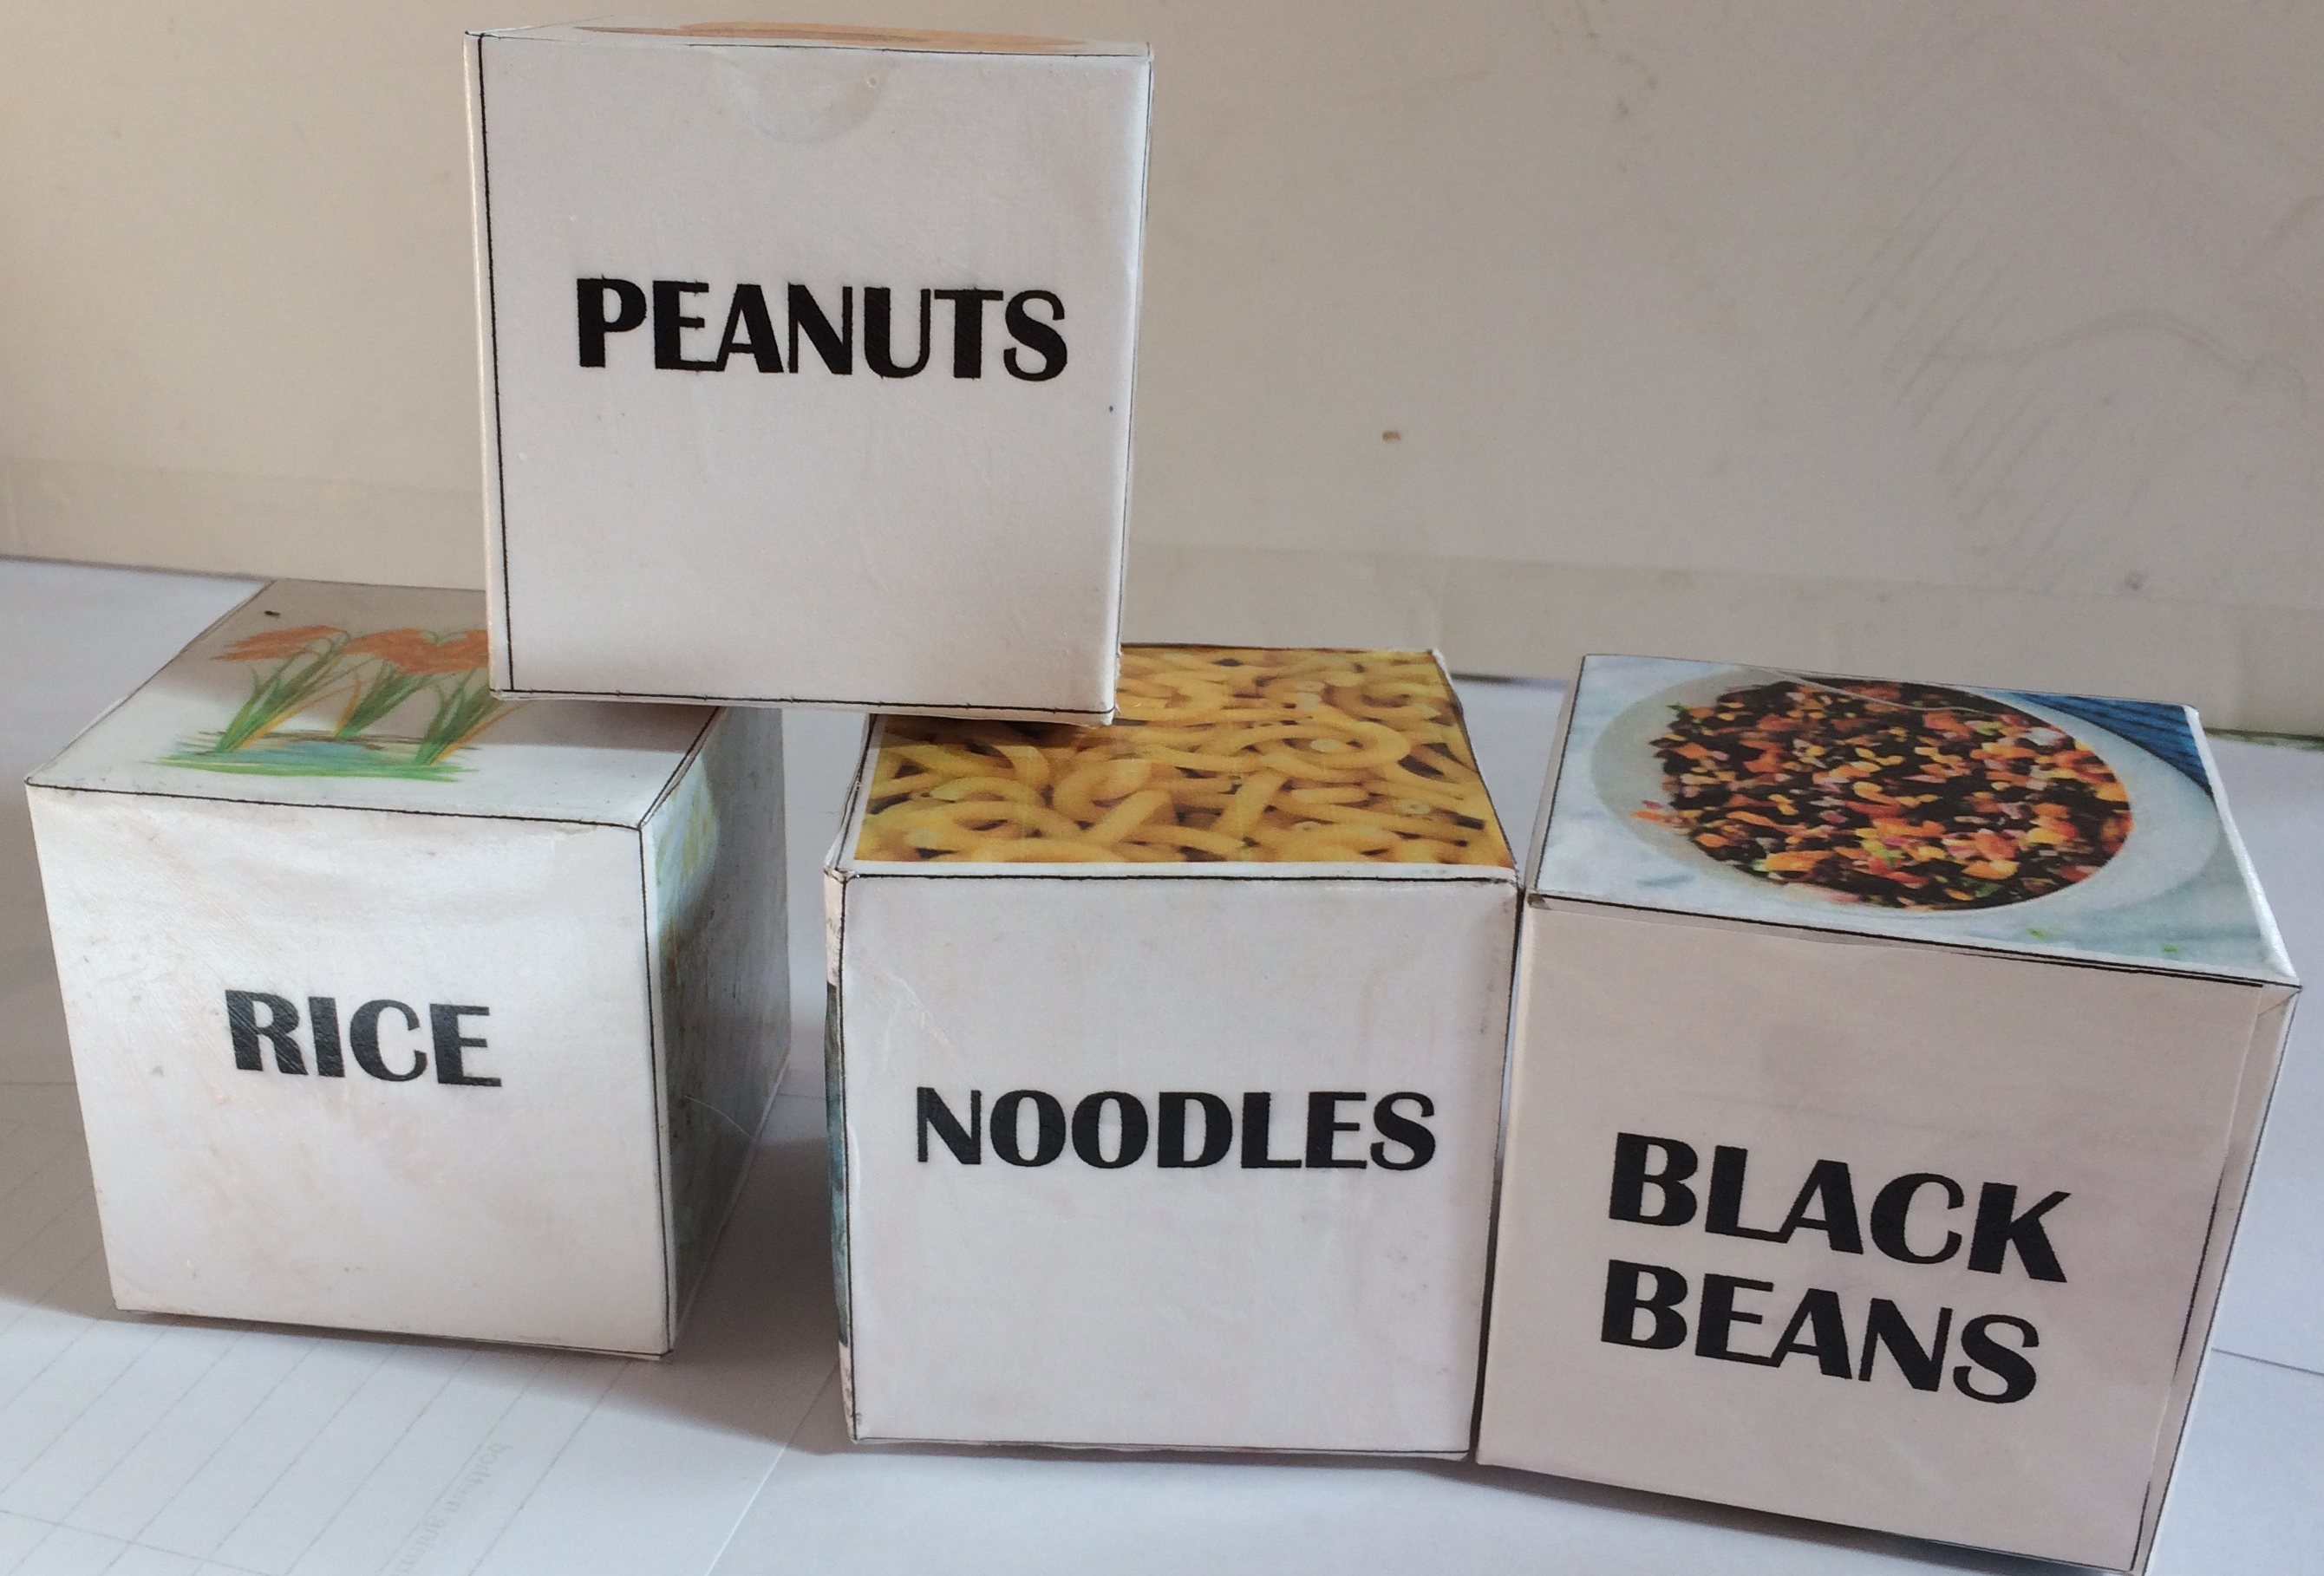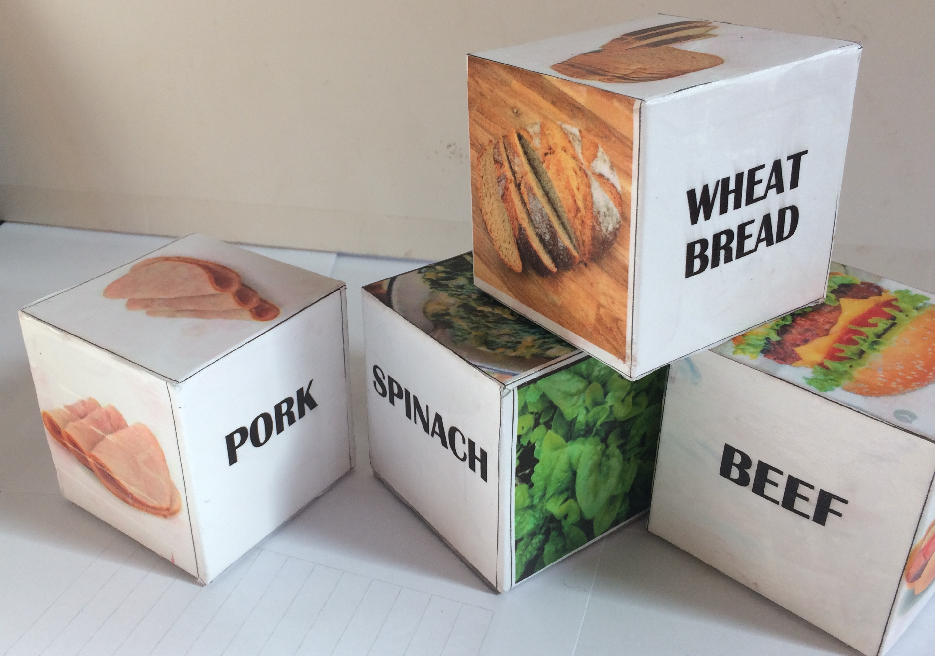

WITH JUST ONE SCALE
Each group of 3 students will designate one person to select a Food Cube and weigh it at the front. They enter the data into the teachers’ computer and bring the cube back to their table - after Everyone has felt the weight pass it to the next table.
If you have enough scales for each group to get one you can give each group a set of cubes. They weigh them,
Everyone gets to hold each one and then they pass the cubes to the next group.

Evaluate - Study your Weight Data - help students if necessary

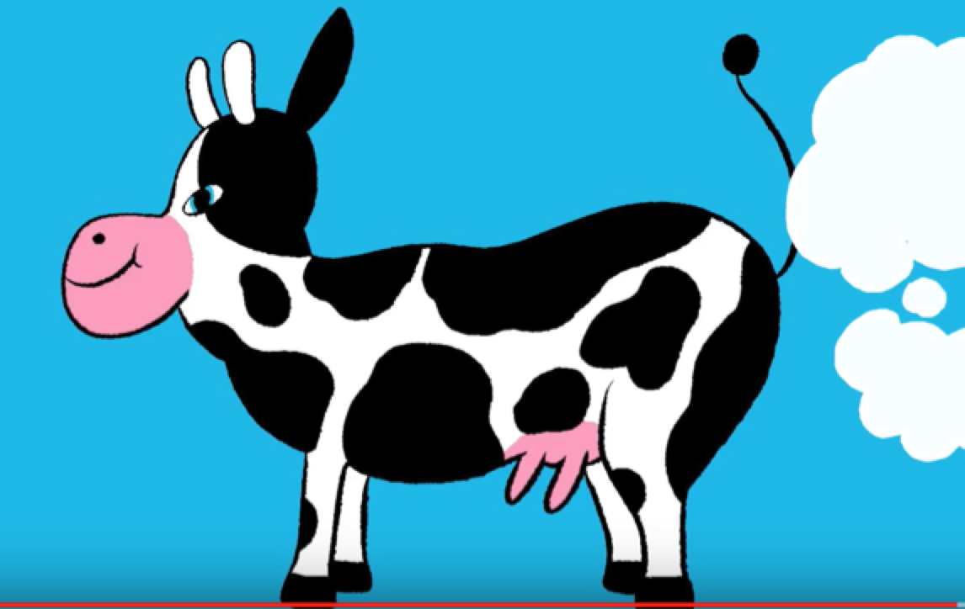
Engage / Explain - Movie - Eat Less Meat (1:30)
https://www.youtube.com/watch?v=uh-tECeaMCA
One way to do this might be to play it straight through and THEN go over the vocabulary terms, and then play if again with lots of pauses so they can answer the questions. Don’t be afraid to talk about the fact that cow burps are just a bad as cow farts. Using these terms will help them remember the lesson.

Explore Water Usage
https://www.watercalculator.org/water-use/foods-big-water-footprint/
This uses both a website and a set of cards (there is also water usage data on the website but it does not cover all the food in the cubes - the set of cards covers that well)
If they have difficulty finding the answers on the website you can lead them using the projector and discuss the answers with them.

Explain/Elaborate/Evaluate Review Chart
Q1. Discuss how the spinach only needs sunlight, water and CO₂ from the air, whereas any animal product involves growing stuff for the animals to eat and only a small fraction ends up as meat. There is also more water, land, transportation etc. involved in raising animals.
Give them time to discuss question 4 with their group. This is perhaps the MOST important part of the whole lesson.
You can go back to the food cubes and get someone to hold Beef and Chicken
Listen to their responses and ensure them that even small steps will help - big changes take more time.
Notes
1. Water Cards
The Ac of Sci ones were not formatted for back-back copying so I made my own from theirs. I can send you the files.
2. Making Cubes
Would love to make and share more sets. The boxes are cheap and I have the files for the covers. The expensive part is the LEAD weights for the meats/cheese. Contact me if you’re interested in making a set. paulineseales120@gmail.com

