Climate Lessons Our Changing Atmosphere Name ____________

In this lesson students use data from the Keeling Mauna Loa Lab to graph and analyze 18 years of CO₂ data, and learn about the role of photosynthesis in Climate Solutions.

Vocab: Atmosphere, Carbon Dioxide, photosynthesis, biosphere, Greenhouse gas (aka GHG)

Materials:
Intro - Globe - point out location of Mauna Loa. Piece of charcoal to discuss Carbon & Carbon Dioxide
Part 1: students in pairs - special graph paper, pencils, data tables
for the class - Masking tape, markers

Intro Discussion
Does anyone know where Mauna Loa is?
Everyone take a deep breath - then slowly breathe out
What was in the IN breath? _______________________ ____________________
What else was in the OUT breath? _______________ _________________
What do plants take in from the air? _______________________________
Write the chemical symbol for carbon dioxide

Engage - Graph the Data Teacher will pass out the data charts & graph paper and explain how to set it up.
Data chart Your Year __________, Graph range _________ to ___________
Graph the data for your year - use a pencil and check carefully - you can work in pairs and take turns to add a point
Have the teacher check your graph and then use a marker to draw a smooth line.

Looking at your own graph
1. What do you notice?

2. What do you wonder?

Analyze your data
3. Which month had the highest CO₂? _______________ the lowest CO₂? _____________
4. Was the 2nd December higher or lower than the previous one __________________ by how much? ________
Class Sharing
1. Which months were the highest most years? _____________________ the lowest? _________________
2. Did any year have a decrease December - December? _______________
Now take your graph to the teacher who will tape one year to the next and paste them on the wall.
3. What do you notice now? ______________________________________________________________________________________________

Nasa CO₂ Video https://www.youtube.com/watch?v=x1SgmFa0r04 3:10mins
1. This video is for which year? ___________ It starts in __________________________
2. Which colors indicate low CO₂ ______________________ high CO₂? _______________________
3. Carbon dioxide is a _____________ _____________________ gas , which means it traps ___________________
4. Does the CO₂ stay where it starts? __________________ Explain ________________________________
5. During spring and summer a lot of CO₂ is _____________________________________________________
6. By fall what happens? _________________________________________________________________

The Soil Story by Kiss The Ground https://youtu.be/UvRlIf3ccVA
1. Everything alive is made of _________________
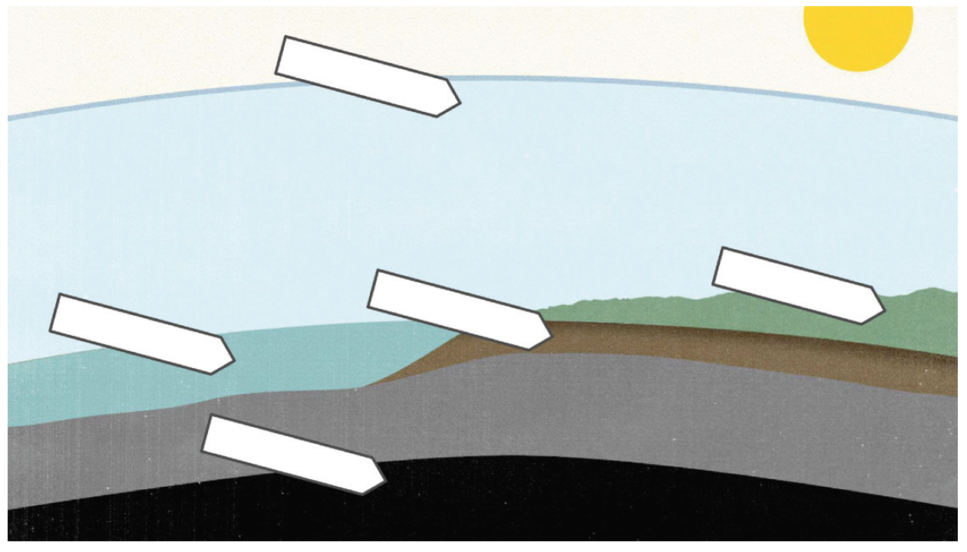
2. On your diagram label the five areas

3. For millions of years the carbon was in balance until _______________________ started taking it out of the ground
4. The way people farm is also putting carbon (CO₂) into the __________________
5. Excess carbon is also being absorbed by the _______________ causing ________________ ______________________
6. We need to stop using _____________ ____________ _____________________ - ________ aka ______________ __________
7. Plants use _______________________ & _______________________ & __________________________
for _________________________________ which makes ________________________
8. Some carbon is stored in the _____________________
9. A thin layer of _______________________ helps keep more carbon in the ___________________________
10. Other good farming practices include (name one) ______________________________________
11. Healthy soil also keeps more _____________ in the soil.
Follow-up
1. Add arrows to your diagram to show these - just use arrows and the numbers
Land - A. Animals exhale CO₂ P. Plants take in CO₂
Ocean- O1. Ocean absorb CO₂ O2. CO₂ evaporates from the Ocean
2. Draw in an oil well to show human extraction - write in lots of CO₂ symbols in the air
Summary
Write a sentence or two to explain the class graphs
1. Why is the overall graph going up?

2. Why does the CO₂ come down between May and November?

3. Write one idea for cutting down our CO₂ emissions (more on this in later lessons)

