Our Changing Atmosphere - Teacher Guide for student WS ChangAtmo
additional files keelgraph, MaunaLoa.xls

Based on an Exploratorium Activity: https://www.exploratorium.edu/snacks/our-changing-atmosphere
And “The Soil Story” curriculum by Life Lab https://kisstheground.com/soil_story_curriculum/

In this lesson students use a data from the Keeling Mauna Loa Lab to graph and analyze 18 years worth of CO₂ data. They then learn more about CO₂ distribution and the overall carbon cycle.
After the two videos and the questions they will realize what an important role photosynthesis plays.

NOTE this could also be used in a Math Class

Guiding Questions
1. How is the atmosphere changing?
2. What is the meaning of the patterns in these changes?
3. How can understanding this pattern help us understand possible solutions to the problem
NGSS
Disciplinary Core Ideas : MS - ESS3-D Global Climate Change
(Connections to ESS 3-C Human Impacts, ESS2-D Weather & Climate)
MS - PS1.A Structure and Properties of Matter
Science and Engineering Practices - 1, 3, 4, 5, 8
Crosscutting Concepts - 1, 2, 3, 4, 5,7
5E’s see below
Vocab: Atmosphere, Carbon Dioxide, photosynthesis, biosphere, Greenhouse gas
Materials:
Intro - Globe - point out location of Mauna Loa, Piece of charcoal
Part 1: students in pairs - graph paper, pencils, data tables
for the class - clear tape, masking tape, markers
Intro - Engage
Does anyone know where Mauna Loa is?
Everyone take a deep breath - then slowly breathe out
What was in the IN breath? What else was in the OUT breath?
What do plants take in from the air?
What is Carbon? show lump of charcoal - Talk about how CO₂ is an invisible gas - show the symbol
Explain that when we talk about
“Carbon in the Soil” we don’t mean lumps of charcoal but carbon compounds - anything organic is a carbon compound
Graph the Data - Explore
Teacher Print the file MaunaLoa.xls , 6 years /sheet 18 years total. Cut into sections for each year
Depending on the student experience with decimals have them all draw a line on a piece of scratch paper
Carefully mark the mid point Label one end 390 the other 391
Get them to practice 390.5 390.7 390.1 etc.
Say “Don’t be afraid to ask for help”
Set up Graph - Demonstrate on Document viewer
Use file Keelgraph for the graph (info in the header/footer)
Students need to label
bottom (Horiz) - x axis - Month 1-12 - add (12) to the bottom of the y axis - for the previous year
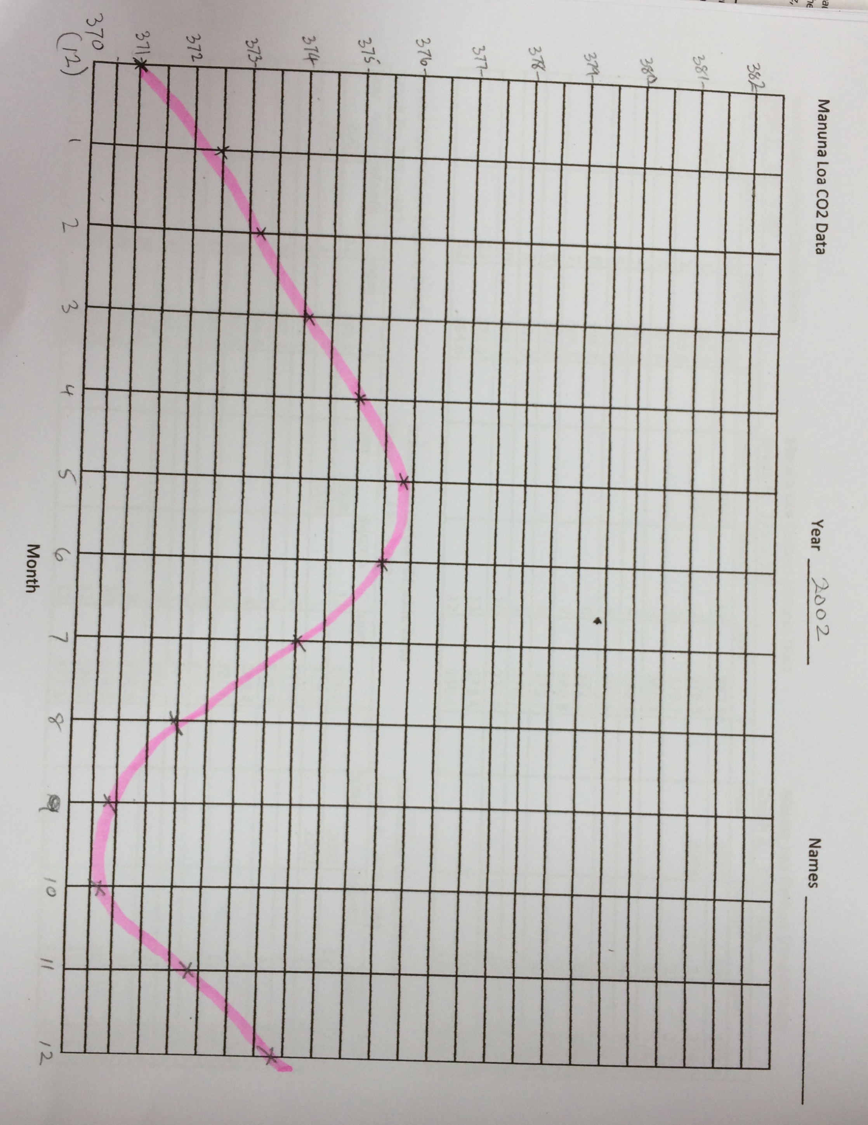
Vertical - Y axis - LOOK CAREFULLY AT YOUR DATA TABLE
Find example “Graph F 400 -> 412” or similar for your data
put the lowest number at the bottom of the y axis (400) and up count 2 squares add one
and write # (401)
You should be ending with the highest number listed
Teacher will quickly check your axes
LABEL y axis CO₂ ppm
- explain that ppm is PARTS PER MILLION

Students Graph the data for year - use a pencil and check carefully - TEACHER will check
Then they use a marker to draw a smooth line - sample 2002
Graph questions - see student sheet - Evaluate
Joining the graphs - cut the right edges and trim the left edges a little to make it easy to match adjacent graphs.
After 3 or 2 graphs you’ll need to offset the next set to make the CO₂ ppms match - point this out to the kids as you get them to help.
Videos Engage/Explain
Nasa CO2 Video https://www.youtube.com/watch?v=x1SgmFa0r04
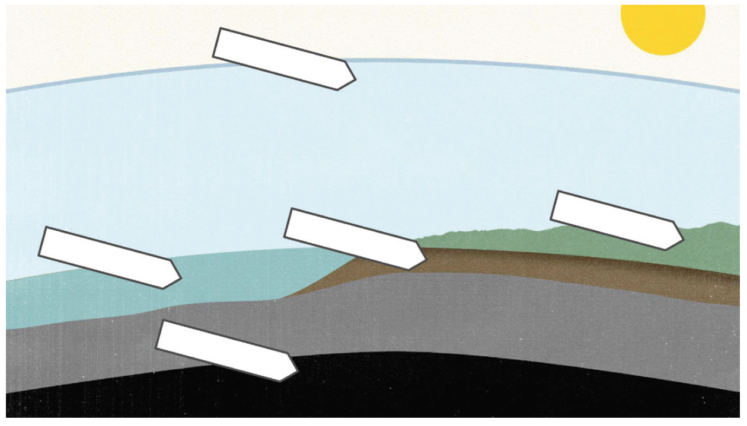
Pause this as needed or help with answers
The Soil Story by Kiss The Ground https://youtu.be/UvRlIf3ccVA
Suggest playing this through once - Say “don’t try to answer this first time”, and then play it again with enough pauses.

Follow-Up - by just using letters to label the parts of the graphic they won’t have to struggle trying to write small enough for the boxes.

Summary Elaborate/Evaluate
Allow enough time for class discussion of this. Move to the next lesson if necessary.

Extensions
The entire Soil Story curriculum is available for free at https://kisstheground.com/soil_story_curriculum/
It is excellent curriculum designed for 5th grade. We used just a small part in this lesson.

The movie set in Santa Cruz county “The Dirt on Climate Change” is another follow-up. https://vimeo.com/265117298

