Climate Lessons Coral - Teacher Guide for student WS Coral

Based on a California Academy of Science demo at 2019 CTSA event:
https://www.calacademy.org/educators/lesson-plans/coral-bleaching-talking-about-climate-change-sustainable-solutions

Materials
Coral - faux coral is the cheapest - I got mine from Richardsseashells.com
Resin/Faux (Small) White Coral Cluster (EA) Price: $4.95 each

Thermo-chromic paint on line from Xalica (Amazon) 20g of Thermochromic Temperature Activated Pigment Powder
- Heat Sensitive Color Changing Powder for Slime, Paint, Resin, Epoxy, Nail Polish, Ink,
White primer paint used as the base
The coral and a class set of wood pieces painted with the paint.
For the experiment you’ll need plenty of hot water. Suggest telling the students they only get 200mls each or lose points
In the Monterey Bay area you can borrow all this from paulineseales120@gmail.com

Guiding Questions
1. What is causing Coral Bleaching? What is Ocean Acidification?
2. How can we reduce the problems ?

NGSS
Disciplinary Core Ideas : MS - ESS3-D Global Climate Change
(Connections to ESS 3-C Human Impacts, ESS2-D Weather & Climate)
MS - PS1.A Structure and Properties of Matter
Science and Engineering Practices - 1, 3, 4, 5, 7, 8
Crosscutting Concepts - 1, 2, 3, 4, 5,7
5E’s see below

Vocab: Atmosphere, Carbon Dioxide, photosynthesis, biosphere, Greenhouse gas, Fossil Fuels, Carbon sink
Ions, Acidification
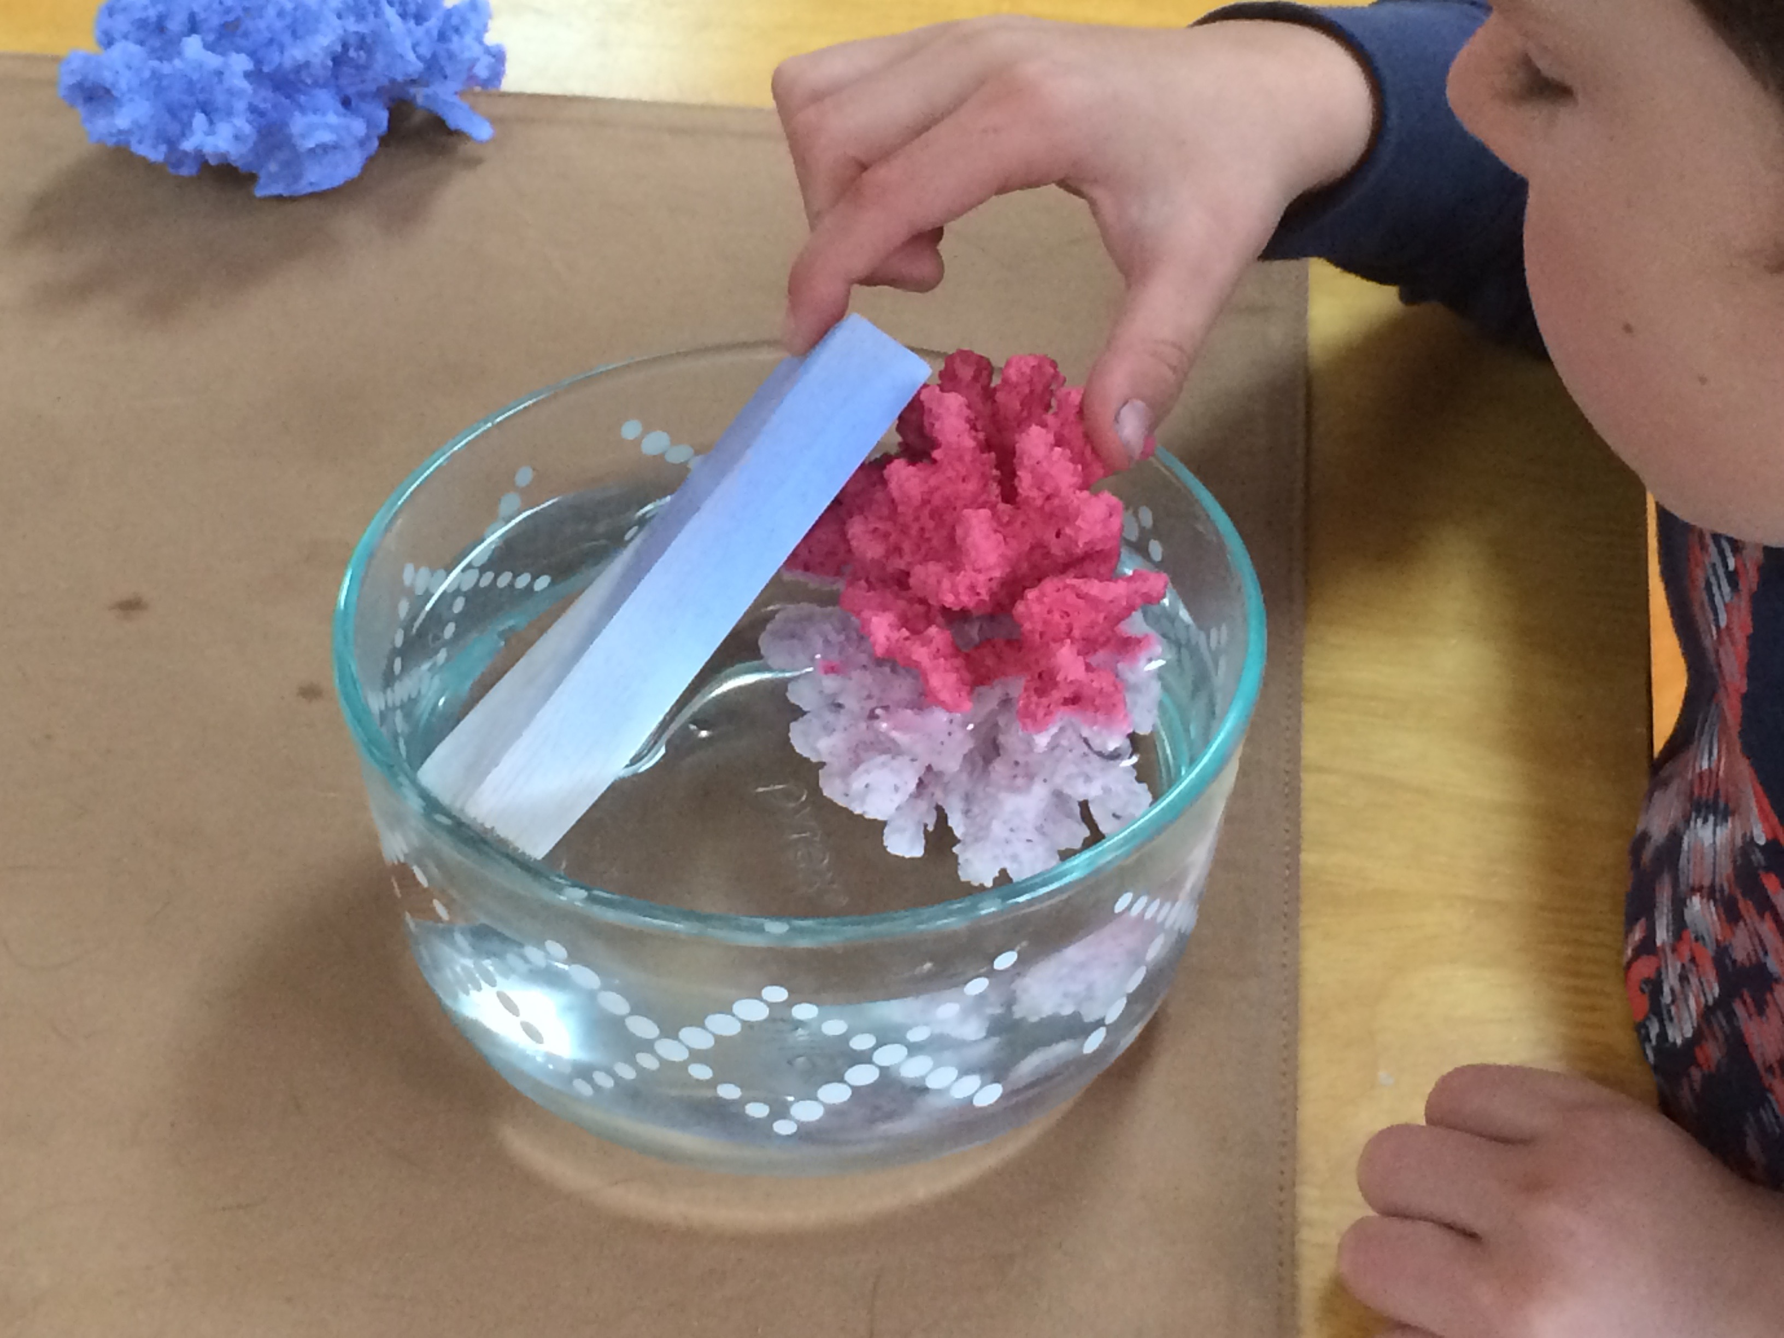
Intro - Engage
In this lesson students will be motivated by a fascinating demo. They will set up their own simple experiment to find out more.
Start with the coral in a glass bowl of cold water. Briefly discuss coral biology:
a colony of live creatures - what makes the pretty colors - (details of all this will come later in the video)
Have another glass bowl of HOT water (about 100degF or 40C) but don’t let the kids know it’s hot.
Ask a volunteer to move the coral to the other bowl. They will see it turn white as it goes in. Ask another student to return it to the cold water. Have a student put one finger in each bowl and tell the class what they felt.

Video 1 - Coral Bleaching - Engage
https://www.youtube.com/watch?v=iW8nCALx5iA (2:41)
Play the Youtube at 75% speed - maybe play it through once with pencils down and then go back with pauses to give them time to write answers.
Explore/Evaluate
Tell them you made this the coral models with special paint.
Ask “what do you wonder?” or prompt “how warm does the water need to be?”
Now show them the wood painted with the same paint and ask them to plan an experiment to find out what temperature it changes at.
Explain that UNLIMITED Hot water will not be available. Suggest 200 mls each group to start with. Extra possible with loss of points for the project.
They need to outline their plan on a sheet of binder paper and all sign their agreement to it, before bringing it to you for approval and materials. This will preclude Mary saying - “well I didn’t want to do it that way - so I should get more points than the rest of my group”
Don’t give unlimited time and encourage repetition and going down and up. (some more hot water allowed for that.)

Collect their data by coral color - board or computer visible to all. (there were 2 different dyes red and blue - supposedly the same temperature sensitivity and the purple is just a mixture. But let the students figure this out based on their data.

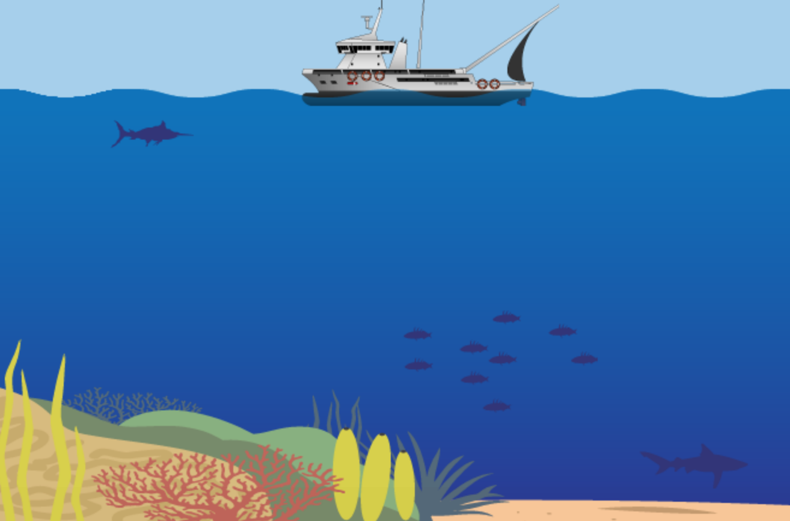
Engage/Explore 2 Computer Activity

climatekids.nasa.gov Games,
Coral Bleaching

Make sure the students start by reading the
HOW TO PLAY first and answering Qs 1,2,
Discuss how the activity is set up to look at one variable at a time and why this is important.
Evaluate/Explain
Discuss their results and conclusions

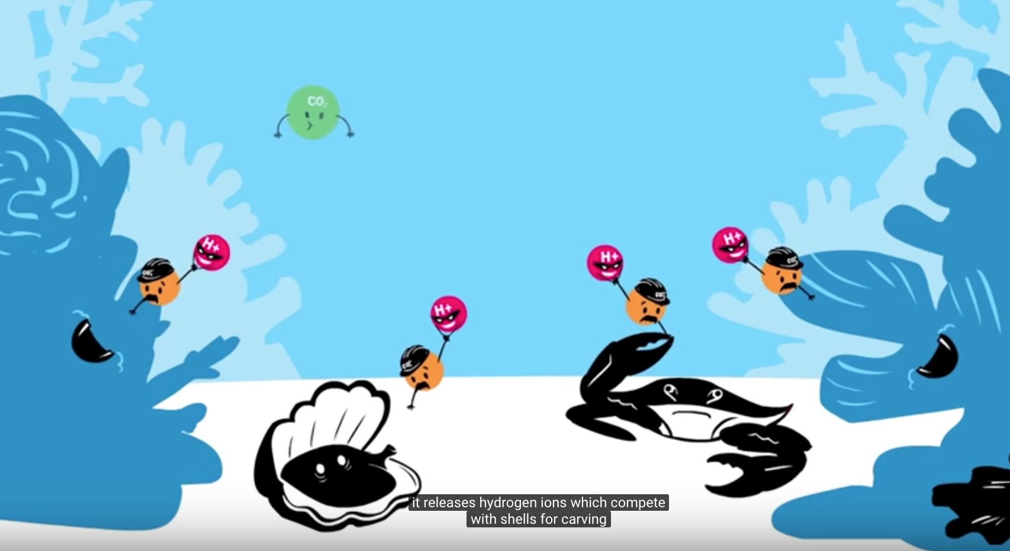
Engage/Explore 3 Ocean Acidification
https://www.youtube.com/watch?v=Wo-bHt1bOsw
(3:01)
Briefly review vocab first.
Play the Youtube at 75% speed - maybe play it through once with pencils down and then go back with pauses to give them time to write answers.

Conclusion Elaborate/Evaluate
Allow enough time for class discussion of this. Have it moved to the next lesson of necessary.

Additional Resources
https://oceans.taraexpeditions.org/en/rp/activites-educatives-blanchissement-du-corail/

climatekids.nasa.gov At the top click on Water then What is Ocean Acidification?

