Teacher Guide for EN Roads Climate Simulator Activity
- Developed by Pauline Seales email paulineseales120@gmail.com

Guiding question Can humans make changes to drastically reduce climate change?

Lesson Type Suitable for remote learning OR classroom learning

Content standards MS/HS ESS2.D Weather and Climate,
ESS3.C Human impacts on Earth Systems ESS3.D Global Climate Change with connections to LS4.C Adaptation
Cross Cutting Concepts 1-5,7
Science and Engineering Practices 1-8

Materials All students need internet access and a paper or online worksheet

Preparation
Students should already have learned the basics of Climate Change before starting this solutions activity. We have a variety of ways activities for this.

Vocabulary Simulation A computer model
Greenhouse Gases Gases which act like a blanket around the earth
Sliders Computer controls which allow you to change something
Renewables Energy which is not “used up” ex. Wind or solar
Afforestation Planting more trees
Electrification Using clean electricity instead of oil, coal, gasoline or
natural gas
Methane Powerful heat trapping gas emitted by cows
Efficiency changing to equipment which wastes less energy

Students will be able to Discuss the relative effects of a variety of climate solutions strategies

Social & Emotional Learning Support All discussions to include feelings and concerns

Instructions for teachers EnRoads is a wonderful climate simulation software which can be used in a variety of ways. To use remotely, zoom breakout rooms will be helpful with approx. 4 students per group. This will allow the extremely important discussion to take place.
NOTE - the writer of this lesson is available to help on zoom as a co-host.

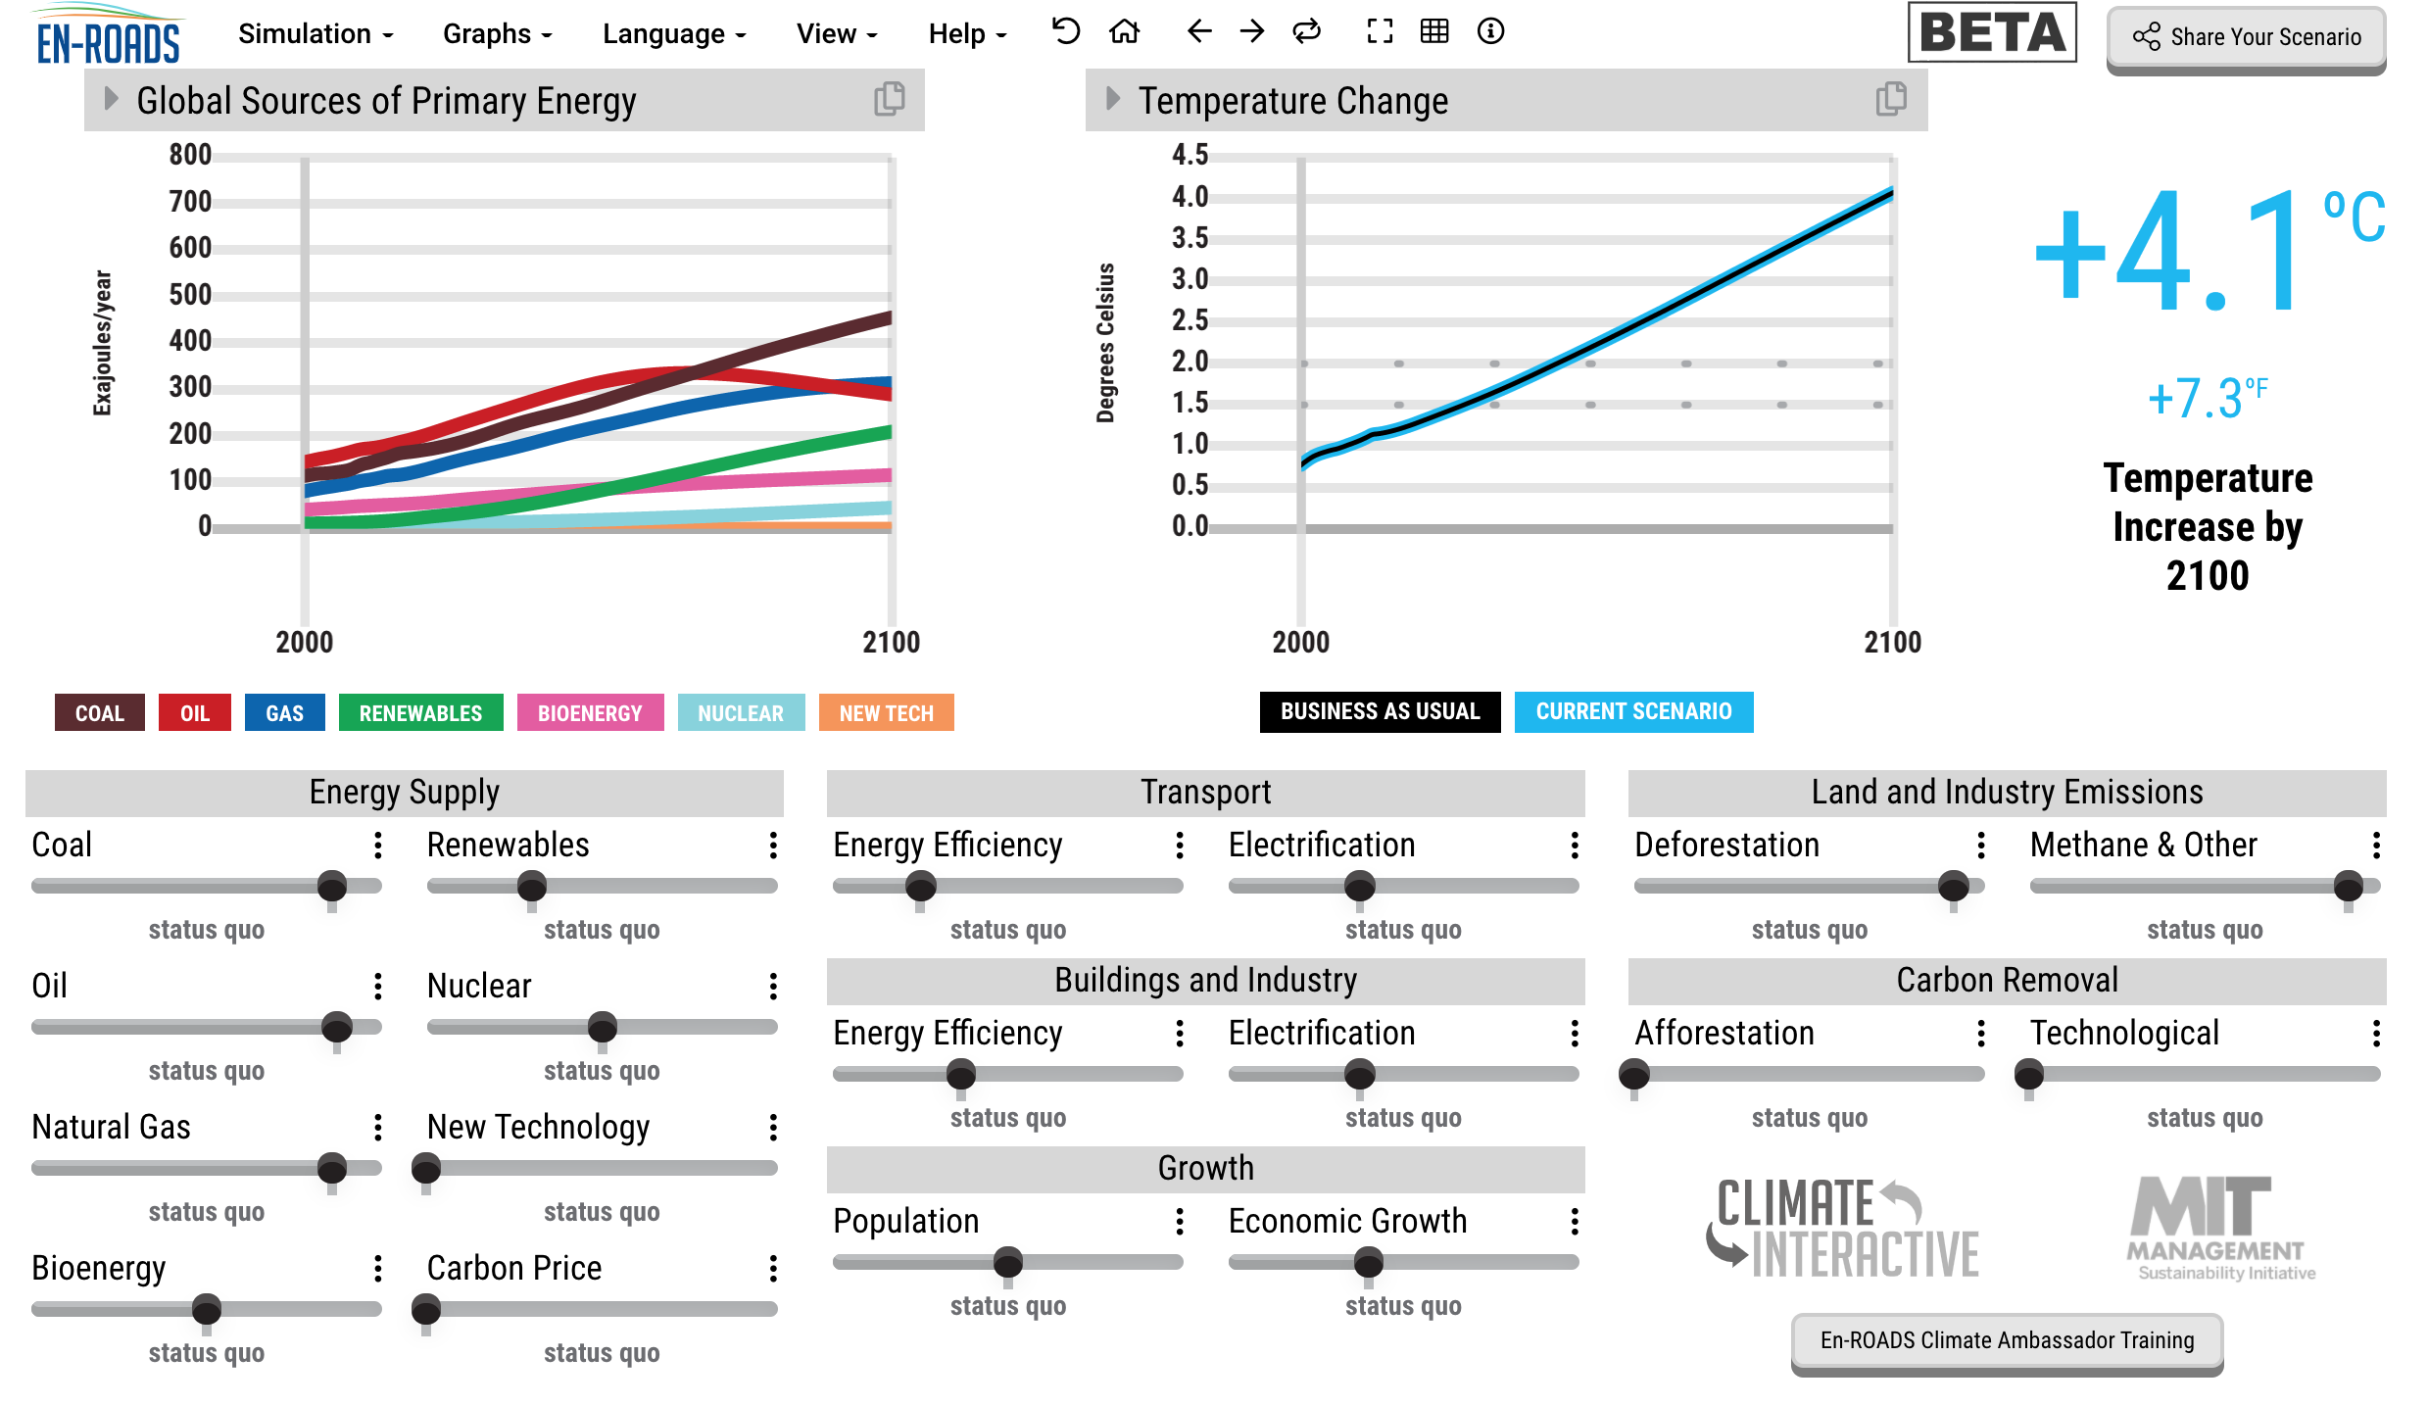
Student work sheet ENRdsLes

Part 1. Engage
Start by introducing the SW to the
entire class and engaging them.
Show the Control Panel Graphics and make
sure they understand the terms.
(In a live classroom hand out laminated
copies to each pair of students)

Part 2. Explore Explain with an example
Demonstrate how to change the right hand graph to GHG net emissions and then start the breakout rooms.
At the end of this part they need to type the sliders they used into the chat.
Back with the whole group you will display the results of ALL the sliders they used so far.
Ask which solution they found to be the most powerful so far.
(Note if no-one chose “CarbonPrice” demonstrate this and have them add it for themselves)

Part 3. Have them all match their screens to yours and then have them use the “Afforestation” and “Technological “ sliders and describe the results on their paper. Be sure to point out that the green area below the x axis of the graph represents carbon removal by growing things.
Below is just a possible example of a final screen.

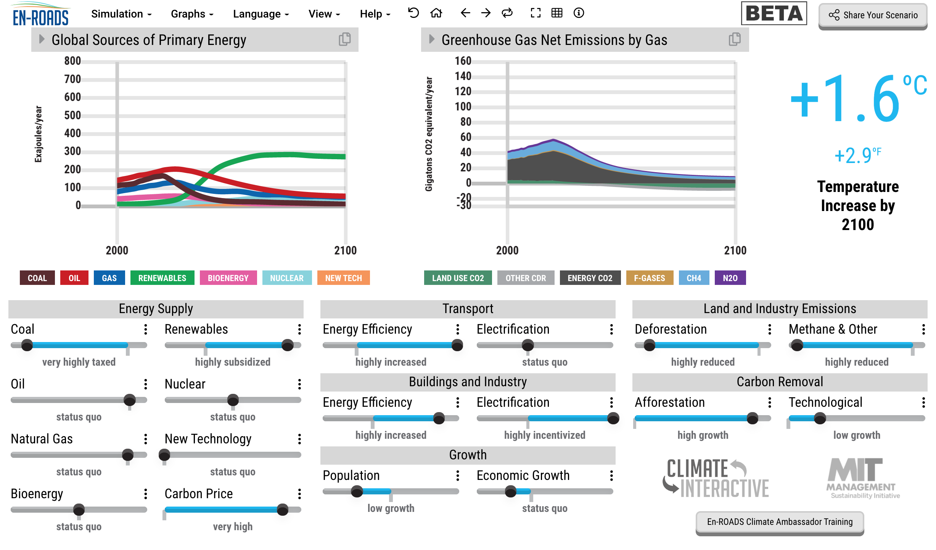

Part 4. Explain Class questions and review

Part 5. Elaborate and Evaluate Everyone needs to complete this after asking questions as needed.

Additional Solutions lessons Optional
- Drawdown activity with cards – Middle/High School – classroom activity!
  - DDown ActCards,
  - Student WS DDownActWS,
  - teacher guide DdownTch , review powerpoint DDownActiv,
For remote learning - Higher grade option – Student WS Solutions1_1-

2. Climate Solutions Web Search Activity File solproj20
- Remote or classroom
Uses the Stanford Solutions website by Mark Jacobson

