Teacher Guide for Climate Solutions Web Search Activity
- Developed by Pauline Seales email paulineseales120@gmail.com

Guiding question How can we switch to clean energy sources?

Lesson Type Suitable for remote learning OR classroom learning
BUT once the COVID crisis is over there is a highly engaging hands-on classroom activity you can start with - we have 12 sets of equipment and will be happy to bring to anywhere in Santa Cruz and N. Monterey counties. The same videos are used in both so if you’ve already done the hands-on activity just start on page 2 of this one.

Solar Activity with lights, batteries and mini solar cells |  | File SolTech | https://scruzclimate.org/education/k-12-lesson-plans/ | Teacher guide  SolarTeach,

Content standards MS/HS ESS2.D Weather and Climate,
ESS3.C Human impacts on Earth Systems ESS3.D Global Climate Change with connections to LS4.C Adaptation
Cross Cutting Concepts 1-5,7
Science and Engineering Practices 1-8

Materials All students need internet access and a paper or online worksheet

Preparation
Students should already have learned the basics of Climate Change before starting this solutions activity. We have a variety of ways activities for this. see https://scruzclimate.org/education/

Vocabulary
Part 1 a) Pre-play questions - review before starting video 1
metal , non-metal, semiconductor, silicon chips
b) Covered by movies A/B (play at 75% speed and review)
PV, Photon, Electron, circuit , battery, Non renewable

Part 2 - Climate Crisis, Justice and equity, Clean energy

Students will be able to discuss
How clean energy is accessible everywhere and has many additional benefits

Social & Emotional Learning Support Data review includes jobs added and health benefits.
The students also review the “Justice and Equity” tab and write about one example.

Instructions for teachers
The movies are engaging and informative (although slightly out of date)
The Solutions Project is from Stanford University and is updated as of 2020
NOTE - the writer of this lesson is available to help on zoom as a co-host.

Student work sheet

Part 1. Engage Start by introducing the pre-play vocab and then play the movies at 75%. Be sure to stop the movie and discuss as you go and/or replay sections.

From movie A
Model of a solar cell
explaining how it acts like
a battery

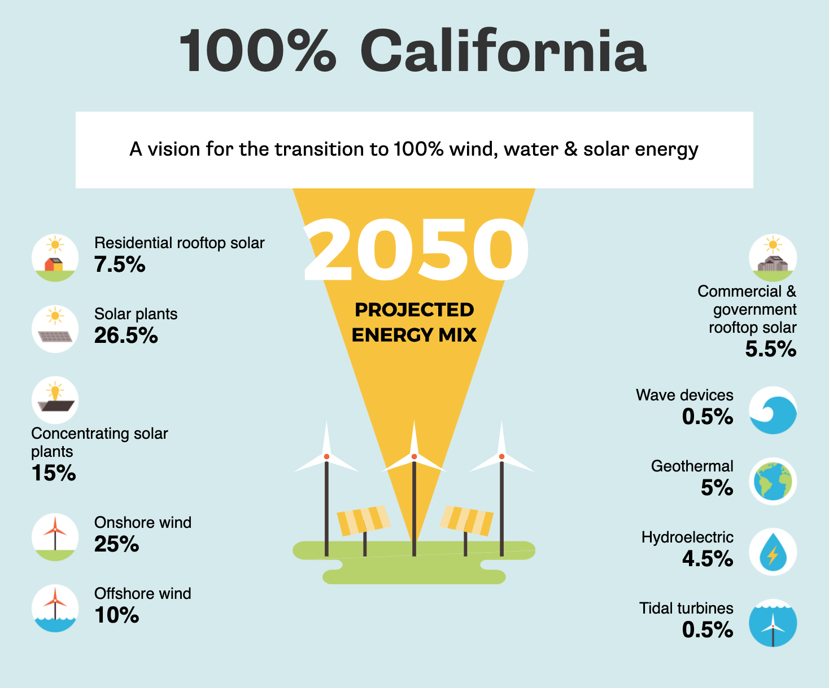
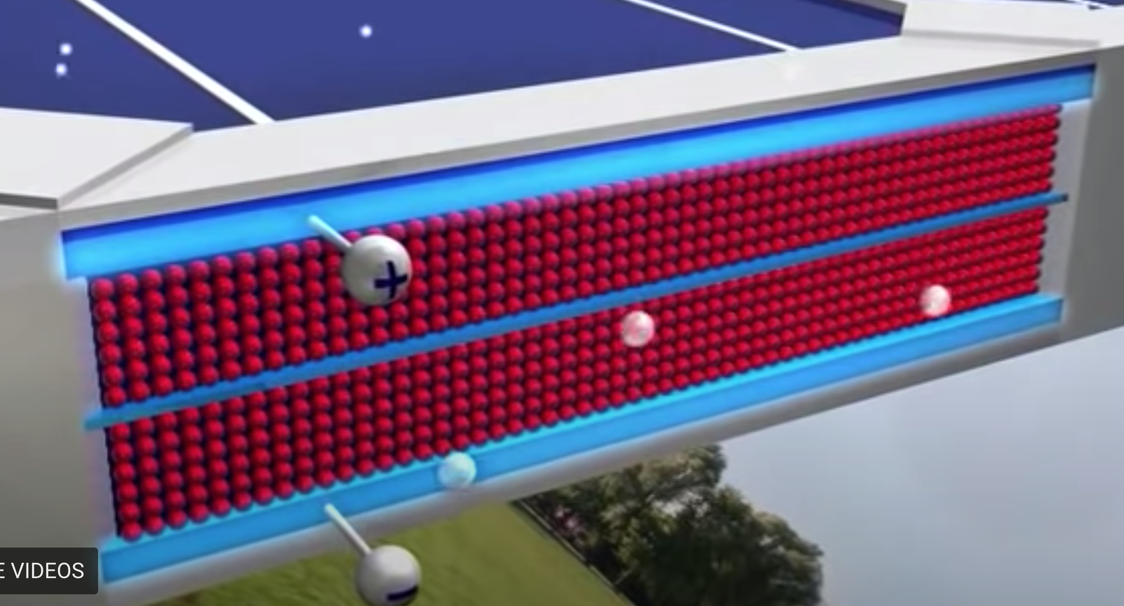
Part 2. Explore

Monitor the students’ progress.

Give help as needed.

If there is a part that is confusing for a lot of people, stop everyone and work through that part together.

Questions 6, 7,8 . Explain , Elaborate and Evaluate

Additional Solutions lessons Optional
- Drawdown activity with cards – Middle/High School – classroom activity!
  - DDown ActCards,
  - Student WS DDownActWS,
  - teacher guide DdownTch , review powerpoint DDownActiv,
For remote learning - Higher grade option – Student WS Solutions1_1-

2. Enroads Climate Solutions Simulation - online activity student WS ENRdsLes
Teacher guide Enrdstchr

