GREENHOUSE EFFECT Activity - Teacher Guide

Guiding Question How do changes in Greenhouse Gas Concentrations affect the climate and how does it work?

NGSS
Disciplinary Core Ideas : MS - ESS3-D Global Climate Change
(Connections to ESS 3-C Human Impacts, ESS2-D Weather & Climate)
MS - PS1.A Structure and Properties of Matter
MS - PS4.A Wave Properties

Science and Engineering Practices - all
Crosscutting Concepts - all

Science Practice
In this lesson students use a pHET simulation to both explore how CO₂ in the atmosphere is affecting climate and how the chemistry of the molecules relates to the greenhouse effect.
The introduction makes sure that the students have the background to understand what is happening with the model.

Vocab: Atmosphere, photon, visible, infra-red, Gases - names and chemical symbols Nitrogen, Oxygen, Carbon Dioxide, Methane, Nitrous Oxide

Materials: Currently (Nov 2021) there is not yet a chrome version of this Java simulation (HTML5).
Many schools have access to a computer lab with macs or PCs. The tech people may need to install Java in order to run the simulation. It’s best to give them a week or two notice.
There is a workaround for this which should also work with Chromebooks - use this link which runs via cheerpj https://phet.colorado.edu/sims/cheerpj/greenhouse/latest/greenhouse.html?simulation=greenhouse

Handouts
A handout per student or pair if they are sharing computers

Time - approx. one 55 min period - possibly continue a second day depending on time needed for introduction

Preparation
Students need to know some basics about the atmosphere. Many students may NOT already know that 80% of the atmosphere is Nitrogen. They probably know that living things need oxygen but not it’s %. They have probably heard of CO₂ but maybe not Methane.
Possible demo – iron filings in a test tube – inverted in a beaker of water.
Percentages and symbols could come from a text or a website or directly from the teacher. Many references on atmospheric composition will also list Argon - explain that it is “Inert” and therefore not included in the simulation.

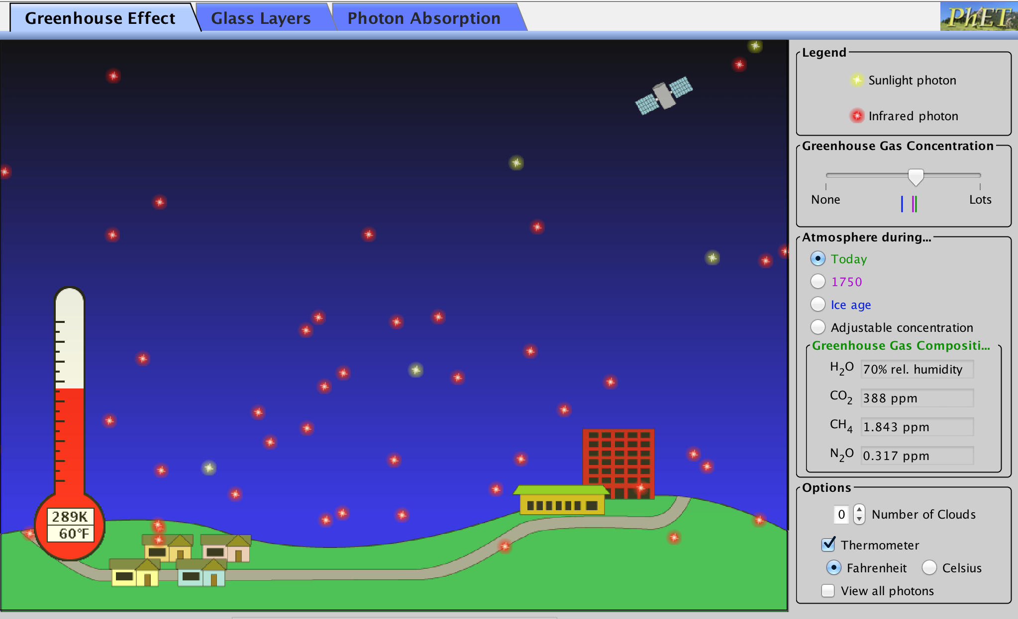
The PHOTON concept needs to be explained briefly as well as the differences between visible and infra red rays.
A “remote” which uses infra-red could be helpful.

Explore 1,2 DEMONSTRATE the simulation as the students open it themselves. Briefly show them the controls they will be using -->

Discuss answers to 1,2 as this is crucial to understanding everything that follows.

The students should then proceed to Step 3. at their own pace.

Explore Step 3
They will record data for Ice Age and other conditions in the data table.
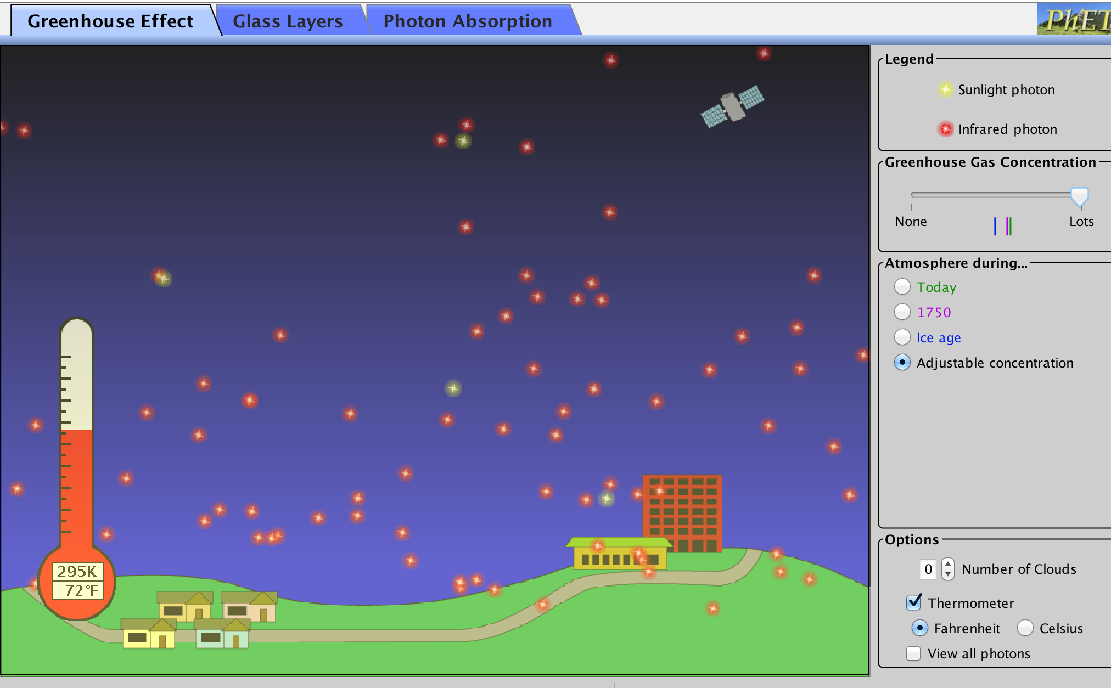
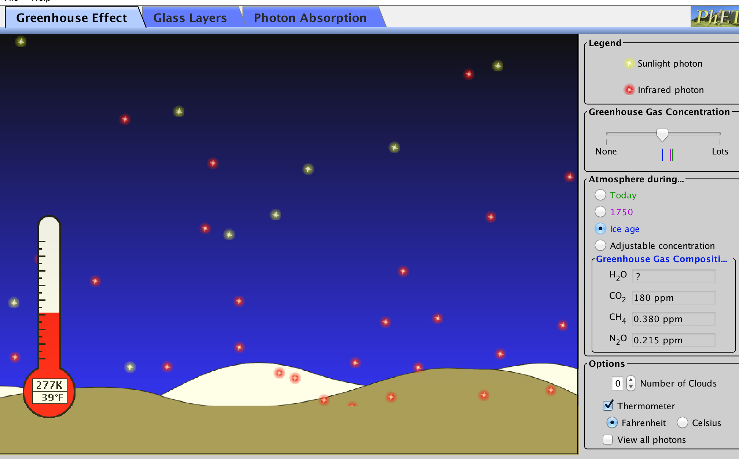

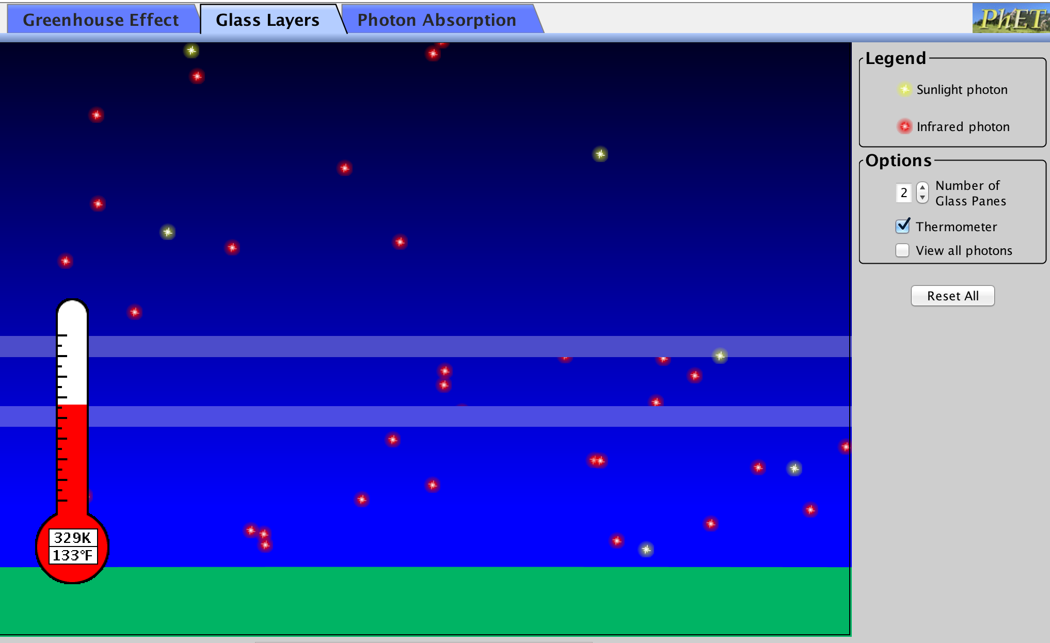
There are important Elaborate and Explain questions before the next Exploration. Allow students to discuss and answer their questions as necessary.

Explore 4 - Glass Layers
This shorter simulation shows glass layers trapping infra-red photons and heating the earth.
The students collect data and EXPLAIN by answering questions.
This helps then understand why the effect is called “Greenhouse Effect”

Explore 5 - Photon Absorption Lab
In this activity the students find out how the different molecules interact with photons.
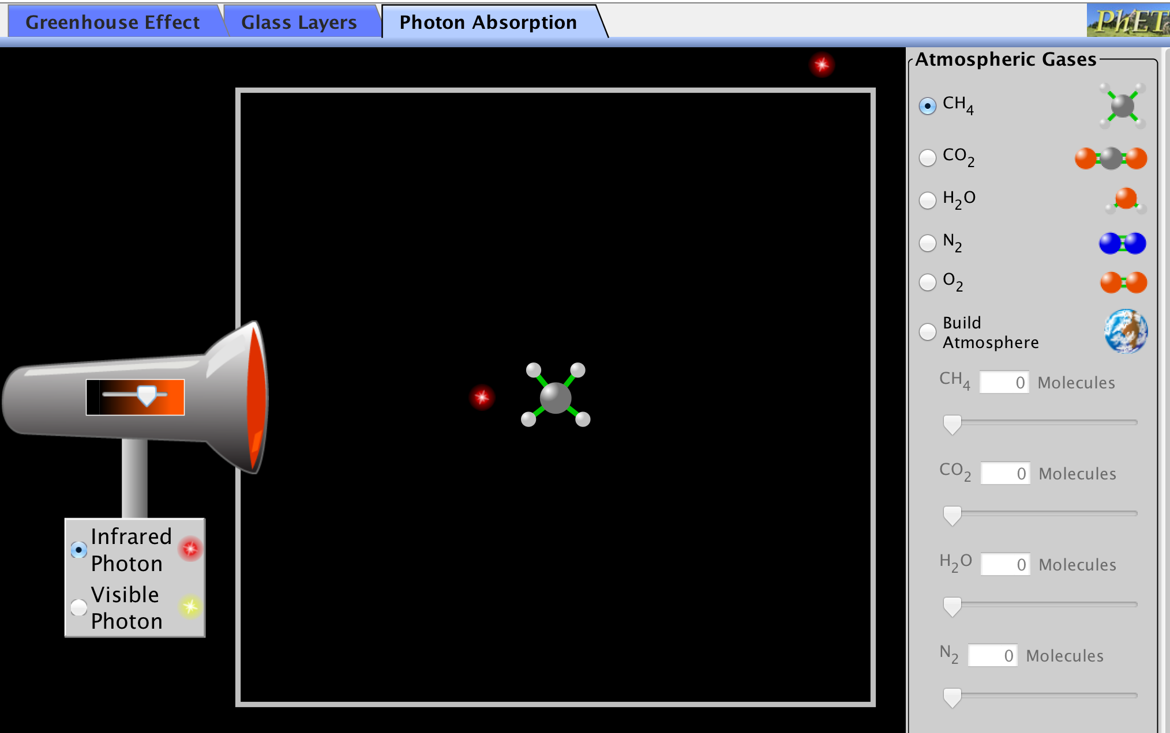

They will discover that none of the gases react with visible light.
CO₂, CH₄ and H₂O all “jiggle” with infra-red and the photons often change direction.

This will explain why these are the Greenhouse Gases.

Explore 5 - Clouds - this activity is Optional - use it for the fastest students and encourage them to do more research. They will observe that clouds can both reflect sunlight back to space - cooling effect, AND trap some infra-red from the earth - warming effect. Scientists do not yet know which effect will dominate but it is starting to look like warming may dominate.

Elaborate and Evaluate
Students can discuss with each other and ask the teacher questions as they work on these answers.
Explain that the “What can we do?” is extremely important and will be covered thoroughly in later lessons.
Its important to have them start thinking right now.

Prepared by Pauline Seales paulineseales120@gmail.com

All questions and constructive suggestions are welcomed
Complete sequence of lessons here
More resources at scruzclimate.org/education and scruzclimspeakers.pbworks.com

