Solar Activity Teacher guide - for Student worksheets Solarshrt, SolTech

Guiding Question
How do solar cells work and how can they help reduce climate change?

NGSS
Disciplinary Core Ideas : MS - ESS3-D Global Climate Change
(Connections to ESS 3-C Human Impacts, ESS2-D Weather & Climate
Science and Engineering Practices - 1, 3, 4, 6,7
Crosscutting Concepts - 1,2,3,5,6

Science Practice
Students learn about how solar cells work through 2 short videos
Then they will experiment with batteries, lights, motors and solar cells

Vocabulary
Metal, non-metal, semiconductor, silicon, photo-voltaic, photon, electric current, renewable

Materials: See each worksheet - the writer has a complete classroom set and will be happy to loan it and help with the lesson or supply a materials list if requested.

Handouts: SolTech or short version Solarshrt,

Time - about 45 min - or slightly longer depending on time used for preparation and intro movies

Preparation
Students should be introduced to basic science of Climate Change through either
videos, powerpoint presentations or a computer exploration of climate.nasa.gov WS ClimNasa_Ice
Suggested powerpoint – Current Climate this will Engage the students

Explore -
Part 1
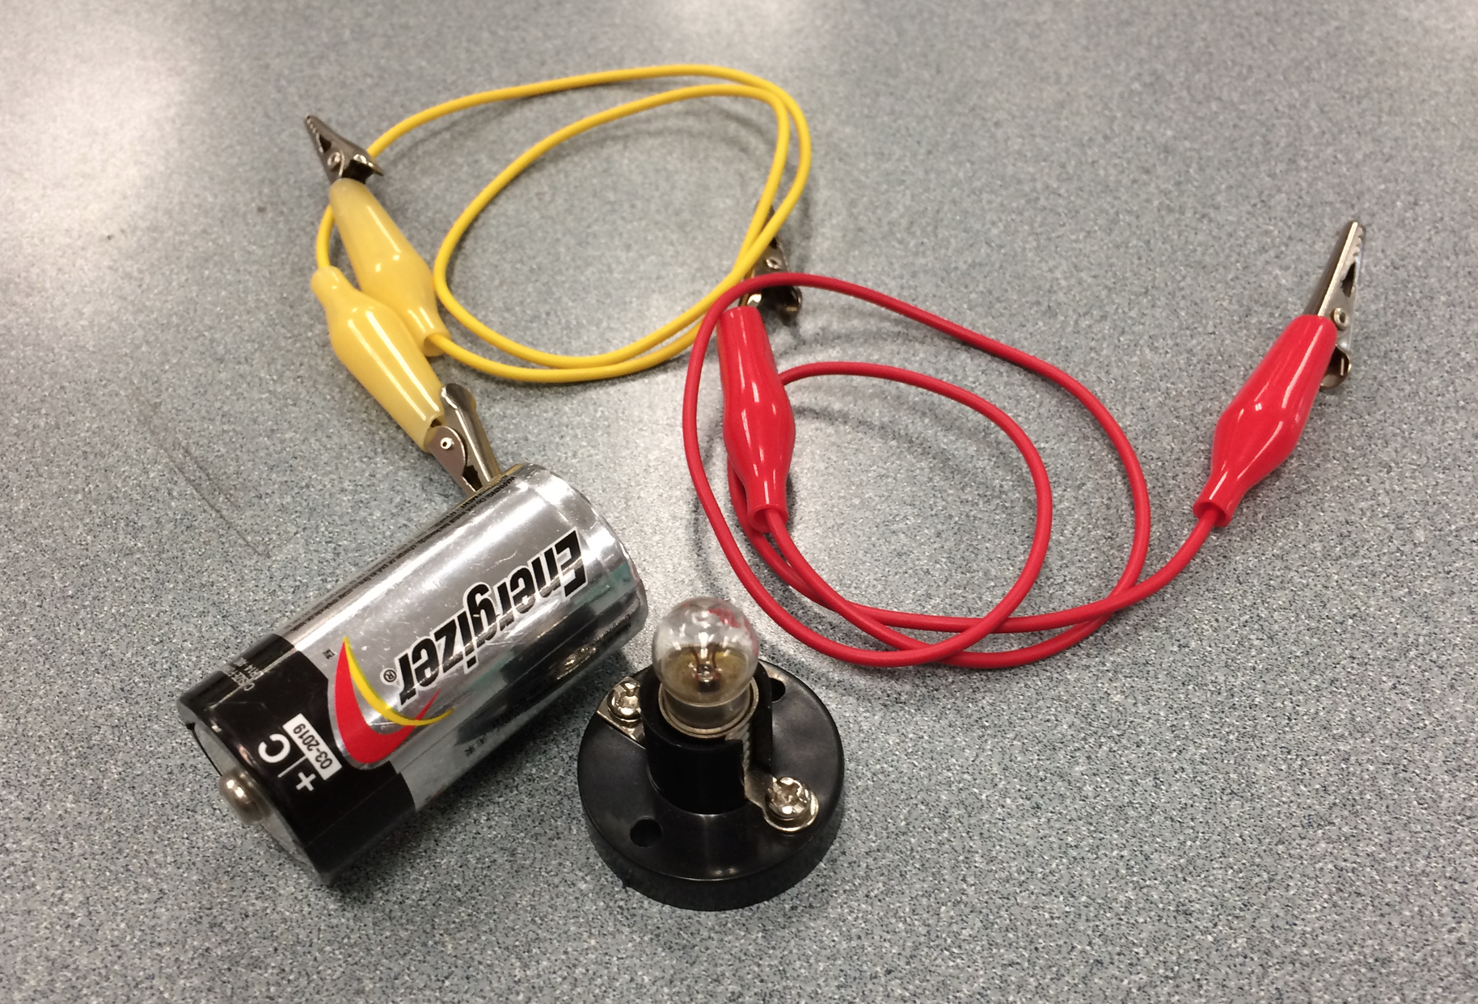
Hands On Activity

Step 1 - Light the bulb and draw a diagram

This ensures that students understand the basic concept of a circuit

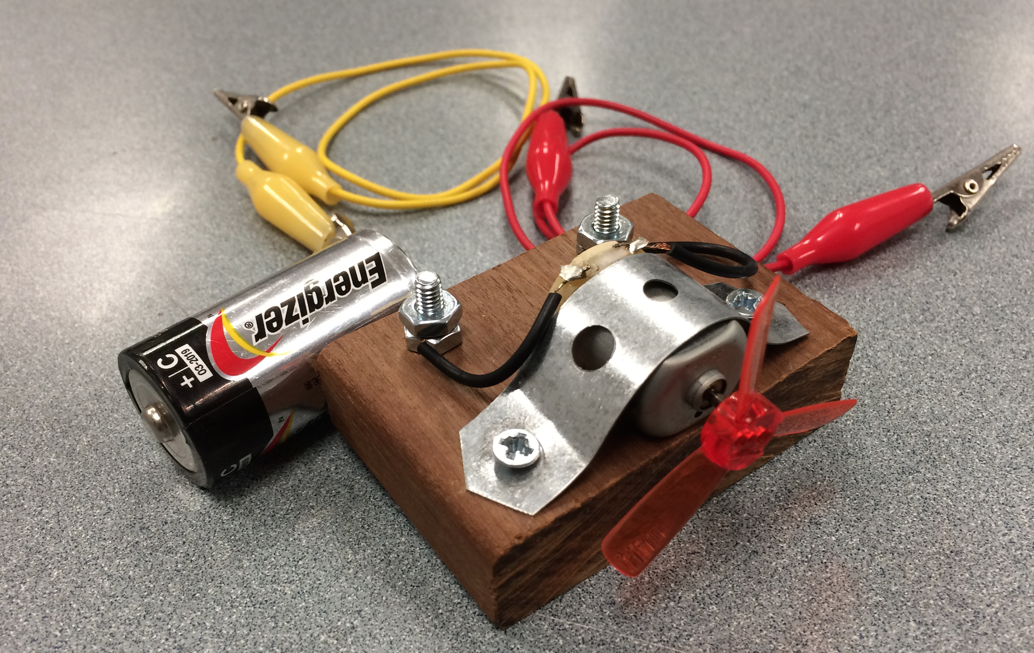
Part 2 - Power the motor with the battery

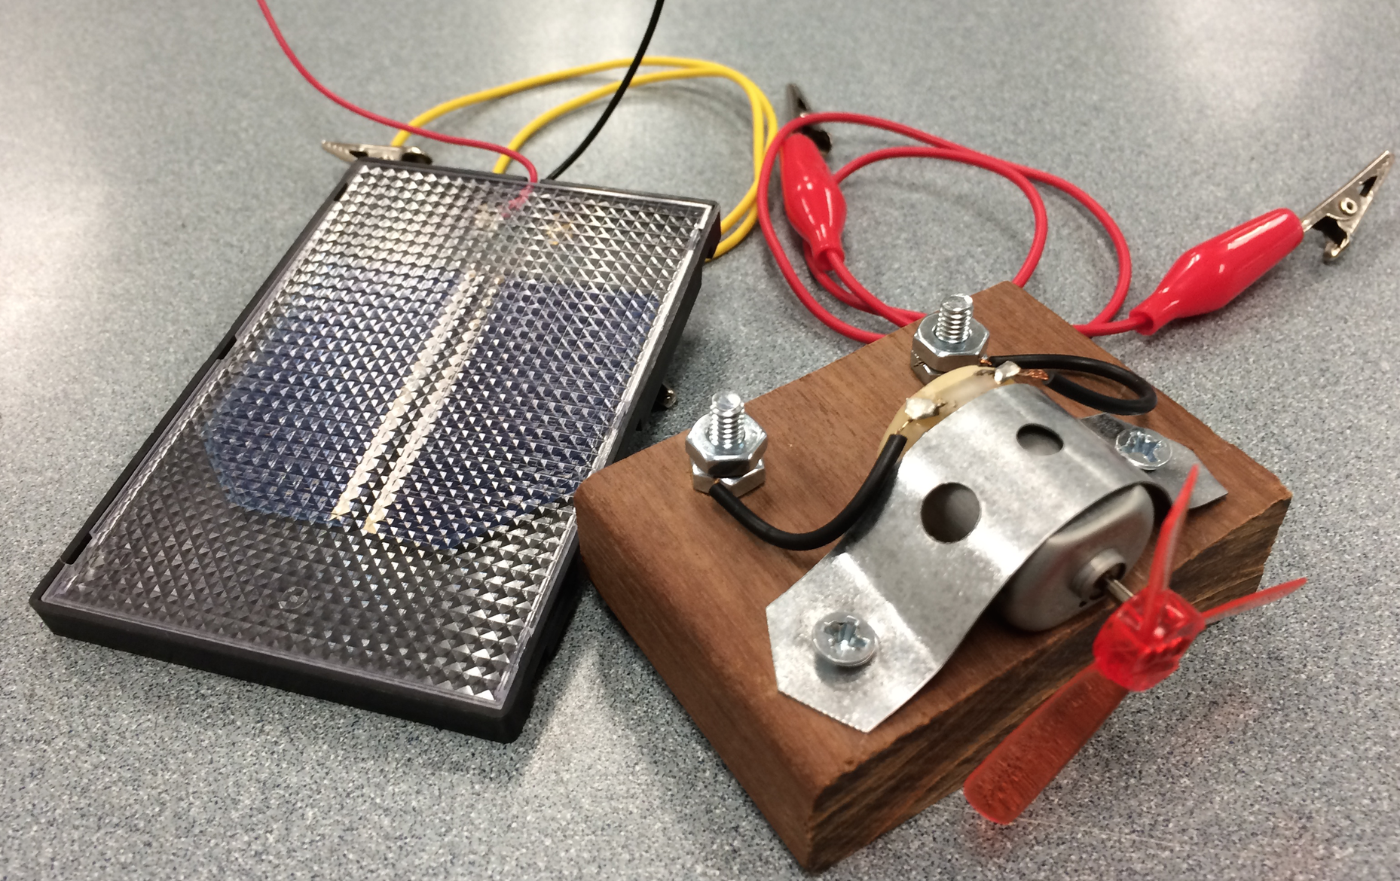
Part 3

Use the Solar cell to power the Motor
OUTSIDE
(Does not work with heavy overcast but thin clouds are OK - on one overcast afternoon the students figured they could wire 2 cells and work the motor)

They investigate how the fan speed changes with shading and angling of the solar cell
Evaluate - student discussions and conclusions
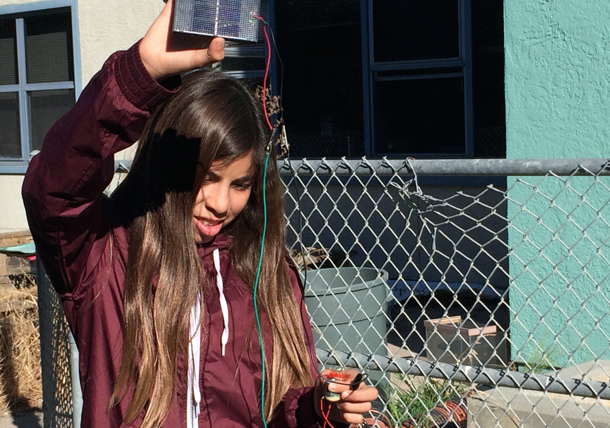

Note 1 – these cells do not quite light the bulbs especially with the outside light making it difficult to see a faint glow – but it’s OK to try!

Note 2
More advanced students could measure current and voltage and calculate the watts, for several different measured angles.
Results will be highly dependent on date/time/latitude.
Results form different class periods could be compared the next day

Shoreline 8th grade student using the equipment

This should be the first in a series of lessons on Climate Solutions and followed with Drawdown (5-12) and Enroads (8-12) lessons or other Climate Solutions lessons.

