Carbon Story Activity - Teacher Guide for student WS CStoryLesson

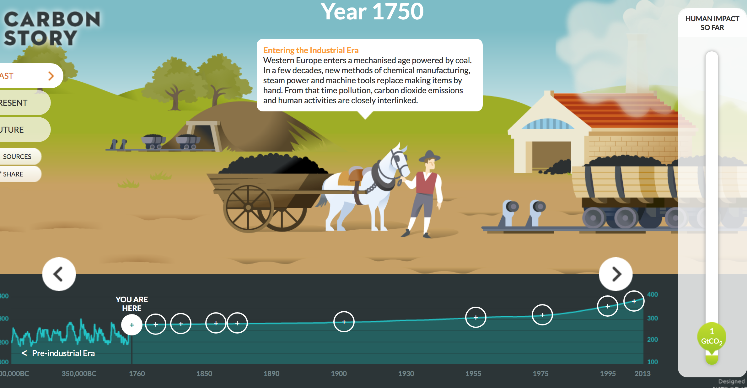
Guiding Questions
1. What is the history of human carbon emissions?
2. What has been the role of the USA in creating the problem?

NGSS
Disciplinary Core Ideas : HS - ESS3-D Global Climate Change
ESS 3-C Human Impacts,
Science and Engineering Practices - 1, 3, 4, 5, 6, 7, 8
Crosscutting Concepts - 1, 2, 3, 4, 7

General info
The student WS lists a 3 min intro video – use this if you have not already introduced Climate Science to the class

Also parts 4,5 are for advanced students only
Suggest removing from the worksheet for most classes but keeping the evaluation questions at the end.

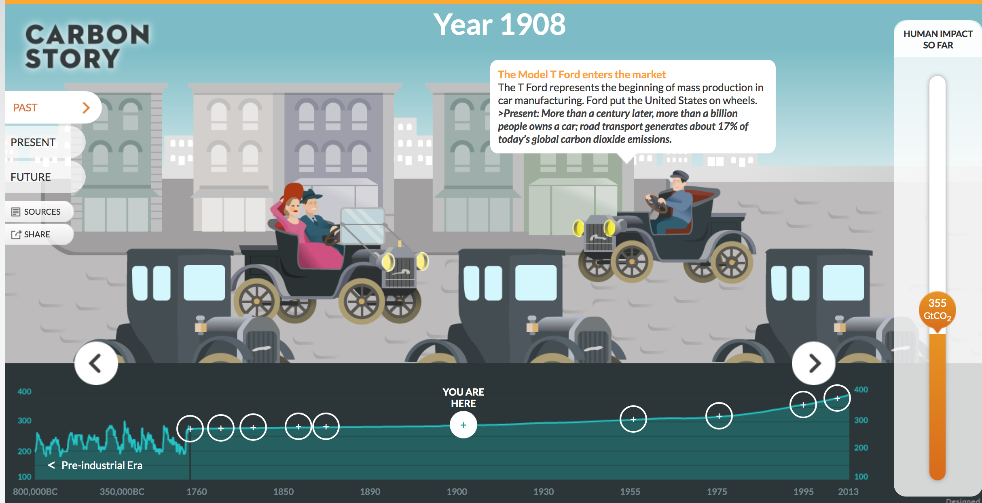
Science Practice

Vocab: emissions, heat-trapping gases, combustion of fossil fuels, deforestation, global warming.

Materials: Chrome books or similar small computers. No more than 2 students to one device.
Handout / Worksheet
A handout per student or pair if they are sharing computers

Time - approx. one 55 min period - possibly continue a second day depending on time needed for introduction

Explore
Part1 a https://scripps.ucsd.edu/programs/keelingcurve/ Explore historic CO₂ concentrations and complete the 2nd column on the student WS. To get all the info they will need to click to get the various time scale graphs starting at 800k. Guide this part!
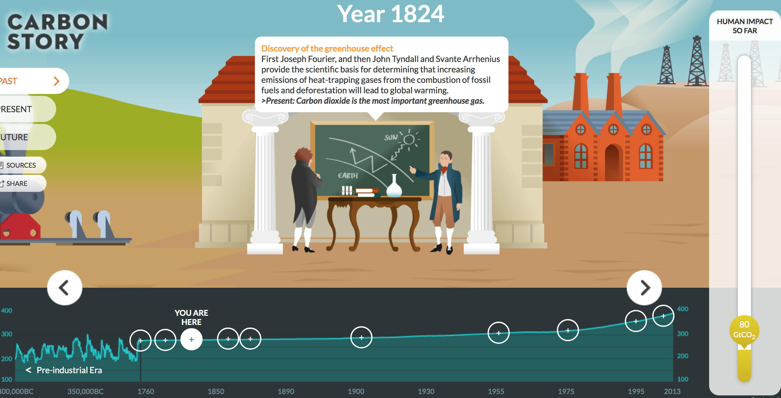
b. http://www.globalcarbonatlas.org/en/outreach history of climate change. This will help them understand the scope and background of the problem.

Starting at 8000,000BC students trace life styles, discoveries and accumulated CO₂ in Gtons.
They will discover that CO₂ concentrations were constant for a very long time before the industrial revolution.
They will complete the rest of the data table on the front page.

The Explore and Explain questions will get the students thinking and Evaluating the information

Part 2 , 3 - The Present
A thorough look at who has been producing all the CO₂ and how.

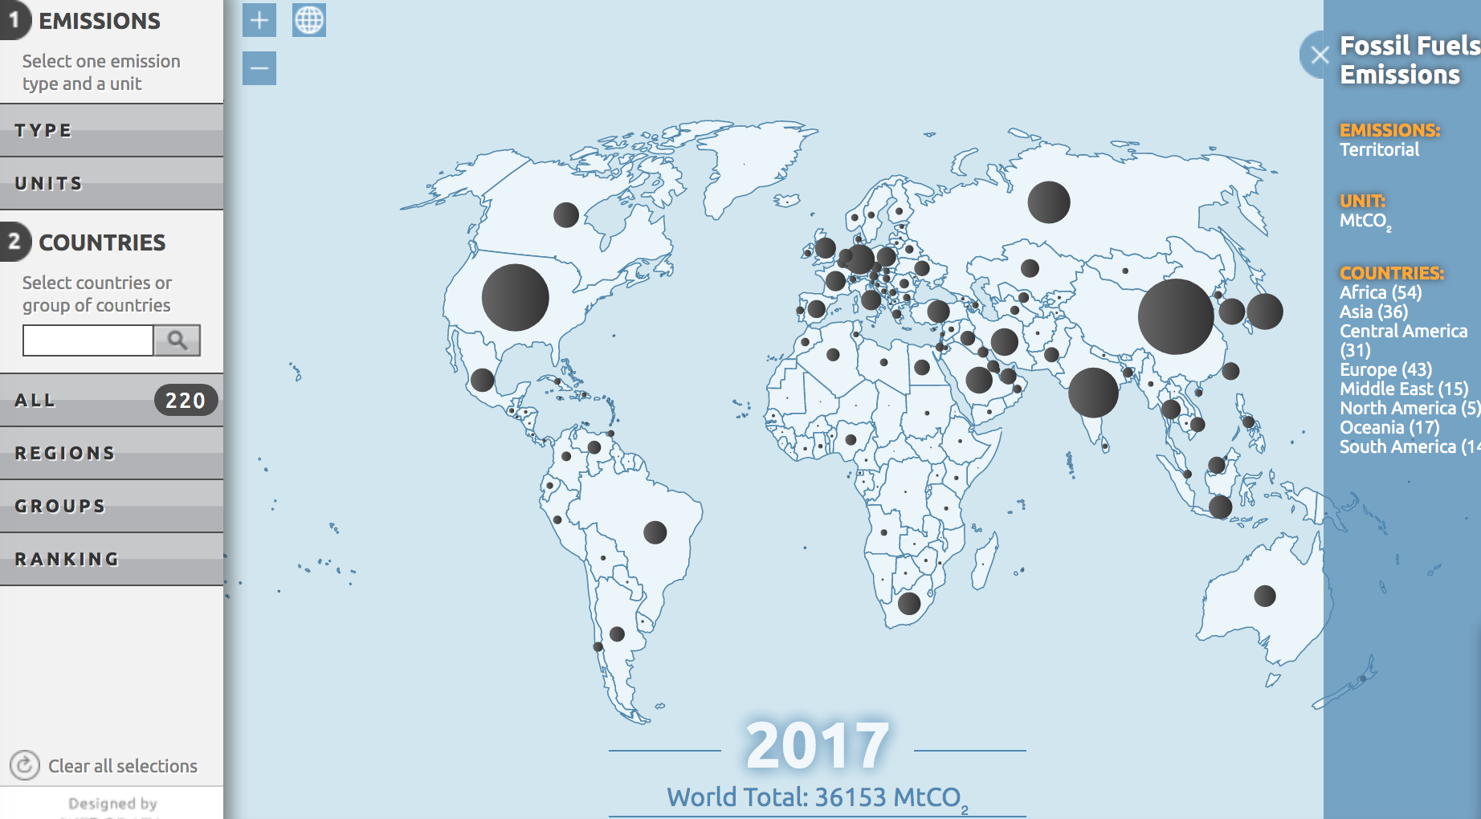
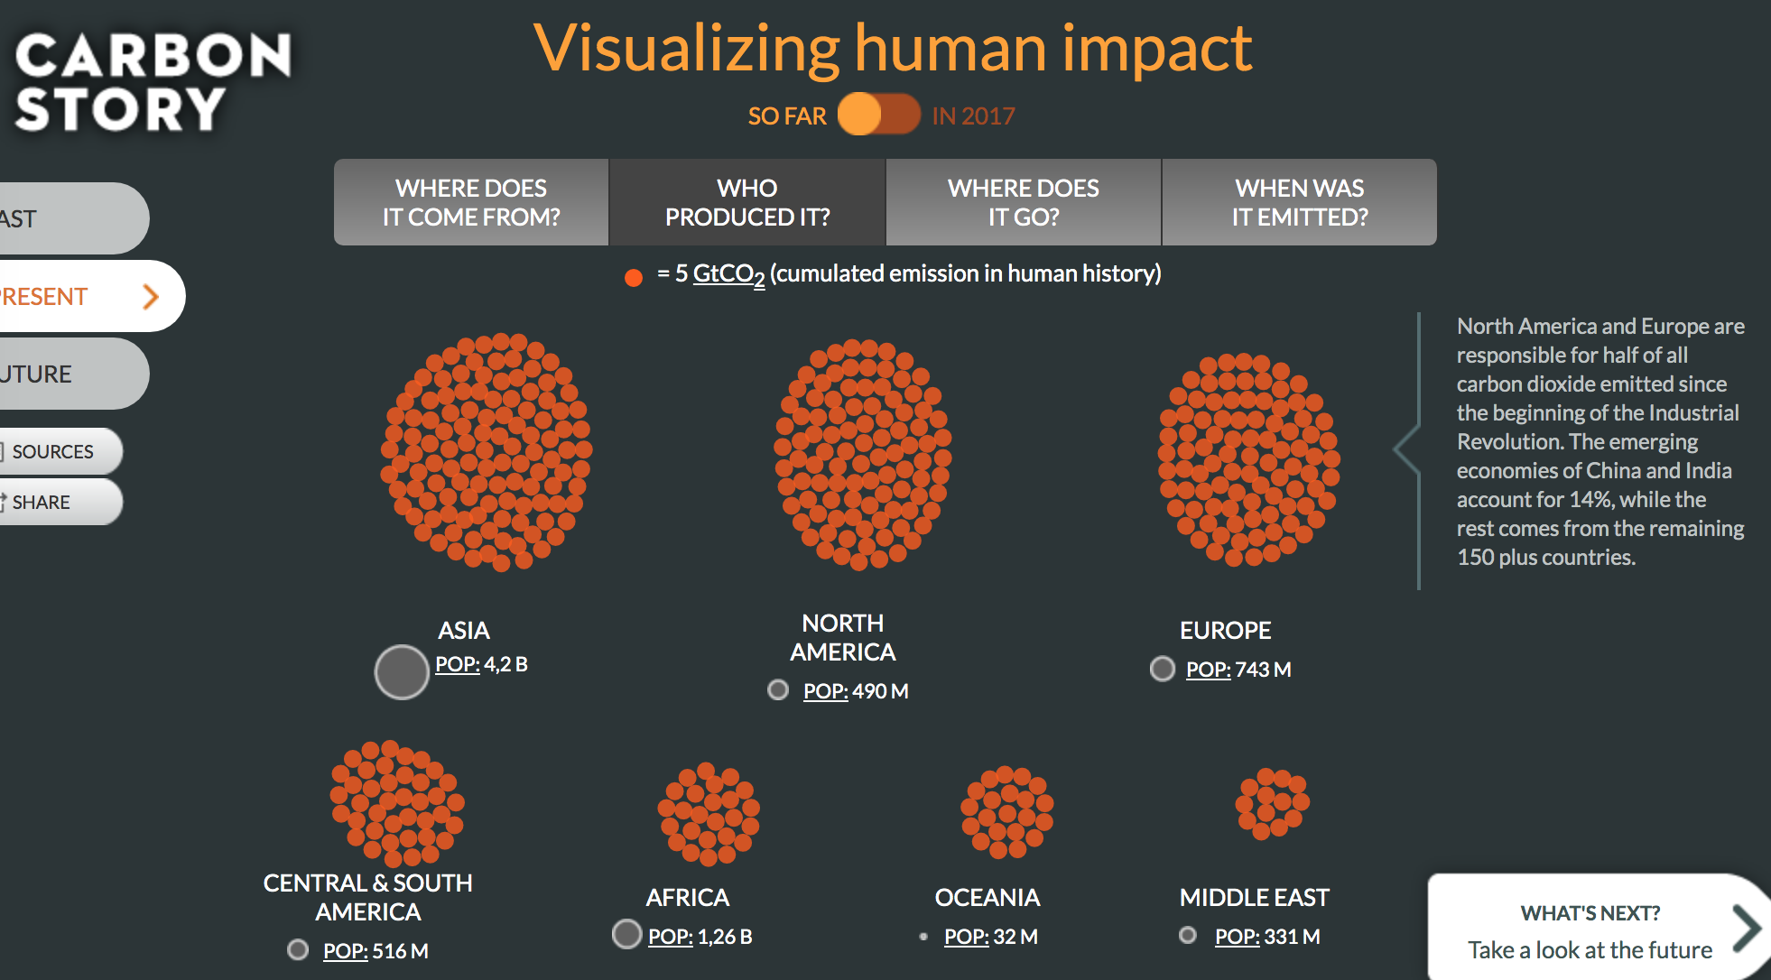

Part 3 - Map View looks at emission changes since 1960

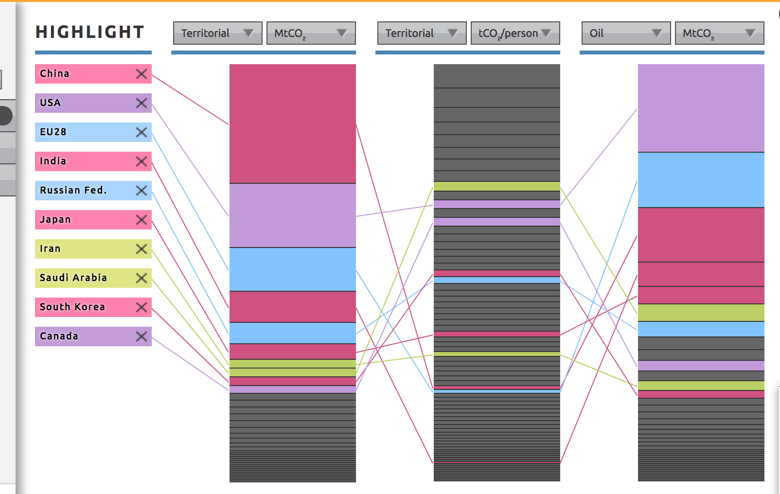

Part 4-
Might be difficult for younger students
Go to evaluation

Ranking looks at PER CAPITA Emissions
Showing the still US far ahead of other large countries

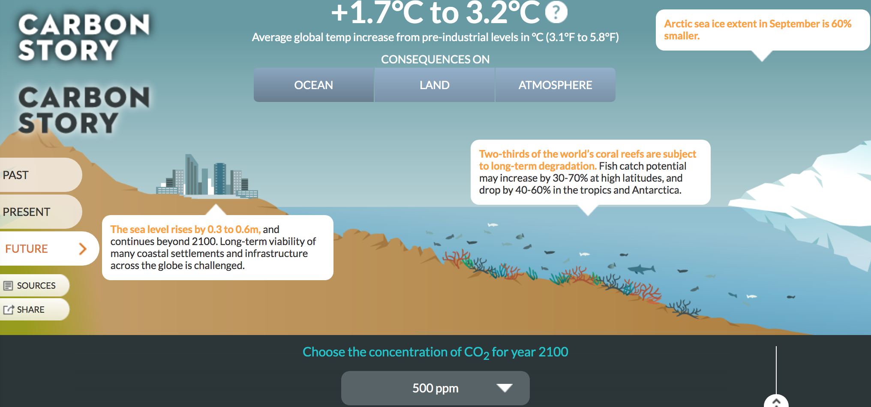

Part 5- Looking to the Future
Sadly this is already out of data as Climate Change is happening MUCH faster than predicted when the site was developed

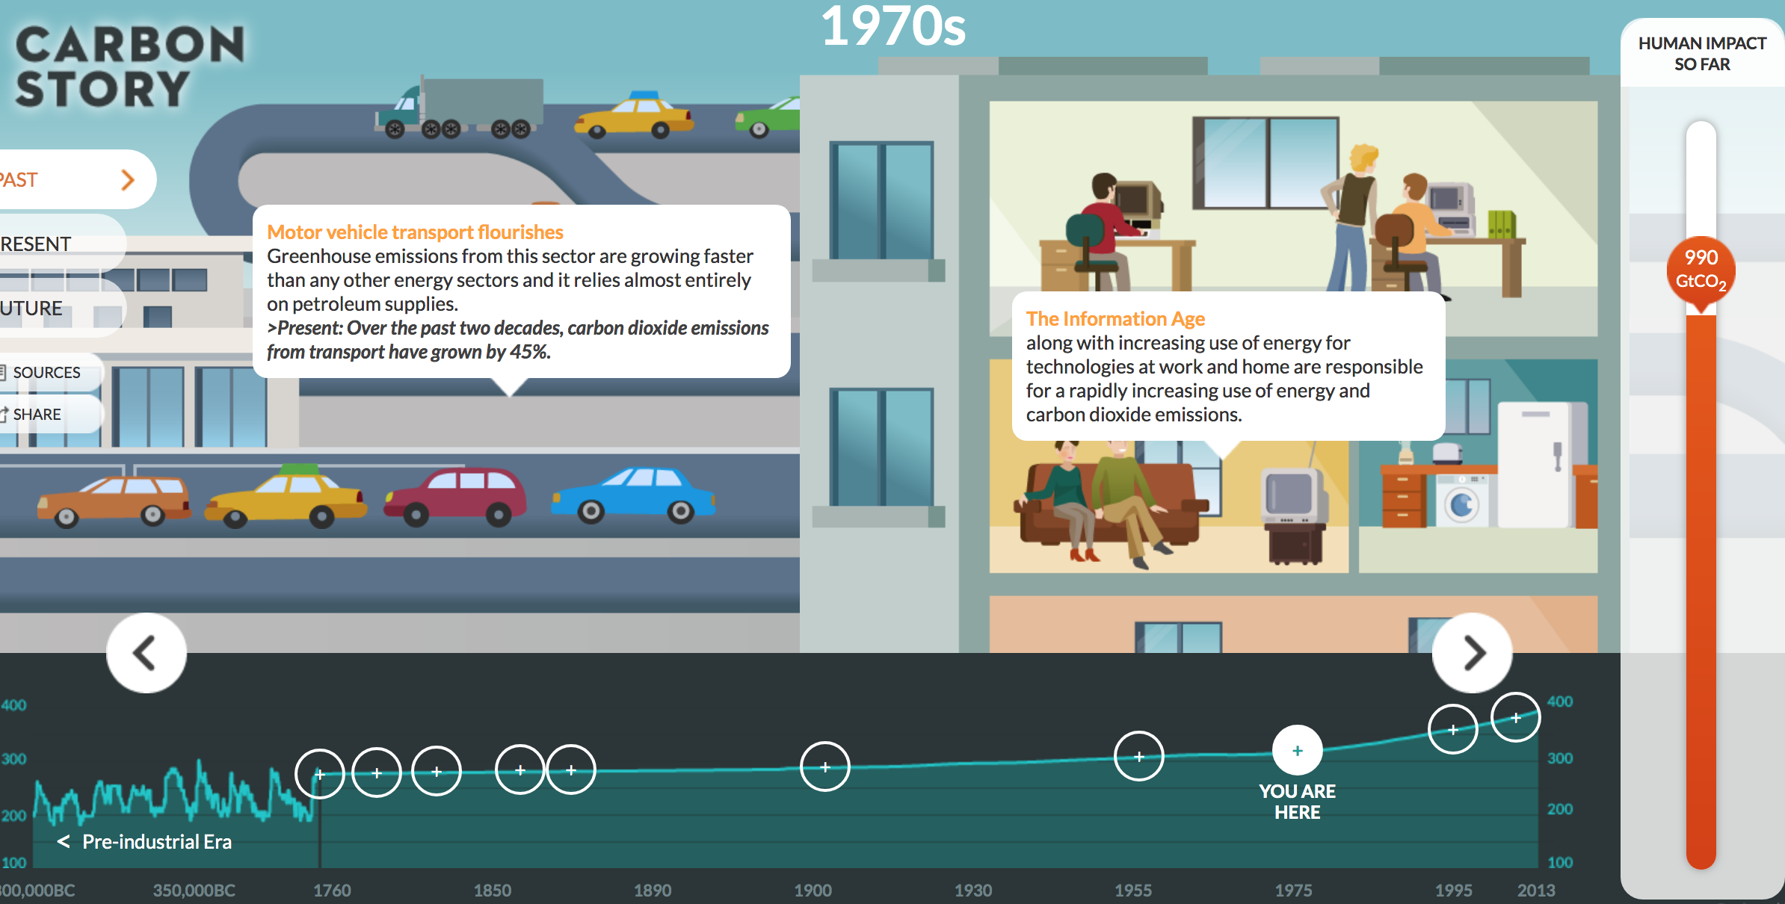

Prepared by Pauline Seales paulineseales120@gmail.com All questions and constructive suggestions are welcomed More lesson at scruzclimate.org/education

