Shade as a Climate Option - Temperature measurements at paired sun-shade locations in Santa Cruz, CA during a heat wave

Peter Weiss-Penzias, Jarett Jones, Saleem Mokatrin, Isabella Trask
University of California, Santa Cruz, Department of Environmental Studies

October 25, 2022
pweiss@ucsc.edu

Introduction

Prevalence of shade trees in urban areas significantly controls the temperature of the surface in these areas, moderating the temperature fluctuations. This is especially important in minimizing summertime temperature extremes during heat waves, which can reach unhealthy levels in some urban areas. Many people are susceptible to extreme heat which causes life threatening conditions and mortality. Tree cover in urban areas is also associated with socioeconomic class, with poorer neighborhoods having many fewer trees resulting in average temperatures that can be 4-8°C hotter in poorer neighborhoods compared to richer neighborhoods, which presents a disproportionate risk to human health across classes (Macdonald et al., 2021).

Localized temperature measurements may in fact reveal even more disparity in temperatures between areas with shade and without much shade. Previous studies used temperature measurements from satellites on a kilometer grid scale, but this may be too coarse to understand the effects of shade on temperature moderation on the spatial scale of a city-block.

This research project set out to compare temperatures taken on a 1-min timescale at six locations in a relatively small region of downtown Santa Cruz. Three locations were chosen based on each location having a large sunny area with no shade and a group of trees where there was shade all day. The basic question we wanted to address was if there was a significant difference between the three locations in the shade-sun paired temperatures and whether that difference could be explained by relative amounts of tree cover between the three locations.

Locations

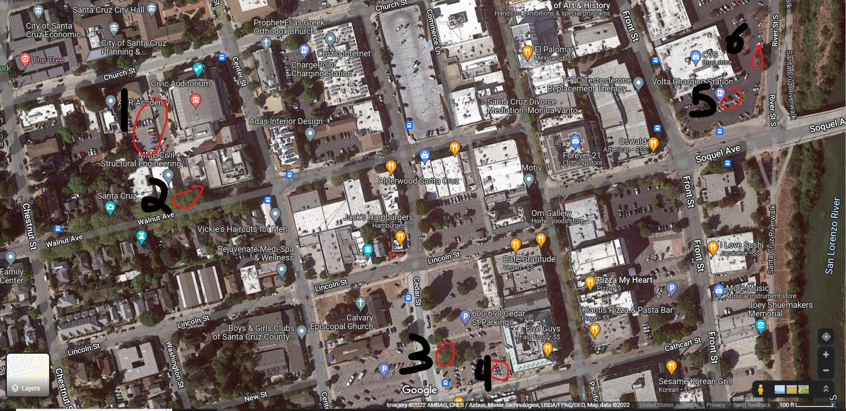

The above map shows the 6 locations used for the deployment of thermometers. Locations 1 and 2 were the sun/shade pair at the Civic Auditorium and Walnut St., respectively. Locations 3 and 4 were at the Farmer’s Market parking lot (sun and shade, respectively). Locations 5 and 6 were in the Trader Joe’s parking lot (sun and shade, respectively). Of the three locations, the Trader Joe’s parking lot has the lowest overall tree coverage on the scale of a city block.

Temperature Measurement Device and Deployment

We used six identical devices purchased from Amazon.com: Govee Hygrometer Thermometer, Wireless Thermometer, Mini Bluetooth Humidity Sensor. These have a bluetooth range of up to 262 ft and the data were retrieved weekly during the experiment.

The Govee thermometers were deployed on August 18, 2022 until September 10, 2022 using a power lift truck and zip-ties with the help of the City of Santa Cruz. The thermometers were attached to tree branches in the shade, and to light poles where there was no shade (“in the sun”) at a height of 5-7 meters. The data in this report are from August 31 until September 10 when a severe heat wave occurred.

Results - The Labor Day Heat Wave of 2022

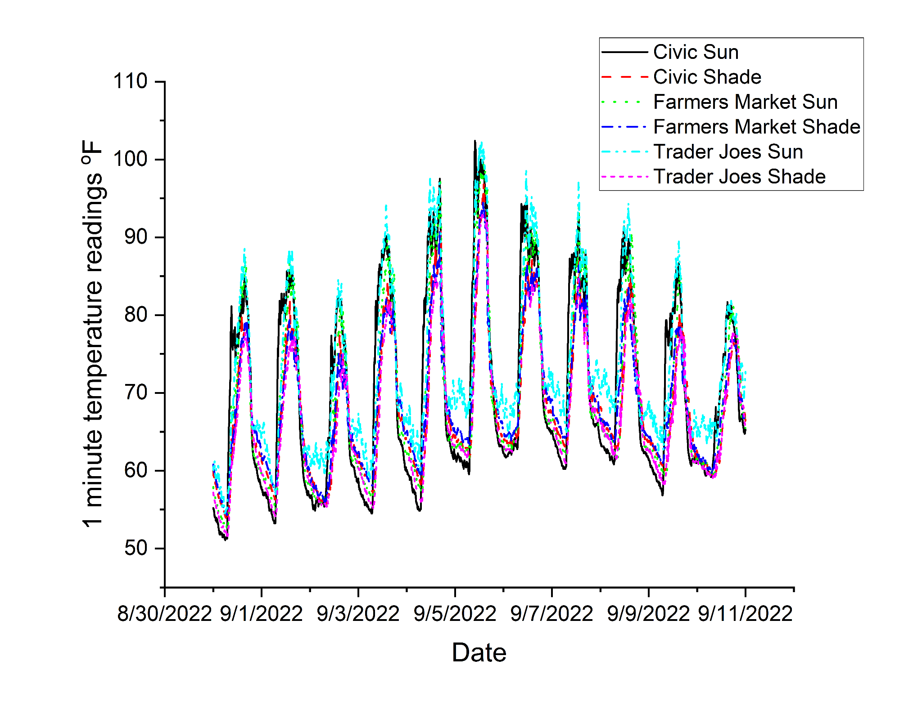
Figure 1: Raw 1-min temperature data from six thermometers in Downtown Santa Cruz over the time period when a severe heat wave occurred.

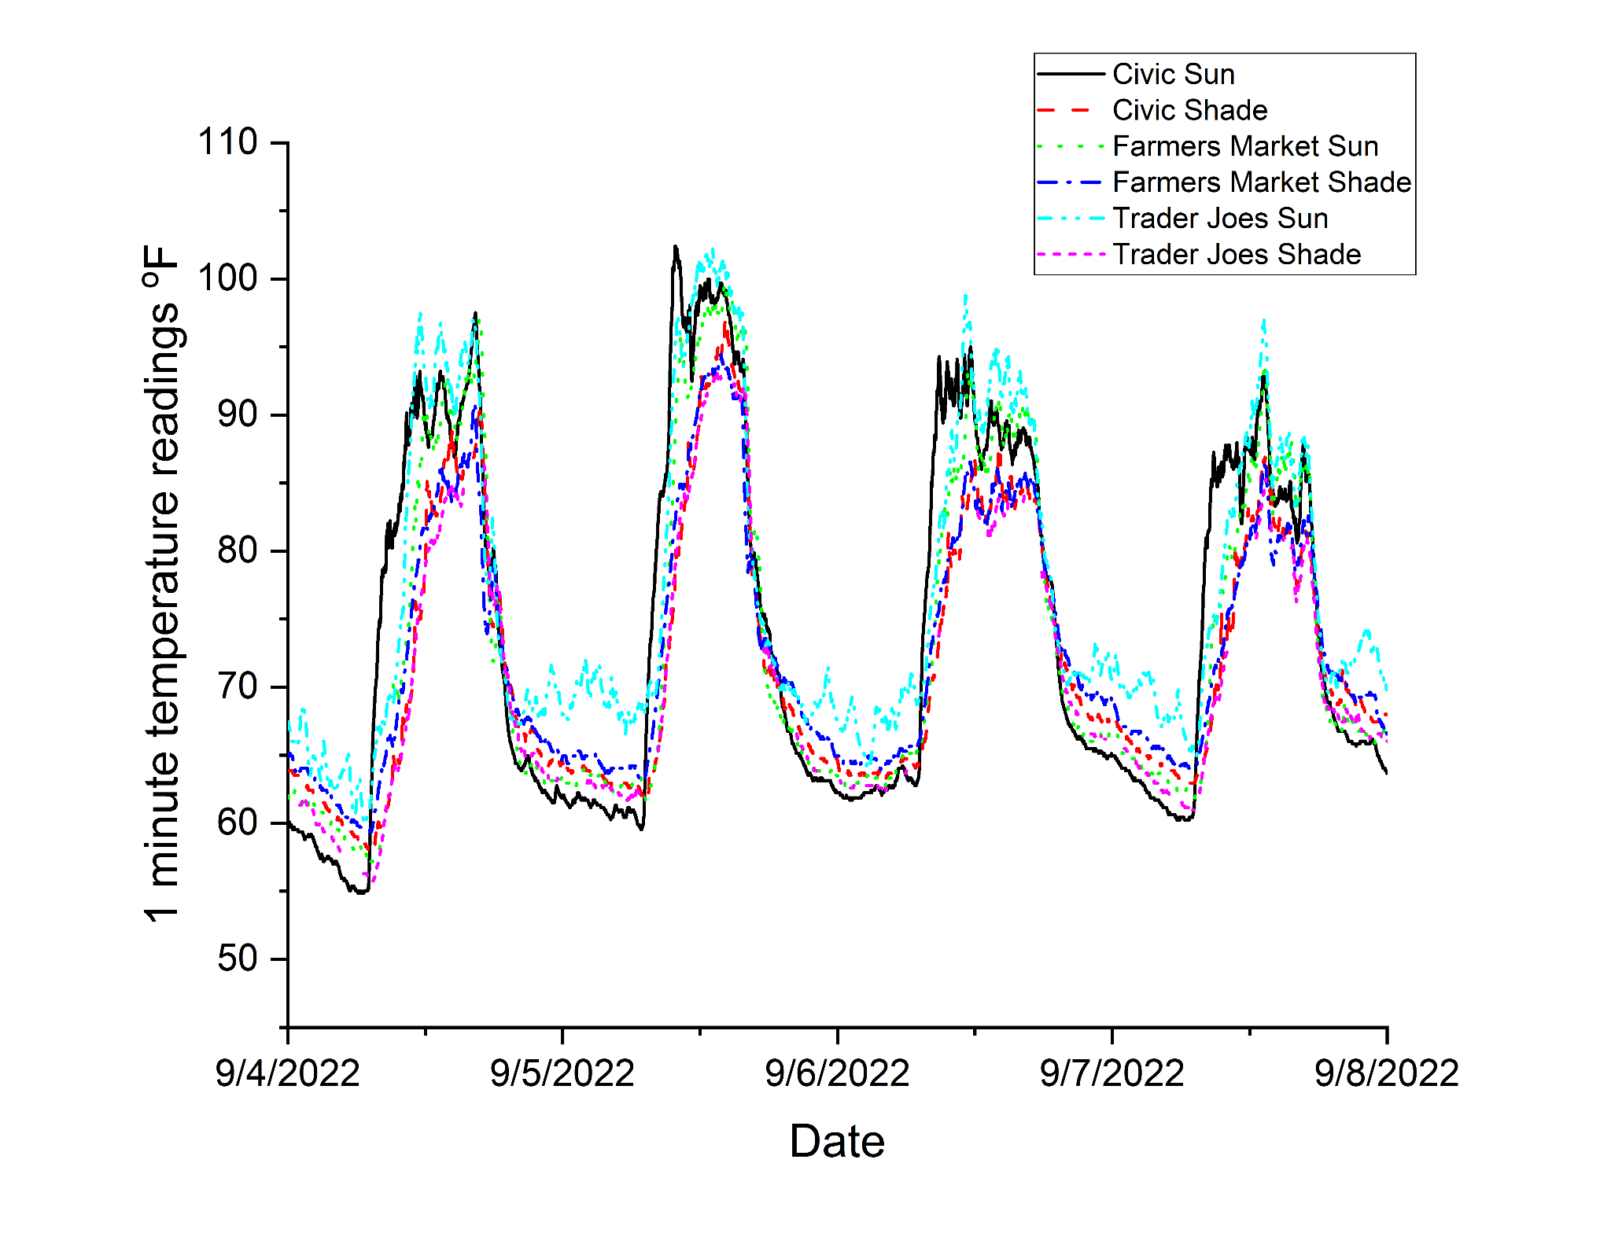
Figure 2: Close up in time showing the hottest 4 days in downtown Santa Cruz

 | N total (1 min data) | Mean ºF | Standard Deviation ºF | Minimum ºF | 1st Quartile ºF | Median ºF | 3rd Quartile ºF | Maximum ºF
Civic Sun | 15840 | 70.5 | 12.1 | 51.1 | 60.8 | 66.0 | 81.0 | 102.4
Civic Shade | 15648 | 68.4 | 8.6 | 53.8 | 62.2 | 66.0 | 74.5 | 96.8
Farmers Market Sun | 15444 | 69.4 | 10.9 | 52.3 | 61.3 | 65.5 | 77.9 | 99.5
Farmers Market Shade | 15840 | 68.9 | 8.2 | 54.3 | 63.1 | 66.7 | 74.5 | 94.5
Trader Joes Sun | 15840 | 73.0 | 10.2 | 54.5 | 65.7 | 70.0 | 80.1 | 102.2
Trader Joes Shade | 12294 | 66.7 | 8.3 | 51.6 | 60.8 | 64.8 | 72.3 | 93.2

Table 1: Statistics on the measurements from six thermometers over the period Aug 31 - Sep 10, 2022.

 | avg delta T (sun - shade) all times | avg delta T (sun - shade) morning | avg delta T (sun - shade) afternoon
Civic | 1.79 | -2.56 | 5.27
Farmers Market | 0.57 | -1.47 | 4.94
Trader Joes | 5.53 | 4.92 | 8.93

Table 2: The average temperature differences between the sun and shade pairs at the same location. Positive numbers indicate the thermometer in the sun is warmer than the one in the shade and negative numbers indicate the opposite. Afternoon is defined as 12:00 to 17:00 and morning is 01:00 to 06:00.

Discussion

Not surprisingly the thermometers in the sun had higher mean temperatures than the ones in the shade (Table 1). However, when we look at the difference between temperatures between the sun/shade pair of thermometers, we see that while daytime temperatures were higher at the sunny location, at night for two of the sites (Civic and Farmer’s Market) the temperatures were higher on the thermometer in the shade (Table 2). This indicates that the presence of the trees moderated both the high and low temperatures.

The temperature trends at the Trader Joes parking lot locations were quite different from the other two sites. The thermometer in the sun at this site had the highest mean temperature (Table 1) and the highest daily maximum temperature (Figure 1 and 2). The sun thermometer also had the highest nighttime temperature (Figure 1 and 2), much different than any of the other thermometers.

The difference between the sun and shade thermometers at the Trader Joes parking lot was 4.92°C during the morning and 8.93°C during the afternoon, indicating the anomalously high temperatures experienced at this site compared to the others.

The Trader Joes parking lot has very few trees and this could be a reason why we observed this anomalous temperature behavior. However, we can’t rule out other explanations such as being closer to the river and great air flow coming from the ocean/upriver. However, that a clear temperature pattern was observed in line with our original hypothesis, suggests that further study is warranted to determine the effects of shade cover on temperature patterns in urban spaces.

Reference:
McDonald RI, Biswas T, Sachar C, Housman I, Boucher TM, Balk D, et al. (2021) The tree cover and temperature disparity in US urbanized areas: Quantifying the association with income across 5,723 communities. PLoS ONE 16(4): e0249715. https://doi.org/10.1371/journal.pone.0249715

